

Annotating & Academic Notetaking:
A Student Guide to Active Reading

What Is Annotating?
Annotating means marking up your text to make sense of it as you read. This can include:
- Underlining or highlighting key ideas
- Writing notes or questions in the margins
- Paraphrasing content in your own voice
- Marking things you don’t understand to return to later
- Drawing connections to other texts, ideas, or experiences
- Using symbols (e.g., ! for something surprising, * for important, ? for confusing)

Why Is Annotation Important?
- Increases retention: You remember more when you think while reading.
- Deepens understanding: Helps you slow down and process meaning.
- Prepares you for writing: Annotated texts become pre-writing tools.
- Supports class discussion: You’ll have something to say—and something to quote.

Techniques for Annotating Effectively
Technique | How to Use It | Why It Works
Highlight Sparingly | Mark only thesis statements, keywords, or turning points | Keeps the focus on what’s truly important
Margin Notes | Summarize, question, paraphrase, or react to key sections | Makes reading visible and personal
Symbols/Abbreviations | Use a combination of symbols and custom shorthand (see below for more) | Quick reference and pattern recognition
Says/Does Method | Write what the text says (content) and does (function) next to paragraphs | Sharpens rhetorical analysis
Text Connections | Link to personal experiences, current events, or other texts | Encourages synthesis
Keyword Tracking | Circle or list recurring words, phrases, or themes | Aids comprehension and reveals focus areas

Symbols/Abbreviations:
If you do not have your own system, consider beginning with or building on the annotations in the following chart:
Symbol | Meaning
✓ | Mark points/concepts you want to talk about in class discussion
✓✓ | Mark points/concepts you want to include in your project
box  +  Underline | Draw a box around key terms and then underline the definition. For example:  is a school of literary theory that focuses on the reader and his/her experience reading a literary work.”  Reader response theory is
circle | Circle rhetorical signposts (clues the author gives the reader about where the text is heading). For example:  first  second  third  This theory is composed of three parts: …”
? | Use this to mark information you have a question about or don’t understand
[brackets] | Use these to labels the author’s thesis statement or position
* | Use to indicate a passage that helps you better understand the author’s argument
! | Use this to denote passages that surprised you or seemed strange

Academic Note-Taking Strategies
Use these structured methods with or after annotating to organize what you’ve learned:

1. Cornell Method
Divide the page into three parts:
- Left: Cues or questions
- Right: Notes from the reading or lecture
- Bottom: Summary of the page

2. Outline Method
Use indents and bullet points to show main ideas and supporting details. Works well for logical, structured readings like textbooks.

3. Double-Entry Journal
Split the page into two columns:
Text / Quote | Response / Reflection
"She argues that housing is a right..." | This relates to the discussion on tenant protections we had in class.

Visual Strategy: Wheel-and-Spoke Method
What it is: A visual diagram that places the main idea at the center (the “hub”) and branches supporting ideas or related concepts outward like spokes on a wheel.

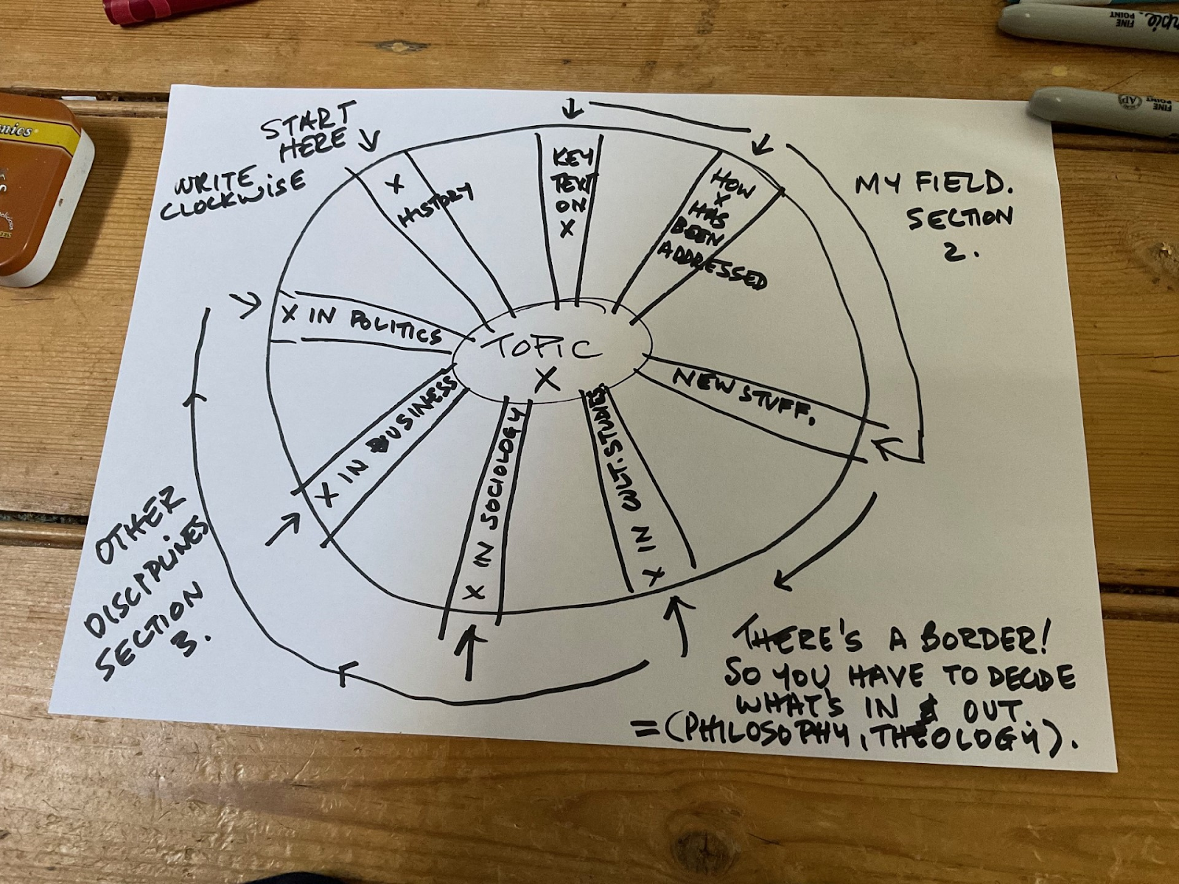

Source: https://patthomson.net/2023/07/31/the-wheel-approach-to-literatures-work/
Why it helps:
- Organizes complex arguments
- Shows relationships clearly
- Helps you visualize structure for essays or presentations
How to Use It:
- Write the central idea or thesis in a circle in the middle.
- Around it, draw spokes for each key point, argument, or theme.
- On each spoke, note supporting evidence, examples, or page references.
- Connect related spokes to highlight links between ideas.
Try It: After annotating a reading, draw a Wheel-and-Spoke map for the text.
- Hub = the text’s central claim or topic
- Spokes = each supporting argument or concept
- Add brief quotes, notes, or personal connections to each spoke

Practice Task
Pick a short article or excerpt (1–2 pages) and do the following:
- Highlight or underline the thesis and two supporting points.
- Write 2–3 margin notes: paraphrase, question, or respond.
- Circle or list repeated keywords.
Draw a Wheel-and-Spoke map of the author’s argument.
Write a 3-sentence summary using your notes.

