

Composing Professional Emails

A business email is a type of professional document that gives directions, outlines procedures, requests data, supplies a response and confirms decisions. The five main components of a business email are the subject line, the greeting, the body, the closing and the signature.

General Guidelines
- Consider who the reader is and why they should care about this subject
- Ask readers to take an action and/or be aware of something
- Be polite and respectful
- Include dates, times, and places when relevant
- Use concise language
- Avoid sarcasm to prevent misinterpretation
- Be aware of others’ privacy when forwarding messages
  - Remove that ugly string of FWD:FWD:FWD: or RE:RE:RE:
- Be considerate of time limitations when setting/requesting deadlines
- When attaching a file, always refer to the file in the body of the email
  - Announce its presence, explain its significance, and provide directions
- Do not use business email accounts for personal use

Formatting Considerations
- Limit emails to one screen in length
  - Don’t make readers scroll unless absolutely necessary
  - If the message won’t fit, email is probably not the right medium
- Leave white space between salutations, paragraphs, and signatures
- Use bullets and/or numbers for lists and ideas
- Avoid potentially unfamiliar acronyms/abbreviations and clichés
- Avoid emoticons, colors, or other confusing symbols
- Use correct spelling, grammar, and mechanics
- Avoid typing in all caps or all lowercase letters

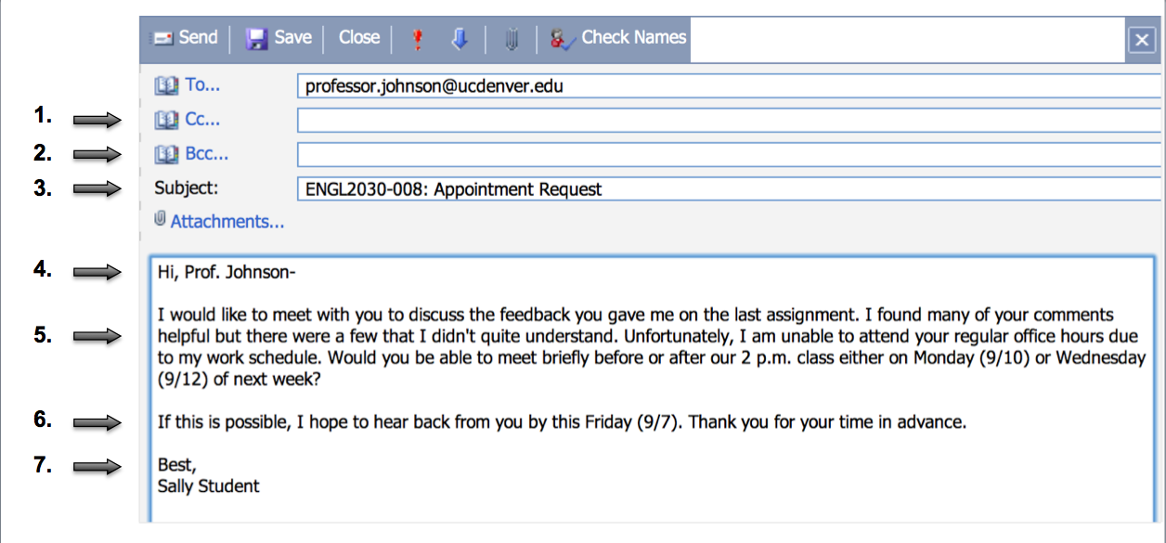
- Cc (Carbon copy):
- Ensures all interested persons are up-to-date with the conversation
- Mentions all recipients in the body of the message
- Never used to blow the whistle or “tattle,” (e.g., copying the boss to get someone in trouble)
- Bcc (Blind carbon copy):
- Useful for protecting the privacy of recipients on large mailing lists
- Considered unethical and a breach of conversation privacy for most other uses
- Subject Line:
- Provides a concise topic to helps readers determine the priority of the message
- Avoids one-word descriptions (e.g., Important, Help, or Urgent)
- Greeting:
- Uses the addressee’s name and includes their title (e.g., Ms., Dr., Professor)
- Uses formal phrasing with title (e.g., “Hello” or “Good Afternoon”)
5. Body:
- States purpose in the first sentence and explains the issue logically
- Limits the number of topics for clarity and avoids multiple requests in a single email
6. Closing:
- Defines a clear deadline for response
- Provides a call for needed action
7. Signature:
- Uses phrases or words conveying respect and formality(e.g., “Sincerely,” “Best regards,” “Best”)
- Includes full contact information, when necessary
For further information/related concepts, please see the following handouts:
- Principles of Business Writing

