

The Basics of Syntax: Dependent Clauses
As the “The Basics of Syntax: Independent Clauses” handout discusses, all clauses have a subject and a verb. But clauses come in two forms: independent and dependent. This handout will examine dependent clauses and how to identify and construct them to add subordinate (often referred to as restrictive, non-restrictive, or relative) information to sentences.

Identifying Dependent Clauses

Unlike an independent clause, a dependent clause cannot stand alone as a complete sentence. To identify the difference between these two clauses, look for two types of signal words that often start a dependent clause: subordinating conjunctions and relative pronouns.

Subordinating Conjunctions
This type of word signals the addition of supplemental information that enhances, clarifies, or further describes the independent clause. What’s unique about subordinating conjunctions is that they are simply added to the beginning of an independent clause, transforming it into a dependent clause:
- Independent clause:
  - The researchers tested for alkaline in the water
- Dependent clause:
  - Because the researchers tested for alkaline in the water
That dependent clause then must be connected to an independent clause to form a complete sentence:
  - The experiment more accurately determined the sample’s acid neutralization capabilities [independent clause], because the researchers tested for alkaline in the water [dependent clause].

Notice that in the above example, the accuracy of the results is the main idea while the testing for alkaline frames or sets up that idea. In other words, the meaning conveyed in the dependent clause is subordinate to (lesser than) the independent clause. But that subordinate relationship is of a specific kind. As seen in the graphic below, different subordinating conjunctions can indicate different relationships between dependent and independent clauses. Choose one that best fits your meaning.

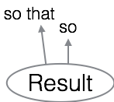
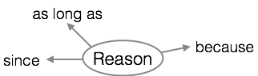
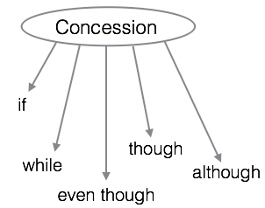
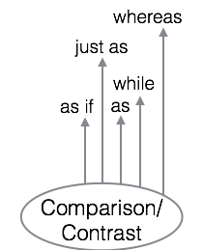
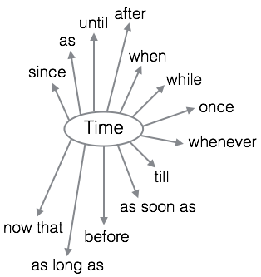
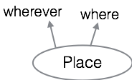
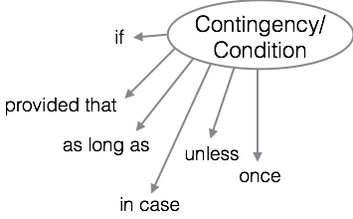

Common Subordinating Conjunctions

Relative Pronouns
- Unlike subordinating conjunctions that are added to independent clauses, relative pronouns replace an independent clause’s subject, transforming it into an independent clause:
  - Independent clause: The researchers tested for alkaline in the water.
  - Dependent clause: Who tested for alkaline in the water
- The relative pronoun, “Who,” stands in for the noun, “The researchers,” and the rest of the clause remains the same. Of course, the dependent clause then must be connected to an independent clause by placing it next to the person, thing, or idea it modifies:
  - The researchers, who tested for alkaline in the water, more accurately determined the sample’s acid neutralization capabilities.
- Below are the relative pronouns:

that | which | who | whom | whose

Composing with Dependent Clauses
Remember: a dependent clause cannot stand alone in a sentence and either must be turned into or linked to an independent clause. For the latter option, there are three choices writers must consider: placement, effect, and punctuation.

Placement
When composing with dependent clauses, a writer can position them before, within, or after the independent clause. Consider the following examples:
- Before: Because it served as an under-the-radar form of communication, call-and-response singing was an important part of African-American slave culture.
- Within: Call-and-response singing, which was an important part of African-American slave culture, served as an under-the-radar form of communication.
- After: Call-and-response singing was an important part of African-American slave culture because it served as an under-the-radar form of communication.

Notice how the rhythm of the sentences varies with each placement of the dependent clause. Understanding how to manipulate this rhythm allows writers to control the pace and flow of information.

Effect
Along with rhythm, the placement of the dependent clause and the decision to use either a relative pronoun or a subordinating conjunction creates different meanings and effects.
- Emphasize Action: Using a relative pronoun as a signal word allows a writer to use one subject and attribute more actions, or verbs, to that subject
  - The researchers, who tested for alkaline in the water, more accurately determined the sample’s acid neutralization capabilities.
    - There is one subject (“researchers”/“who”) but two verbs (“tested” and “determined”). The focus is on one subject with further emphasis on what the subject is doing or being.
- Emphasize Relationships: Using a subordinating conjunction, on the other hand, allows a writer to emphasize a particular relationship between the clauses
  - Because the researchers tested for alkaline in the water, the experiment more accurately determined the sample’s acid neutralization capabilities.
    - Here the focus is on the relationship the dependent clause has with the independent clause: Testing for alkaline is the reason (“because”) the experiment can accurately determine acid neutralization capabilities.

Punctuation
The choice to use a subordinating conjunction vs. a relative pronoun, and the placement of the dependent clause in the sentence determines punctuation. See our “Understanding Commas” handout, particularly the sections detailing subordinating conjunctions, complex sentences, and non-restrictive clauses.

Avoiding Common Errors: Fragments
A dependent clause that is not attached to an independent clause is a fragment, a partial sentence punctuated like a full sentence. The presence of a subordinating conjunction or relative pronoun is a signal that additional information (in the form of an independent clause) is needed.

Subordinating Conjunction Fragment
Example: While our society has declared racism to be a thing of the past.
Although there is a subject, “society,” and a verb, “has declared,” the subordinating conjunction “while” signals that this is a dependent clause. To revise, a writer has two options:
- Delete the subordinating conjunction:
  - While Our society has declared racism to be a thing of the past.
- Connect to an independent clause:
  - While our society has declared racism to be a thing of the past, numerous racially charged incidents continue to erupt across the country.

Relative Pronoun Fragment
Example: Which resulted in unclear lab findings and a biased experiment.
The relative pronoun, “which,” stands in for the subject and is paired with the verb “resulted.” But because “which” isn’t the full subject, this clause is dependent. To revise, writers can either:
- Substitute the relative pronoun with a subject:
  - The technician’s mistake resulted in unclear lab findings and a biased experiment.
- Connect to an independent clause:
  - The technician’s mistake, which resulted in unclear lab findings and a biased experiment, led to a second round of tests.

