
Articles

Articles are a type of determiner that precede nouns. English has two kinds of articles:
- The definite article (the), which is used in reference to specific nouns
- Indefinite articles (a or an), which are used in reference to non-distinct nouns
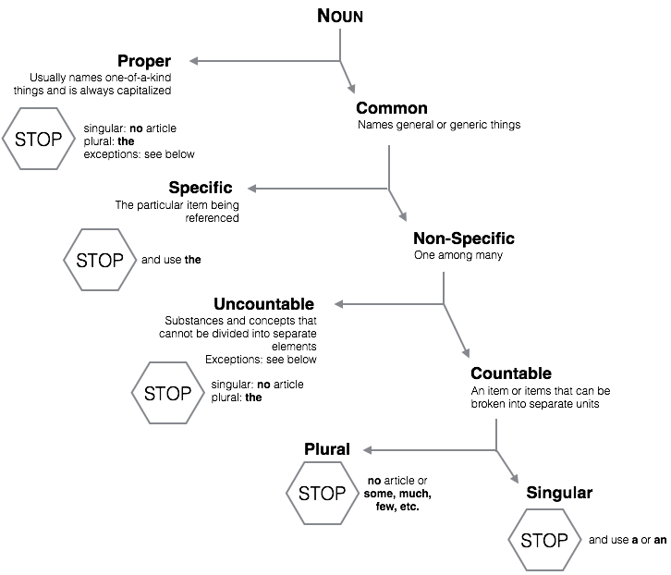
There are, however, many exceptions to this rule. In order to determine the correct article usage, take the noun in question and work your way through the following chart:

General Exceptions
Non-specific uncountable nouns receive articles when referring to the same noun in context.
She had information about the spy. When the investigator asked to see the information, she refused to give it to him.

Proper Noun Exceptions

Proper noun common noun + “of”
- the University of Colorado
- the Fourth of July
- the Statue of Liberty

Highways and bridges
- the New Jersey Turnpike
- the Santa Monica Freeway
- the Golden Gate Bridge

Buildings, hotels and museums
- the Empire State Building
- the Hilton Hotel
- the Denver Art Museum

Country names with a phrase
- the Dominican Republic
- the People’s Republic of China
- the Czech Republic

Geographical areas
Seas, oceans, gulfs, rivers, and deserts
- the North Pole
- the Midwest
- the Rio Grande
- the Pacific Ocean

Historical periods and events
- the Enlightenment
- the Renaissance
- the Civil War

Groups
- the Taliban
- the Mafia

Titles
- the President of the United States
- the Hiring Coordinator of Time-Warner
- the Emperor of Japan

Uncountable Noun Exceptions

A mass made up of parts
Clothing; equipment; furniture; garbage; homework; information; jewelry; luggage

Abstract concept
Advice; courage; education; fun; happiness; health; honesty; knowledge; success

Natural substances and diseases
Air; blood; cotton; hair; heat; ice; water; wood; wool; diabetes; influenza; measles

Games
Checkers; chess; soccer; football; basketball; tennis

Subjects of study
Biology; chemistry; economics; history; physics

