

Rhetorical Analysis

Unlike a typical academic paper where the writer analyzes and evaluates the content of an author’s argument, the writer of a rhetorical analysis is more concerned with how an author has made the argument. A rhetorical analysis identifies and evaluates the various rhetorical strategies that authors use to achieve their purpose, and also comments on the medium’s effectiveness. In this paper, it’s not important whether or not you agree with the author’s argument–what matters is whether you think their argument is effectively written for their audience.
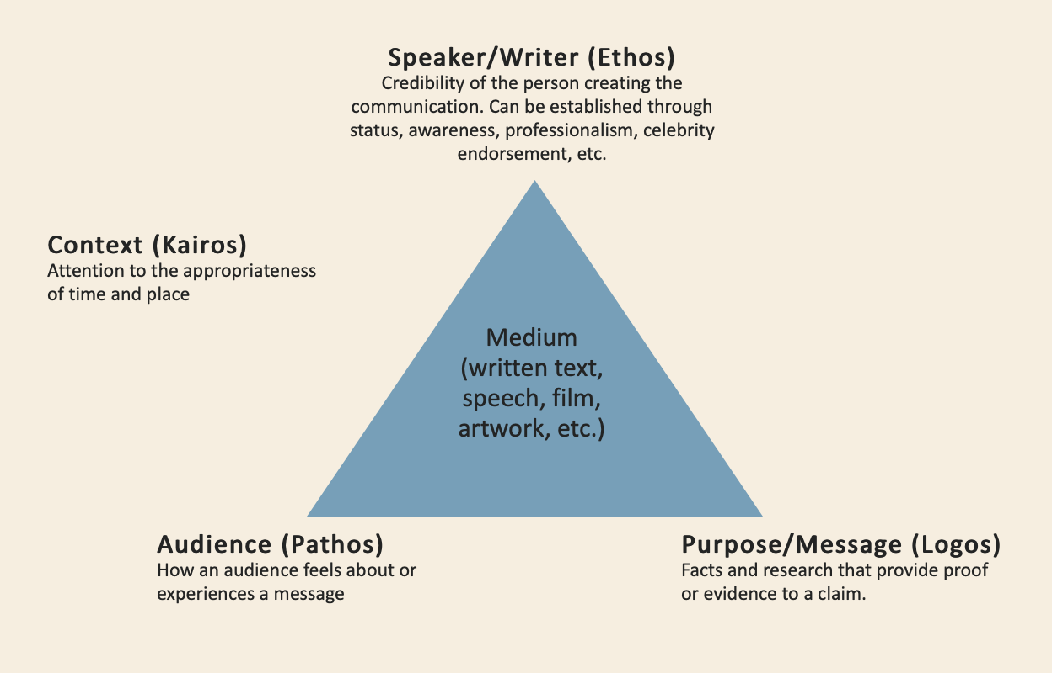

Rhetorical analysis treats all texts as situated within a context that informs the message and its reception by an audience. The piece cannot be understood in isolation from its context. A rhetorical analysis seeks to understand how the speaker, the purpose, the audience, and the medium all interact to bring meaning to the text. A rhetorical analysis often examines several dimensions of Aristotelian argument to understand the strategies of the author and their effectiveness: Ethos, Pathos, Logos, and Kairos.

Ethos
An ethical appeal. Argument relies on the character, qualifications, or authority of the speaker.
- Example: “I am a husband, a father, and a taxpayer. I've served faithfully for ten years on the school board. I deserve your vote for city council."
- Questions to assess Ethos:
  - Who are the authors/speakers? What is known about them and what makes them qualified to write on the subject?
  - Who is the publisher/journal, and what is their reputation?
  - Does the author look at both sides of the issue objectively, or does the text contain bias?

Pathos
An emotional appeal. Argument relies on stirring the audience's emotions; tries to create fear, sadness, contentment, joy, pride, etc.
- Example: “This Politician wants to hurt the elderly by cutting Medicare.”
- Example: “If you loved me, you would have called."
- Questions to assess Pathos:
  - Does the author leverage emotions or feelings toward their purpose? Is it effective in achieving their goal?
  - How do I feel about this text? How might others feel? What specific language causes these feelings?

Logos
An appeal to logic and reason. Arguments rely on evidence, data, research, statistics, etc.
- Example: “We do not have enough money to pay for improvements to our railroads, and without improvements, this transportation system will fail and hinder our economy. Therefore, we should raise taxes to pay for better railroads."
- Questions to assess Logos:
  - What premises does the author use to set the groundwork for their argument? Are they sound?
  - How does the author organize their main points? Are there clear transitions and connections between them?
  - Does the author clearly lead the reader through their reasoning?

Kairos:
An understanding of the appropriateness of the time and place for the delivery of an argument.
- Example: When a person makes a joke and another person responds, “Too soon,” this refers to the joker’s lack of attention to Kairos.
- Example: a commemorative poem on the anniversary of a public figure’s death.
- Questions to assess Kairos:
  - In what context does the argument occur (time, place, etc.)? How does the context affect the medium? How does the author acknowledge the current context of the issue?
Beyond these elements, a rhetorical analysis might also respond to any of the following questions:
- What is the primary goal of the text based on the author’s intentions? Are there also secondary or implicit goals? Who is the target audience? Do the form (organization) and function (purpose) correspond?

