Becoming an “Expert”: Building-Your-Own Wikipedia Page

Should students be citing Wikipedia in their annotated bibliographies? Absolutely not. For one, it’s a tertiary source and tertiary sources should never be included in an annotated bibliography. It’s also not peer-reviewed, which makes it a weak source. Notice, I did not say an unreliable source—it is overall, reliable—however, we want to stick with strong, legitimate sources in our bibliographies.

Nonetheless, students should ABSOLUTELY use Wikipedia as a tool for learning about their topic, especially as it related to context. It’s also a great place to start for sources in regard to those cited in each Wikipedia article.

To grasp and organize content, we will build our own Wikipedia page.

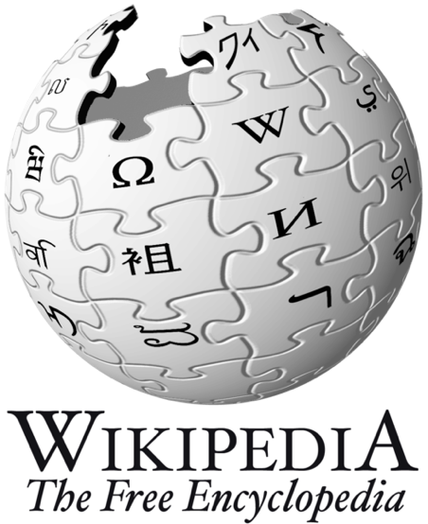

Topic: ______________________________________
___________________________________________
___________________________________________

Summary (5 Ws): _______________________________
____________________________________________
___________________________________________
___________________________________________
____________________________________________
___________________________________________________________________
___________________________________________________________________
___________________________________________________________________
___________________________________________________________________
___________________________________________________________________

Contents
1. Background: ______________________________________________________
1.1. __________________________________________________________
1.2. __________________________________________________________
1.3 _________________________________________________________

2. Lead-Up Events: ___________________________________________________
2.1. __________________________________________________________
2.2 __________________________________________________________
2.3 __________________________________________________________
3. Concurrent Events:_________________________________________________
3.3 __________________________________________________________
3.4 __________________________________________________________
3.5 __________________________________________________________
4. Aftermath:_______________________________________________________
4.1 __________________________________________________________
4.2 __________________________________________________________
4.3 __________________________________________________________

1. Background: ______________________________________________________
__________________________________________________________________________________________________________________________________________________________________________________________________________________________________________________________________________________________________________________________________________________________________________________________________________________________________________________________________________________________________________________________________________________________________________________________________________________________________________________________________________________________________________________________________________________________________________________________________________________________________________________________________________________________________________________________________________________________________________________________________________________________________________________________________________________________________________________________________________________________________________________________________________________________________________________________________________________________________________________________________________________________________________________________________________________________________________________________________________________________________________________________________
2. Lead-Up Events: ___________________________________________________
__________________________________________________________________________________________________________________________________________________________________________________________________________________________________________________________________________________________________________________________________________________________________________________________________________________________________________________________________________________________________________________________________________________________________________________________________________________________________________________________________________________________________________________________________________________________________________________________________________________________________________________________________________________________________________________________________________________________________________________________________________________________________________________________________________________________________________________________________________________________________________________________________________________________________________________________________________________________________________________________________________________________________________________________________________________________________________________________________________________________________________________________________

3. Concurrent Events: _________________________________________________
__________________________________________________________________________________________________________________________________________________________________________________________________________________________________________________________________________________________________________________________________________________________________________________________________________________________________________________________________________________________________________________________________________________________________________________________________________________________________________________________________________________________________________________________________________________________________________________________________________________________________________________________________________________________________________________________________________________________________________________________________________________________________________________________________________________________________________________________________________________________________________________________________________________________________________________________________________________________________________________________________________________________________________________________________________________________________________________________________________________________________________________________________

4. Aftermath: _______________________________________________________
__________________________________________________________________________________________________________________________________________________________________________________________________________________________________________________________________________________________________________________________________________________________________________________________________________________________________________________________________________________________________________________________________________________________________________________________________________________________________________________________________________________________________________________________________________________________________________________________________________________________________________________________________________________________________________________________________________________________________________________________________________________________________________________________________________________________________________________________________________________________________________________________________________________________________________________________________________________________________________________________________________________________________________________________________________________________________________________________________________________________________________________________________

