Who is telling the story?

Oral History Analysis Sheet

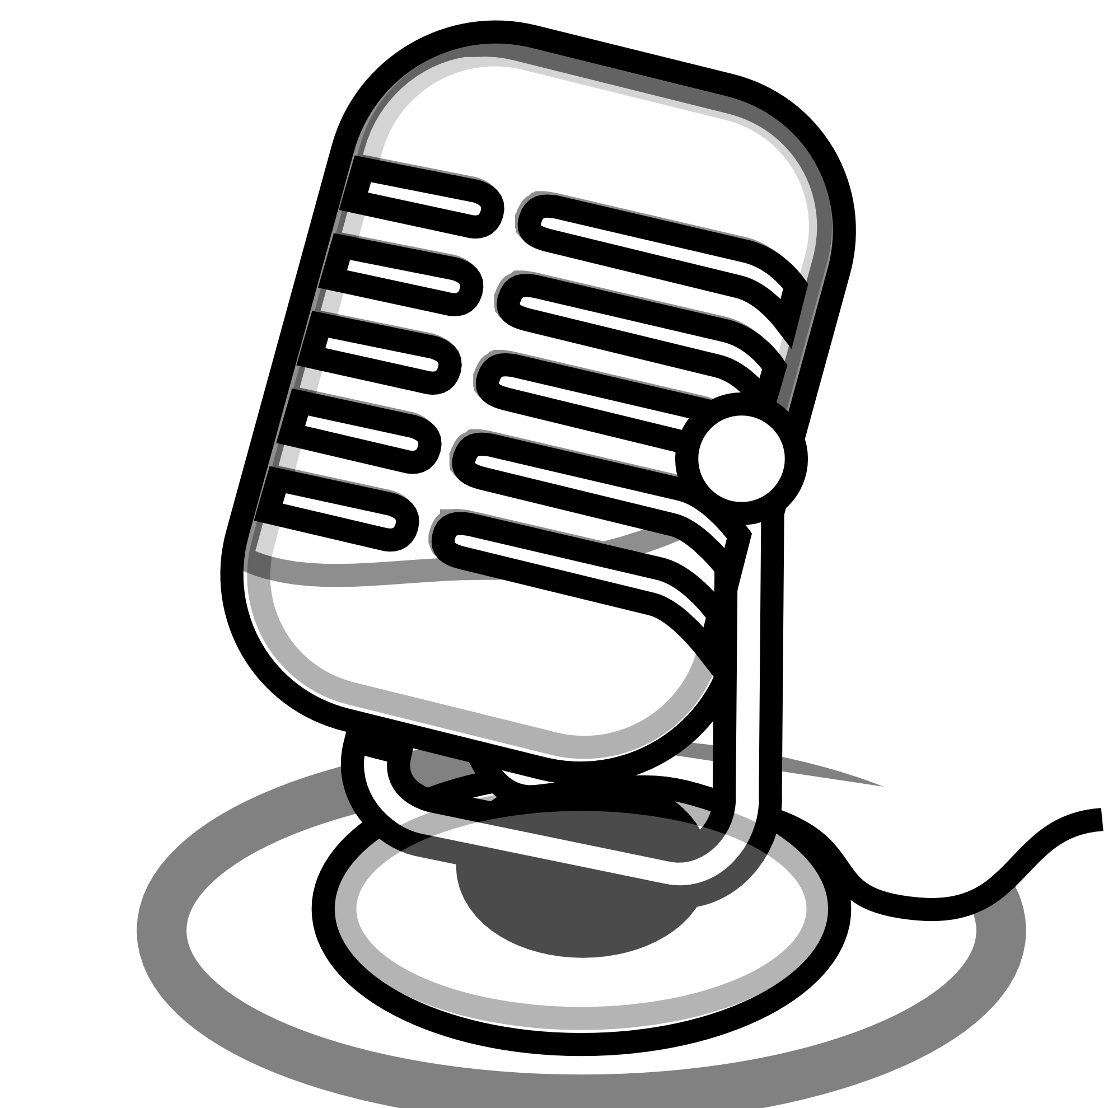

Name: _______________________________

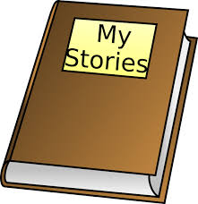

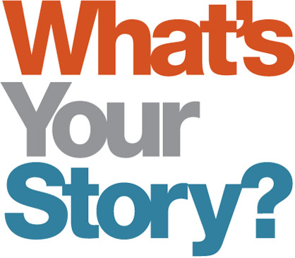

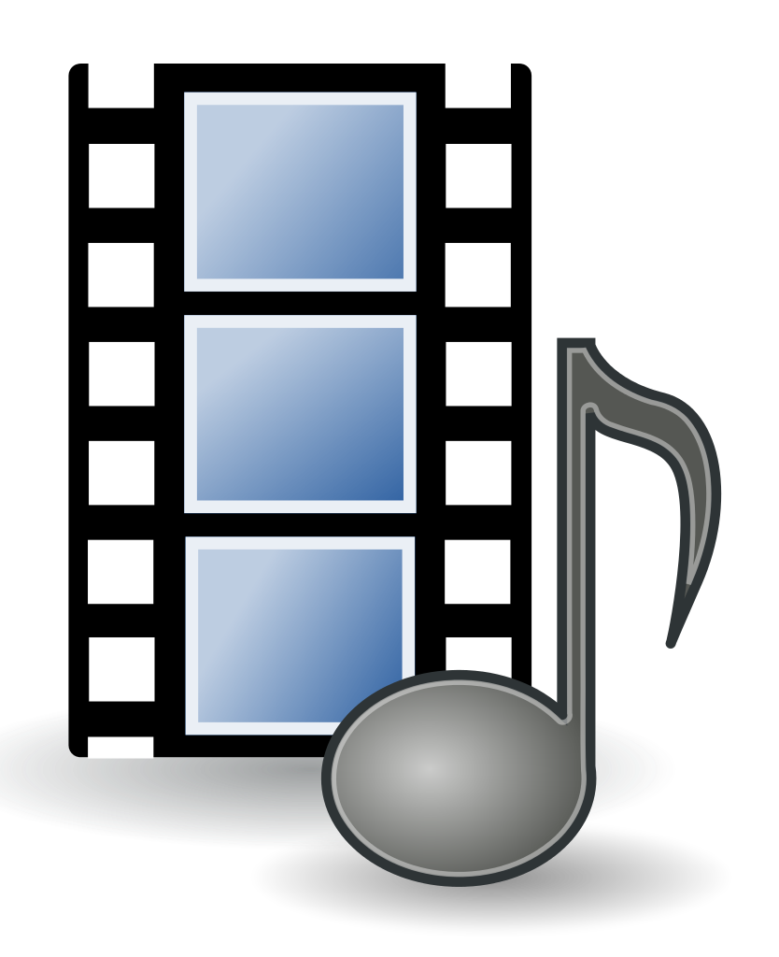

If you could ask this person a question what would it be?

Why are they telling the story? What’s the purpose?

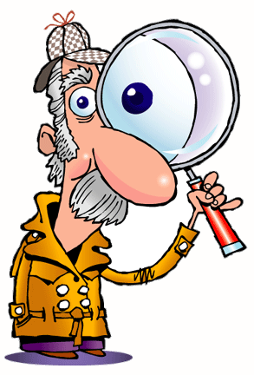

Where was this recording made?

What time period did this story takes place?

How do you know?

____ Audio  
____ Film or video  
____ Written document  
____ Other

What type of recording is it?

**Home**

**Studio**

Other: _________________

What do you notice about the person telling the story?

____ They have an accent  
____ They are old  
____ They are young  
____ They use words I don’t know

What did you learn from listening to this person’s story?

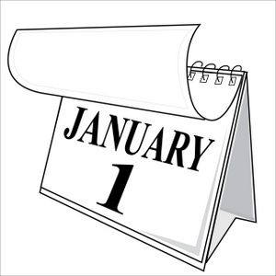

What is their point of view?

