National History day in Colorado
Digital Contest Submission Guidance
2021 Contest Cycle

While we optimistically anticipate to hold the majority of our contest in-person, due to facility limitations and personal preferences, some Regions are holding their contest online. Additionally, it is a possibility that contests may be shifted to an online format on short notice, as the COVID-19 situation is fluid and ever-changing.

Thus, students must be prepared to submit their projects digitally, regardless of the current anticipated format of the Regional Contest.
Students must submit their projects according to the below guidelines to nhdc@ucdenver.edu with their Regional Coordinator cc’ed. The submission must be sent on the digital submission date and time outlined for each region.
If a contest must be held digitally, there will be no delays in project submission.
If a contest proceeds in-person, students will have already submitted papers and websites, and can proceed per normal rules and guidelines for exhibits, documentaries, and performances.

Digital Submission Guidelines
All contest dates, digital submission deadlines, and other contest deadlines are included in this guidance.

Guidelines for All Project Categories
- Submit your project on or before the digital submission deadline to nhdc@ucdenver.edu with your Regional Coordinator cc’ed. Regional Coordinator emails are included in this guidance.
- Format your subject line as follows: Region, Last Name, First Initial., Project Division and Category, for example, Central Plains, Gabehart, K., Senior Paper. If you are a member of a group, list all partner last names, for example: Central Plains, Gabehart/Archer, Senior Group Exhibit
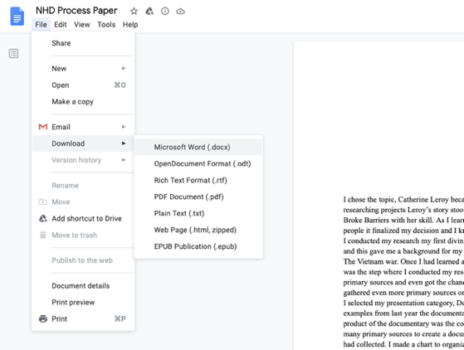
- DO NOT send GoogleDrive links. If you created your project on GoogleDrive, go to your document, select “File,” and then “Download,” and download the file as either “Microsoft Word (.docx)” for documents or “Microsoft Powerpoint (.pptx) for slides. Any project other than large slide files submitted via GoogleDrive will not be judged.

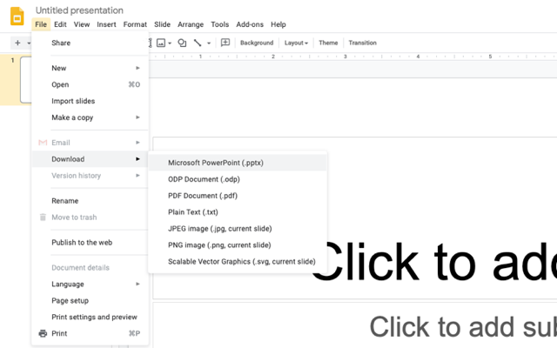

- IF you slides are too large to email, you may share them, but please ensure you provide adequate access permissions. In your file, click “Share” in the top right hand corner, under the “Get Link” portion of the sharing panel, click “Change to anyone with the link.” Be sure that the permissions say “Anyone with the link,” click “Copy link,” and send this link via email. If this is not done, the project will not be judged.
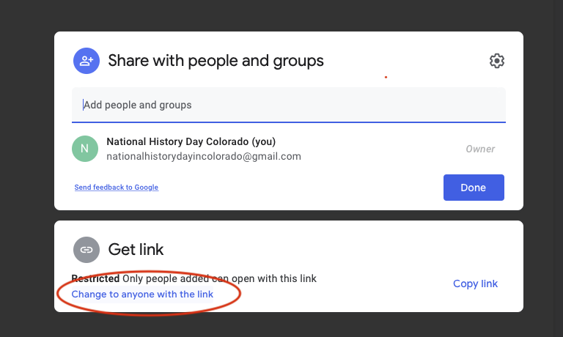

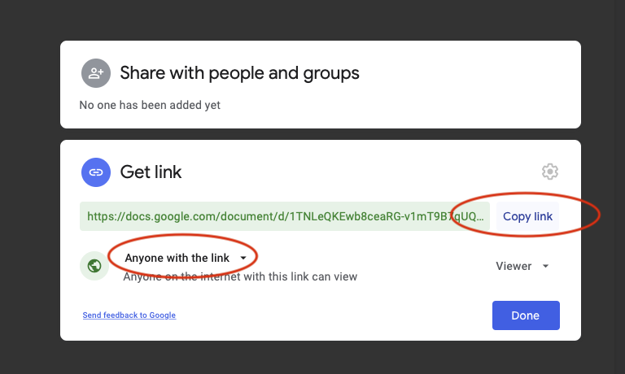

Guidelines for Papers
- Items to submit: title page, completed paper, annotated bibliography, process paper.
- Following the above criteria for formatting your email, attach your title page, paper, bibliography, and process paper in a single file to the email as a word (.doc or .docx) or pdf file. Please note, beginning this year, all paper competitors are required to also complete and submit a process paper.
- Please save your file according the following format: Last Name, First Initial., Division and Category, for example, Gabehart, K. Senior Paper.
- If the paper deadline for your region is BEFORE the digital submission deadline, then it must still be submitted by that earlier deadline. Please still send to nhdc@ucdenver.edu and cc your Regional Coordinator.
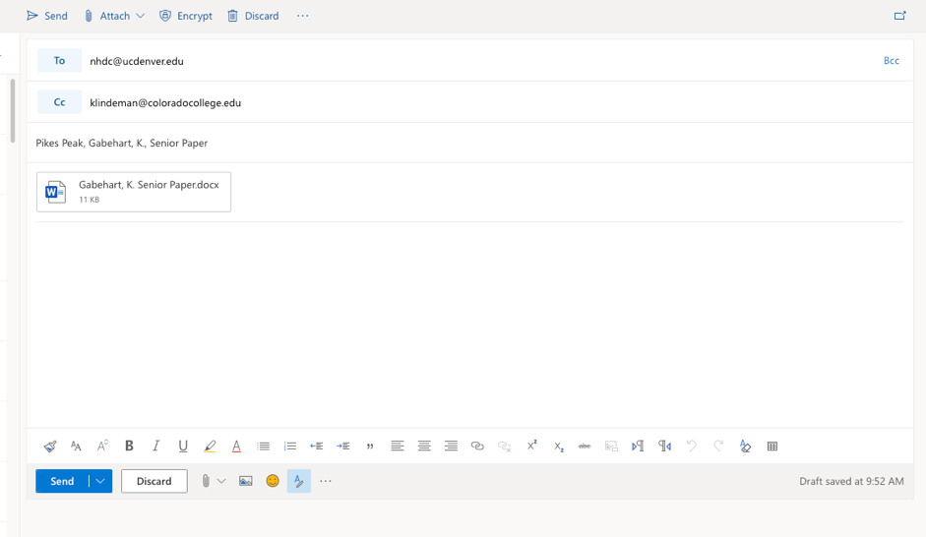
- Email example:

Guidelines for Websites
- Items to submit: website link with bibliography and process paper in the site.
- Following the above criteria for formatting your email, copy and paste your complete website link, being sure to include your unique 8-digit id. For example: site.nhd.org/63935081
- DO NOT send your bibliography and process paper separately. They must be included in your site.
- If the website deadline for your region is BEFORE the digital submission deadline, then it must still be submitted by that earlier deadline. Please still send to nhdc@ucdenver.edu and cc your Regional Coordinator.
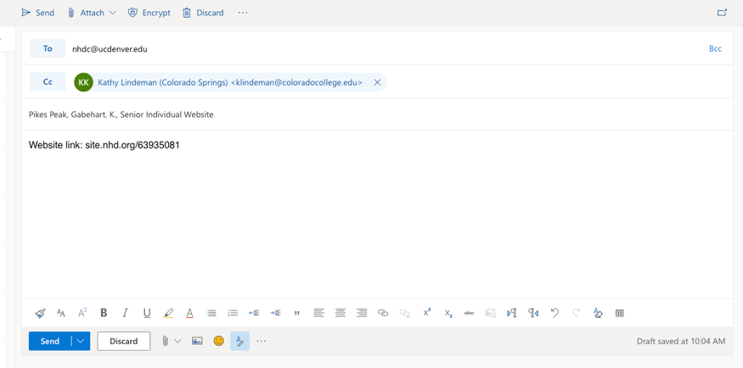
- Email example:

Guidelines for Documentaries
- Items to submit: documentary link, title page, annotated bibliography, process paper.
- Following the above criteria for formatting your email, attach your title page, bibliography and process paper in a single file to the email as a word (.doc or .docx) or pdf file.
- Please save your bibliography and process paper file according to the following format: Last Name, First Initial., Division and Category, for example, Gabehart/Archer, Senior Group Documentary
- Copy and paste your documentary link into the body of the email. Your documentary must be uploaded to Youtube or a similar video streaming site.
- Email example:

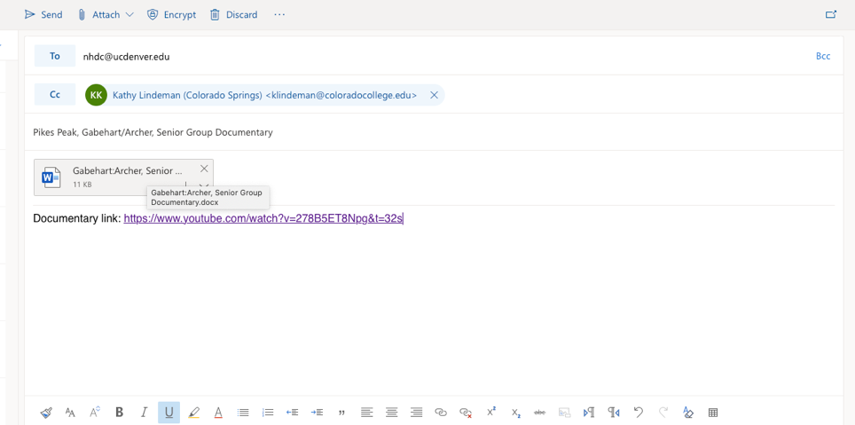

Guidelines for Performances
- Items to submit: performance link, title page, Performance Companion Worksheet, annotated bibliography, process paper.
- Performance Video Submission Guidelines
- Blank Companion Worksheet for Word
- Blank Companion Worksheet for GoogleDocs
- Sample Completed Companion Worksheet
- Following the above criteria for formatting your email, attach your title page, Performance Companion Worksheet, bibliography and process paper in a single file to the email as a word (.doc or .docx) or pdf file. Please note, the Performance Companion Worksheet is for online contests only.
- Please save your file according to the following format: Last Name, First Initial., Division and Category, for example, Gabehart/Archer, Junior Group Performance
- Include a link to a video recording of your performance in the body of the email. Performances must be uploaded to YouTube or a similar video streaming platform. Students may submit audio only if COVID-19 prevents group meetings; Zoom is a great platform to do this if students must do only audio.
- Email example:

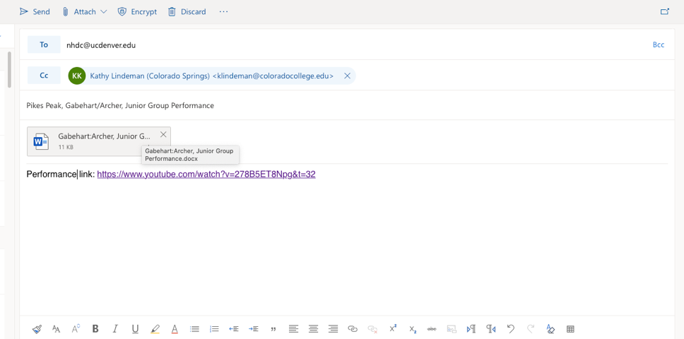

Exhibit Guidelines
- Items to submit: Exhibit slides, title page, annotated bibliography, process paper. You must use the below template for formatting your exhibit slides.
- Exhibit Submission Guidelines
- Blank Exhibit Submission Template for PowerPoint
- Blank Exhibit Submission Template for GoogleSlides
- Sample Completed Exhibit Submission Template
- Following the above criteria for formatting your email, attach your slides as a PowerPoint file (.ppt or .pptx), and your title page, bibliography, and process paper as a word (.doc or .docx) or pdf document in a second file.
- Please save your slides according to the following format: Last Name, First Initial., Division and Category, Slides, for example: Gabehart, K. Senior Individual Exhibit, Slides. Save your bibliography and process paper according to the following format: Last Name, First Initial., Division and Category, Paperwork, for example: Gabehart, K., Senior Individual Exhibit, Paperwork.
- Email example:
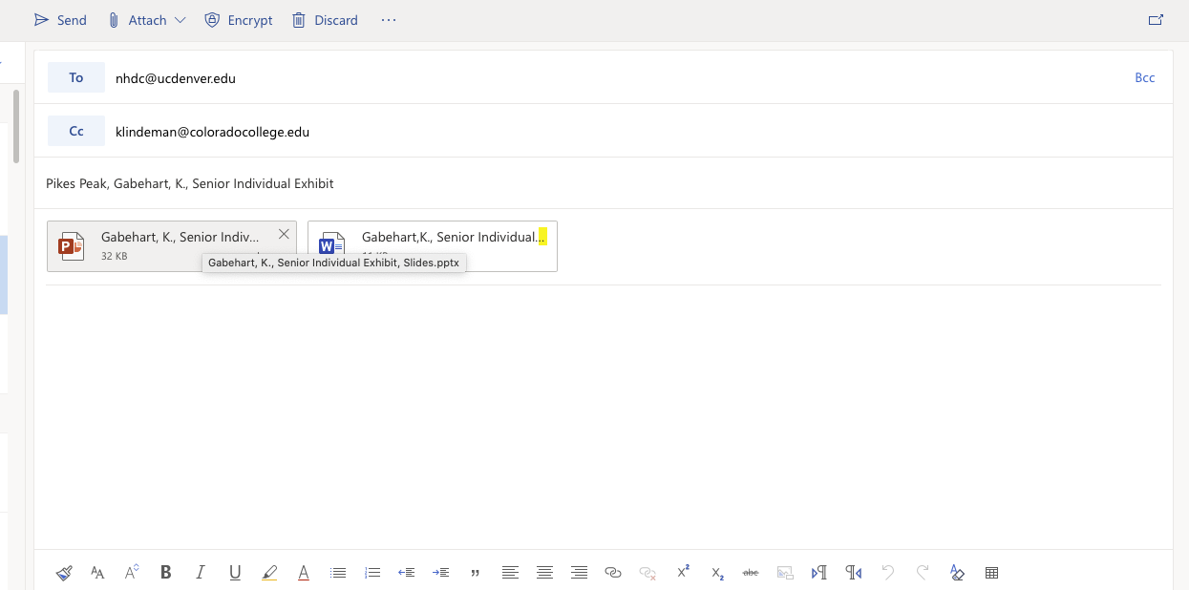

New Rule Book and Evaluation Forms
This year, NHD has released a new Rule Book and new Evaluation Forms. Please review these materials to familiarize yourself with the new rules and judging criteria.
- New Rule Book
- Significant Rules Changes Quick Sheet
- Student Checklists:
  - Website
  - Exhibit
  - Documentary
  - Performance
  - Paper
- Official Evaluation Forms:
  - Website Prelims
  - Website Finals
  - Exhibit Prelims
  - Exhibit Finals
  - Documentary Prelims
  - Documentary Finals
  - Performance Prelims
  - Performance Finals
  - Paper Prelims
  - Paper Finals

Regional Coordinator Information & Contest Dates and Deadlines
San Luis Valley
Coordinator: Ed Crowther (ercrowth@adams.edu)
Location: Adams State University
Contest Date: January 30
Digital Submission Date: January 25 @ 5 pm
Registration Deadline: January 22 @ 5 pm
Paper Deadline: January 22 @ 5 pm
Website Deadline: January 22 @ midnight

Charter School
Coordinator: Paula Worley (paula.worley@crownpointeacademy.org)
Location: Crown Pointe Academy
Contest Date: February 27
Digital Submission Date: February 22 @ 5 pm
Registration Deadline: February 12 @ midnight
Paper Deadline: February 19 @ midnight
Website Deadline: February 19 @ midnight
Fee Deadline: February 25 @ noon ($10)

Pikes Peak
Coordinator: Kathy Lindeman (klindeman@coloradocollgege.edu)
Location: ONLINE
Contest Date: February 27
Digital Submission Date: February 22 @ 5 pm
Registration Deadline: January 31
Paper Deadline: February 15 @ midnight
Website Deadline: February 15 @ midnight

Denver City
Coordinator: Ed Glassman (eglassman6@gmail.com)
Location: History Colorado Center
Contest Date: March 6
Digital Submission Date: March 1 @ 5 pm
Registration Deadline: February 24 @ 5 pm
Paper Deadline: February 24 @ midnight
Website Deadline: February 24 @ midnight
Fee Deadline: February 24 @ midnight ($10)

Southwest/4 Corners
Coordinator: John Hise (jhise2@durangoschools.org)
Location: Fort Lewis College
Contest Date: March 12
Digital Submission Date: March 5 @ 5 pm
Registration Deadline: March 3 @ midnight
Paper Deadline: March 5 @ midnight
Website Deadline: March 5 @ midnight
Fee Deadline: March 3 @ midnight ($3)
Western Slope
Coordinator: Vince Patarino (vpatarin@coloradomesa.edu)
Location: Colorado Mesa University
Contest Date: March 13
Digital Submission Date: March 8 @ 5 pm
Registration Deadline: March 1 @ midnight
Paper Deadline: March 4 @ midnight
Website Deadline: March 4 @ midnight

Boulder
Coordinator: Gina Scioscia
(SciosciaG@boulderlibrary.org)
Location: ONLINE
Contest Date: March 13
Digital Submission Date: March 8 @ 5 pm
Registration Deadline: March 2 @ 5 pm
Paper Deadline: March 2 @ midnight
Website Deadline: March 2 @ midnight
Fee Deadline: March 2 @ 5 pm ($10)

Greater Denver Metro
Coordinator: Kelly Cvanciger (nhdcgreaterdenvermetro@gmail.com)
Location: Bear Creek High School
Contest Date: March 20
Digital Submission Date: March 15 @ 5 pm
Registration Deadline: February 19 @ 5 Pm
Paper Deadline: March 3 @ midnight
Website Deadline: March 3 @ midnight
Fee Deadline: March 5 @ 2:30 pm ($10)

Aurora
Coordinator: Jessica Lira (jlira@auroragov.org)
Location: ONLINE
Contest Date: March 27
Digital Submission Date: March 22 @ 5 pm
Registration Deadline: March 8 @ 5 pm
Paper Deadline: March 8 @ midnight
Website Deadline: March 8 @ midnight

Mountain
Coordinator: John Spierling (jspierling@summitk12.org)
Location: Summit Middle School
Contest Date: March 27
Digital Submission Date: March 22 @ 5 pm
Registration Deadline: March 22 @ 5 pm
Paper Deadline: March 22 @ 5 pm
Website Deadline: March 22 @ 5 pm

Central Plains
Coordinator: Manser Kierstead (mkierstead@esdk12.org)
Location: TBD
Contest Date: April 2
Digital Submission Date: March 26 @ 5 pm
Registration Deadline: March 22 @ 5 pm
Paper Deadline: March 22 @ midnight
Website Deadline: March 22 @ midnight

Greeley/Northeast
Coordinator: Jamie Fogg (Jamie.fogg@unco.edu)
Location: University of Northern Colorado
Contest Date: April 3
Digital Submission Date: March 29 @ 5 pm
Registration Deadline:
Paper Deadline:
Website Deadline
Fee Deadline:

Pueblo/Southeast
Coordinator: Dawn Carver (dawncarver4@gmail.com)
Sandy Hudock (sandyhudock@gmail.com)
Location: CSU Pueblo
Contest Date: April 3
Digital Submission Date: March 29 @ 5 pm
Registration Deadline: March 13 @ midnight
Paper Deadline: March 20 @ midnight
Website Deadline: March 20 @ midnight
Fee Deadline: March 20 @ midnight ($15)

State Contest
Coordinator: Kayla Gabehart (kayla.gabehart@ucdenver.edu)
Location: CU Denver
Contest Date: May 1
Digital Submission Date: April 23 @ 5 pm
Registration Deadline: April 14 @ 5 pm
Paper Deadline: April 14 @ 5 pm
Website Deadline: April 14 @ midnight
Fee Deadline: April 14 @ midnight ($25)

