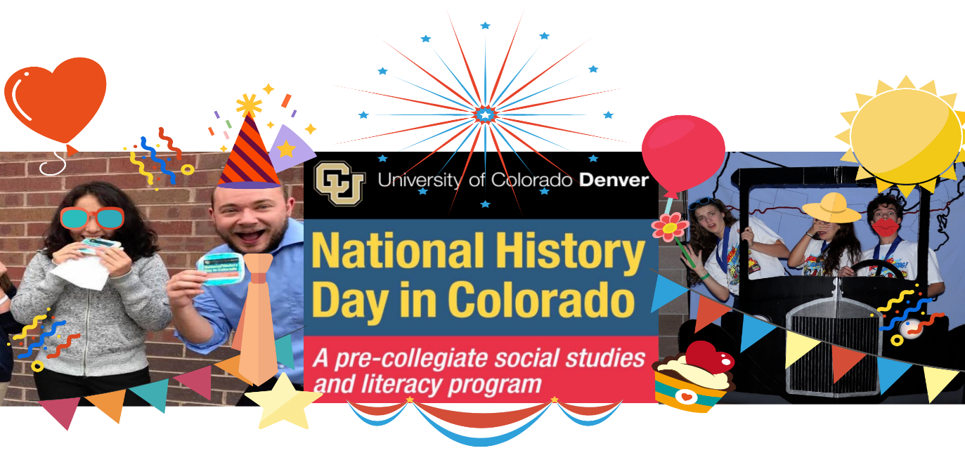

**READY TO PARTY???**

**IT’S A BIRTHDAY AND A CELEBRATION OF THE COOLEST KIDS!**

**First, thank you to our Sponsors!**

**University of Colorado Denver**

**CU Denver College of Liberal Arts & Sciences**

**Daniels Fund**

**Colorado Student Leaders Institute**

**Walter S. Rosenberry, III Charitable Trust**

**TBK Bank**

**Dr. Myra & Mr. Robert Rich**

**Drs. Pam & Frank Laird**

**Jody Georgeson**

**History Colorado Center**

**Teaching with Primary Sources at Metropolitan State**

**Colorado Experience, RMPBS**

**Join the Telethon at any time during the day:** [**https://ucdenver.zoom.us/j/95562514316**](https://ucdenver.zoom.us/j/95562514316)

**Breakfast Schedule (join us with your eggs, your corn flakes or your fruit and yogurt – and you can wear your pjs! We’ll never know!)**

8:00-9:00—Breakfast Program

* 8:00-8:05: Welcome from Celeste (birthday girl)!
* 8:05-8:15: Master of Ceremonies Dr. Patty Limerick (she’s in your AP History book) will say a few words.
* 8:15-8:27: National Qualifying Senior Individual Documentary—Gage Willson, Bear Creek High School, “Star Trek: Breaking Multicultural Barriers Lightyears from Home.”
* 8:27-8:32: Michaela, Alec and Marissa Sirois will tell us about their performance.
* 8:32-8:45: National Champion Senior Group Performance by the Sirois Triplets, Heritage High School, “Driving Towards the Future: How the Lincoln Highway Broke Barriers in Automobile Travel.”
* 8:45-8:50: Jason Hanson, 2018 Founders Award Winner History Colorado Presents 2020 Founders Award…
* 8:50-8:55: ….. to Teaching with Primary Sources at Metro State University! Keith Patterson and Kile Clabaugh accept!
* 8:55-9:00: Message from the NHDC Chair of the Board, Stuart Pattison, TBK Bank. We’ll also be introducing the 2020 TBK National Historians.
* 9:00-9:10: Dr. Patty Limerick will close out this live time – it’s a tradition!

**9:10-9:15: Kayla Introduces the Day and Unveils the 2020 *Paper Journal* –**

**Introduction by Dr. William Wei, Colorado History Council**

**Student Authors:**

**Rebecca Busche, Greater Denver Metro**

**Lauren Deacon, San Luis Valley**

**Kylee Wilson, San Luis Valley**

**Alia Sponheimer, Boulder**

**Ella Frihauf, 4 Corners/Durango**

**Andrew Landau, Boulder**

**Skye McCrimmon, Denver City**

**Mohamed Ibrahim, Greeley**

**9:00 Block**

**Begins: 9:15**

**Block Runtime: 1:15:00**

* Mr. Mitch Whitus, NHDC Paper Judge & Award-Winning Toastmaster, interviews the 2020 *NHDC Journal Authors.*

*Ends: 10:30*

*Transition 10:30-10:35*

* Discuss 2021 Annual Theme: *Communication in History: The Key to Understanding*

**10:30 Block**

**Begins: 10:35**

**Block Runtime: 00:50:00**

* Telecommunications History Group Archives tour with Jody Georgeson, NHDC Board member and THG archivist and board member.
* 2020 Best Project on a Telecommunication Topic: Senior Group Website—April Tong & Sadie Korngold Finkelstein, Fairview High School, “The Digital Camera: Revolutionizing Communication Picture by Picture.”

*Ends: 11:25*

*Transition: 11:25-11:30*

* Discuss our great partners, going right to the source for information, and Special Awards as good places to begin for topic ideas.

**11:30 Block**

**Begins: 11:30**

**Block Runtime: 1:12:33**

* Teaching with Primary Sources at Metro State University Denver is going to teach us all how to use the Library of Congress website – it’s not as overwhelming as you think!
* Senior Individual Performance, Brooke Gaughan, Liberty High School, “Barriers Broken Through an Engineering Marvel: Panama Canal.”

*Ends: 12:44*

*Transition: 12:44-1:00*

* Sneak peek preview of the new exhibit at History Colorado Center – American Democracy: A Great Leap of Faith.

**1:00 Block**

**Begins: 1:00**

**Block Runtime: 1:20:46**

* *Hecho en Colorado* exhibit guided tour at History Colorado Center with Adrianna Abarca, curator and sponsor of this amazing exhibit.
* Special Presentation by Jason Hanson, Chief Creative Officer at History Colorado. “Always Begin Where You Are.” He’ll be talking about oysters!
* 2020 Honor Bell Foundation Best Project on Veterans’ History: Senior Group Documentary, Bryson Shumate & Luke Harwood, Bear Creek High School, “The Secret Code: How the Navajo Language Broke the Barrier to Win the War.”

*Ends: 2:21*

*Transition: 2:21-2:30*

* Discuss NHDC Online Teacher Camp, including dates, perks, how to sign up, etc.

**2:30 Block**

**Begins: 2:30**

**Block Runtime: 1:12:06**

* Conversation with Rocky Mountain PBS about Colorado Experience and the resource it is for teachers, parents, families and students.
* Colorado Experience: “Press of the West” – introduced by Carol Fleischer, Senior Producer.
* 2020 RMPBS/COEX Best in Show Documentary: Senior Individual Documentary, Austin Kurtz, La Junta High School, “Barriers We Must Break—Japanese Discrimination During WWII.”

*Ends: 3:13*

*Transition: 3:13-3:30*

* Discuss the new rules and evaluation forms, notable changes, where to find them etc.

**3:30 Block**

**Begins: 3:30**

**Block Runtime: approx. 1:20:00**

* Black American West Museum guided tour by Board Member Terri Gentry and Board Chair Daphne Rice-Allen (whose father was a Tuskegee Airman!).
* 2020 League of Women Voters Best Documentary for Women Breaking Barriers for Justice: Senior Individual Documentary, Jackson Moody, Fairview High School, “Lady Doctor: Justina Ford’s Defiance of the Supremacist Mindset.”

*Ends: 4:50*

*Transition: 4:50-5:00*

* Discuss NHDC as a literacy capstone and our concurrent enrollment class.

**5:00 Block**

**Begins: 5:00**

**Block Runtime: Approx 1:30:00**

* Denver Museum of Nature & Science conversation with Drs. Tyler Larson and Ian Miller. They bridged the gap between the asteroid mass extinction and the return of life, discovering a missing link in Colorado Springs – they’ll tell us all about it!
* National History Day is in North Carolina! Take a look at the Wright Brothers National Memorial with our intern, Zach Gabehart – he’s studying to be a pilot and air traffic controller.
* Junior Group Documentary National Qualifier: Ken Herrmann and Aditya Dhar, Southern Hills Middle School, “Breaking the Barrier of Flight: Two Brothers and a Dream”

*Ends: 6:30*

*Transition: 6:30-6:35*

* Discuss Student Workbook, Updated Teacher Handbook, and how we are dedicated to helping teacher instruct History Day online, if necessary.

**6:30 Block**

Begins: 6:35

**Block Runtime: 22:14**

* Conversation with the NHDC Student Advisory Board – “why is studying History important” from these amazing students’ perspective.

**Emma Davis Aurora**

**Cate Davis Aurora**

**Brooke Gaughan Pikes Peak**

**Nour Goucem Aurora**

**Nina Hufman Four Corners/Durango**

**Izzy McCarty Central Plains**

**Hannah Mason Greater Denver Metro**

**Newal Nasir Aurora**

**Anastasia Nawrocki Greater Denver Metro**

**Michaela Sirois Greater Denver Metro**

**Alec Sirois Greater Denver Metro**

**Katherine Sewell San Luis Valley**

*Ends: 6:57*

**Close: 6:57-7:00**

**Thank you to all for your continued support – we are serving over 25,000 Colorado kids!**