Denver Mountain Parks National History Day Project Award
The Denver Mountain Parks Foundation will award a $250 REI gift card and a Denver Parks and Recreation SWAG bag to the National History Day participant who submits the best project on a subject related to the Denver Mountain Parks or one of the closely related topics described below.
Colorado is known as an “outdoorsy” state filled with wildlife, scenery, historic places, and opportunities for camping, mountaineering, hiking, mountain biking, rafting, and other nature-based recreational opportunities. But have you ever thought about what it took to protect the parks and open space that so many people visit and love? Environmentalists, politicians, and philanthropists came together in the early 1900s across the nation to protect some of our most wild and historical places. Many people are surprised to learn that Denver was a national leader in the conservation movement and was among the first government entities to formally establish a nature-based park system and to protect the nearly extinct American Bison. This system, called the Denver Mountain Parks, remains one of the most interesting and significant municipal park systems in the nation.
The Denver Mountain Park system was created in 1912, a full four years ahead of the National Park Service and 25 years before the Colorado State Parks system. Denver’s Mayor Robert W. Speer (for whom Speer Blvd is named in downtown Denver) hired famous architects Jacques Benedict and Frederick Law Olmsted, Jr., to design and build a world-class mountain park system. Today the Denver Mountain Park system is listed in the National Register of Historic Places and includes 22 accessible parks and 24 conservation areas spread across 4 counties and 14,000 acres of land stretching from the top of Mount Evans down to the plains near Castle Rock. Some of the best known Denver Mountain Parks include Red Rocks Park, Evergreen Lake, Genesee Park with its famous buffalo herd adjacent to the interstate, and Lookout Mountain Park where Buffalo Bill is buried. In the 1930s, the Civilian Conservation Corps was established by president Franklin Delano Roosevelt to combat the great depression, and the “CCC” contributed a tremendous amount to the state and the Denver Mountain Parks, including construction of the world famous Red Rocks Amphitheatre. Today the Denver Mountain Parks is home to the last remaining intact CCC camp in the nation at Red Rocks Park.
The Denver Mountain Parks system has experienced many changes over the decades and is no longer as well known as it once was, however the story of the recreational and environmental history of Colorado and the Denver Mountain Parks’ place within that context remains compelling. The Denver Mountain Parks Foundation will award a price to the participant who completes the best project on any of the following topics:
- History and development of the Denver Mountain Parks system
- Historical topics related to any of the Denver Mountain Parks
- Historically significant individuals associated with the Denver Mountain Parks, such as landscape architect Frederick Law Olmsted, Jr., famous Colorado architect Jacques Benedict, Wild West showman Buffalo Bill, Colorado Superintendent of Education Katherine Craig, Denver’s Australian-born socialite Florence Martin, architect Burnam Hoyt, and others.
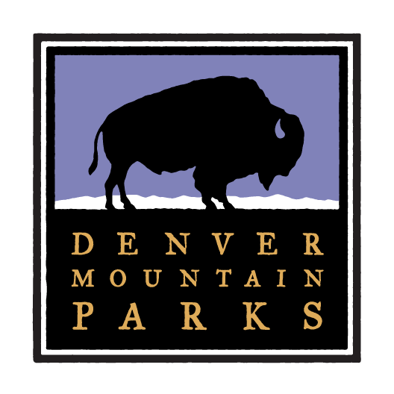
- The Civilian Conservation Corps in Colorado
- The history and legacy of Red Rocks Park and Amphitheatre
- The history and conservation of the American Bison (buffalo)

