Name: _________________________

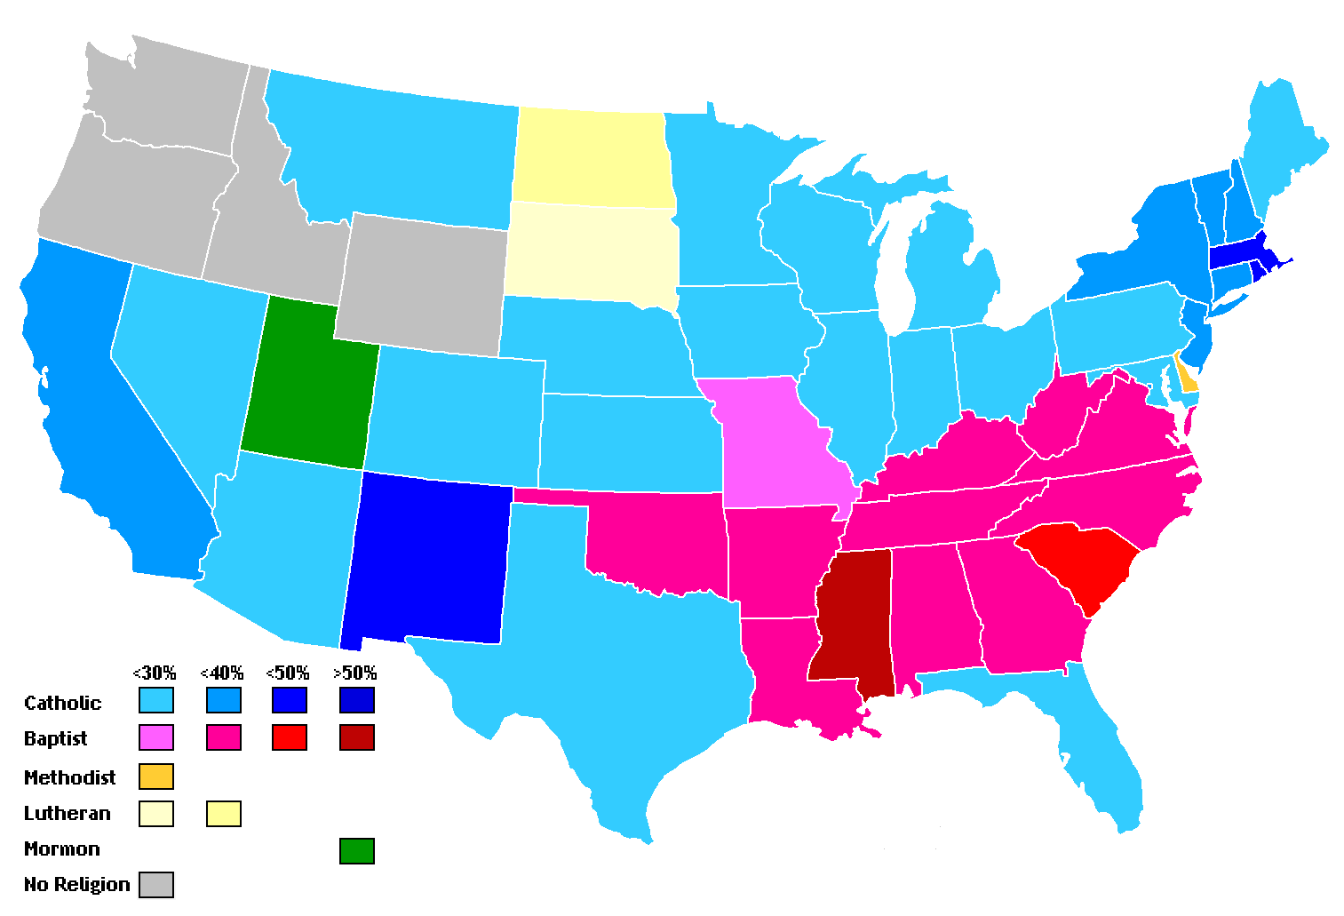

What did you learn from the map?

Is there anything strange or unfamiliar about the map?

Other: _______________________________

What geographic features does the map show? Circle all that apply.

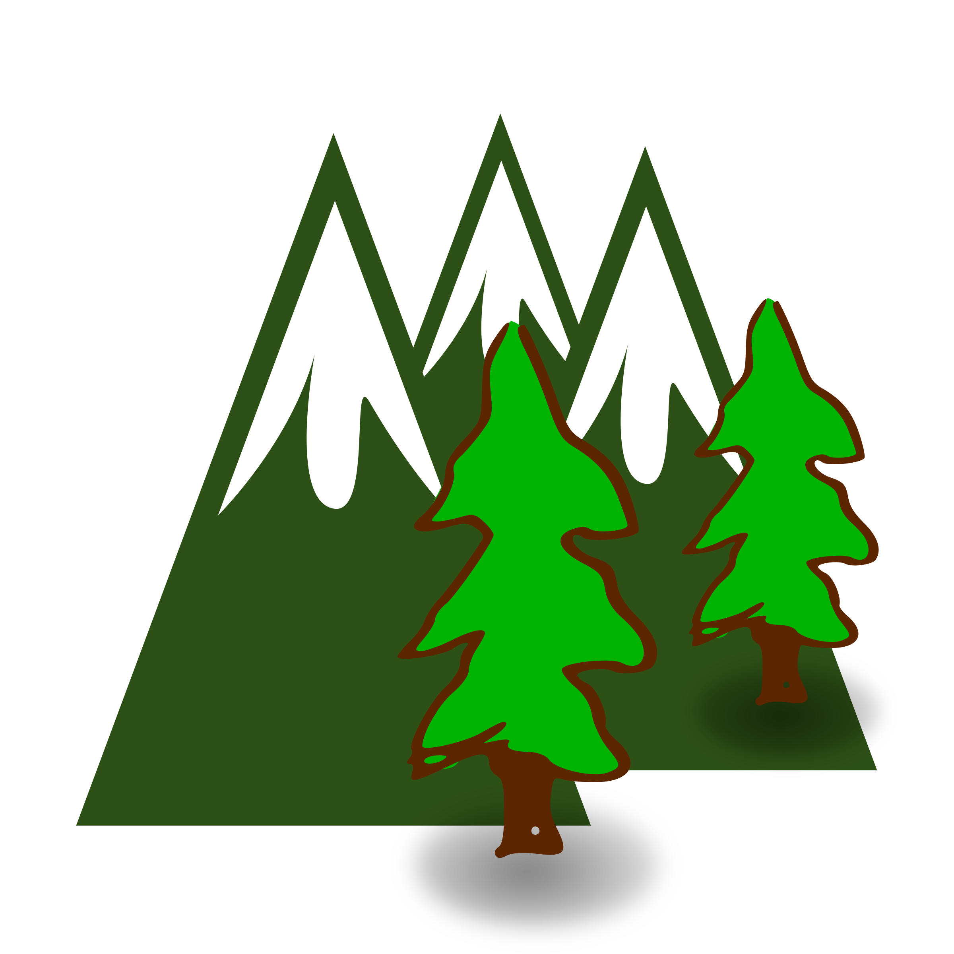

Mountains

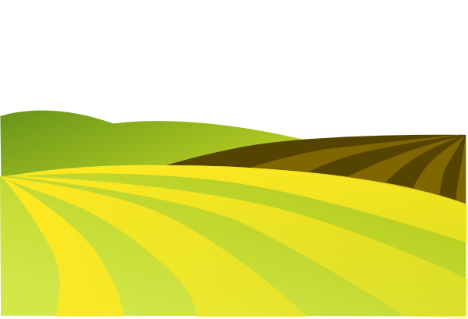

Plains

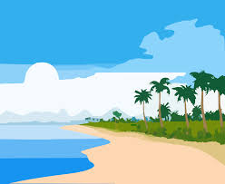

Oceans



Cities/Towns

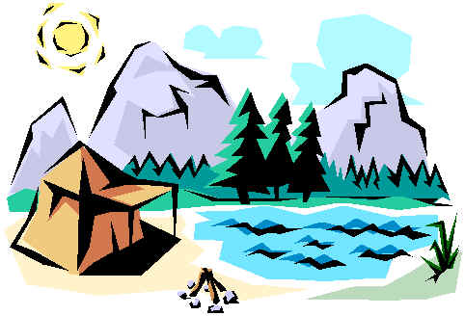

Lakes

Rivers

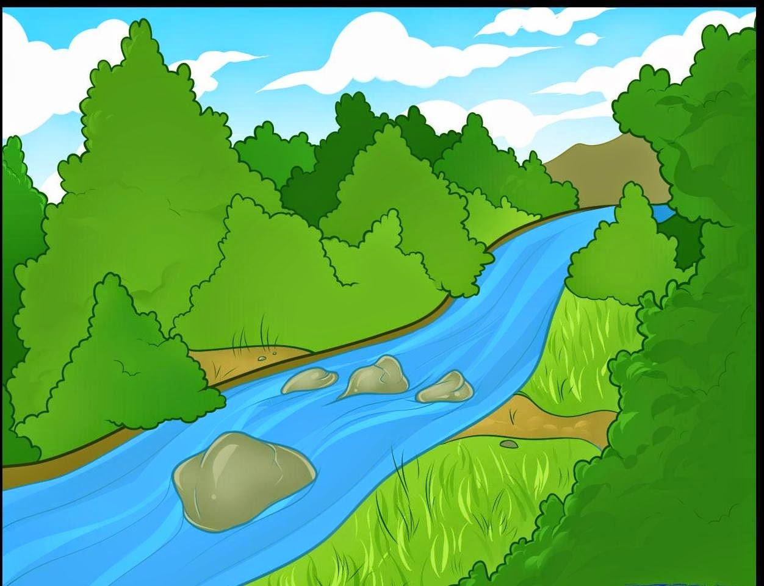

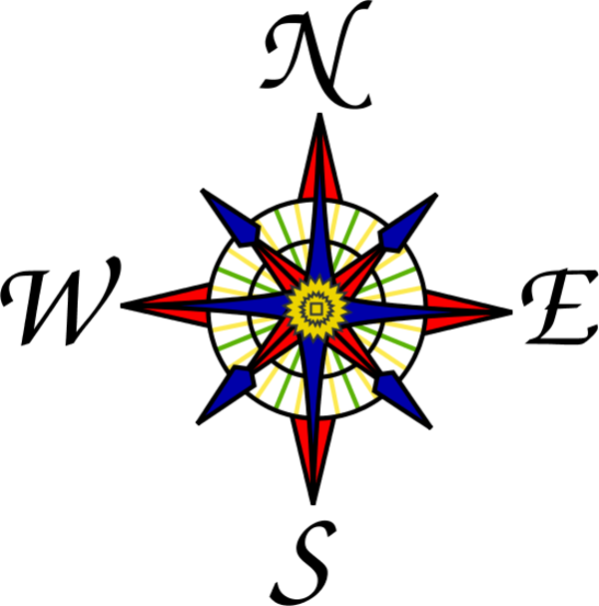

Map Scale

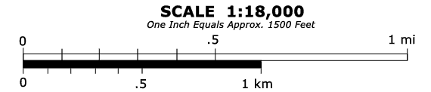

Map Key

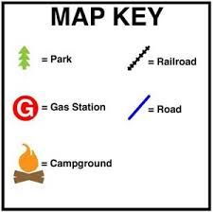

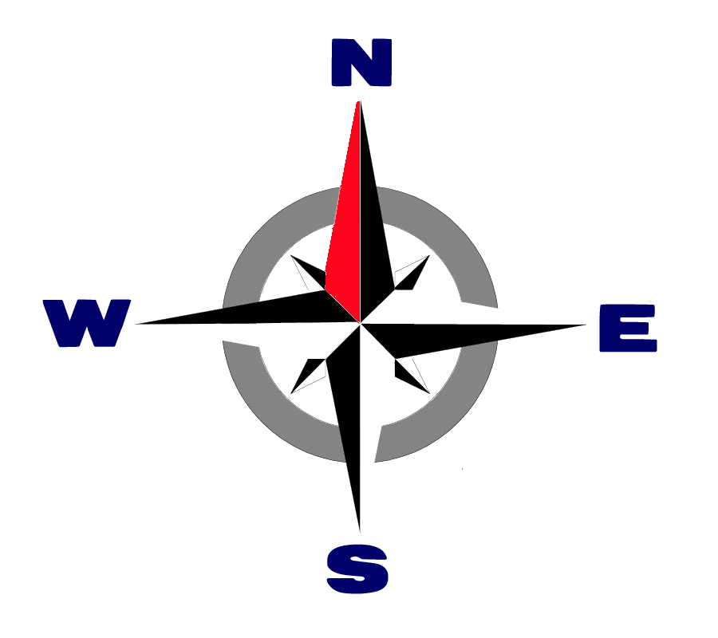

Compass Rose

What geographic tools are on the map? Circle all that apply.

When was the map created?



What questions do you have about the map?

What place(s) does the map show?

Map Analysis Sheet

Physical Map

Topographic Map

Weather Map

Political Map

Bird’s Eye View Map

Hand Drawn Map Map

What type of map is it? Check all that apply.