Constructing Argument
Green-Yellow-Red Essay Structure

- Have students construct a preliminary thesis and gather sources.

- After they have gathered sources, they need to decide how to group them to support their argument using the “bucket method.”
- It may be useful to start with a simple example before moving on to the students’ History Day topics.
  - For example, a sample thesis statement to scaffold this skill might be: “Puppies are great.”
  - Students are then provided pictures of puppies to use as sources—evidence to support their thesis. They will need to use that evidence to determine three reasons why puppies are great.
    - For example: Puppies are great because…
- They are cute.
- They play with toys.
- They cuddle.
  - They then need to sort through the puppy photos and decide which photos support each of their three reasons and place them into “buckets.” You may choose to use real buckets or paper cut-outs, or any other visual to demonstrate the “bucket method.”

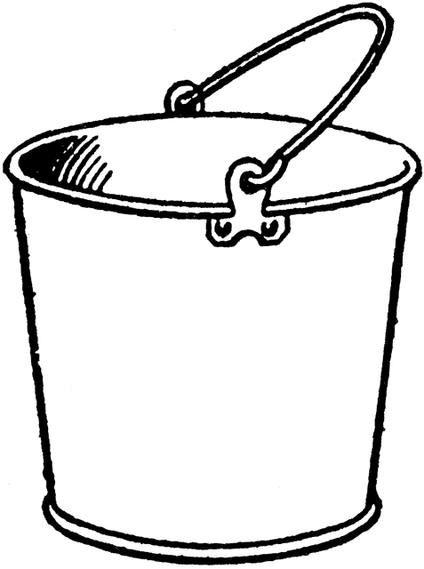
Bucket #1
Bucket #2
Bucket #3
Puppies are
cute.
Puppies play with toys.
Puppies
cuddle.

3. After sorting their sources, students will write “MEAL Paragraphs” using the Green-Yellow-Red Method.
- MEAL Paragraphs:
  - M: Main Point of the paragraph
  - E: Evidence to support the main point, i.e. the photos sorted into buckets
  - A: Analysis to explain the evidence and how the different pieces of evidence work together.
  - L: Link back to main thesis

- Students will write sentences on colored strips of paper in Green, Yellow, and Red, following this format:
  - Green: Go! This is your topic sentence, your MAIN POINT. What is this paragraph about?
  - Yellow: Slow down! Provide EVIDENCE and ANALYSIS to support your main point.
  - Red: Stop! Before you move onto the next paragraph, LINK back to your main thesis!
- Repeat for each paragraph; the introductory and conclusion paragraph will still use the Green-Yellow-Red method, though slightly modified.

EXAMPLE:

Introductory Paragraph
GREEN: The MAIN POINT of your essay: Puppies.
YELLOW: Context: General info about puppies.
RED: Thesis Statement: Puppies are great.

Body Paragraph #1
GREEN: MAIN POINT: Puppies are great because they are cute.
YELLOW #1: EVIDENCE from Bucket #1
YELLOW #2: ANALYSIS about how all the sources from Bucket #1 work together to demonstrate that puppies are cute.
RED: LINK back to the main thesis: Puppies are great.

Body Paragraph #2
GREEN: MAIN POINT: Puppies are great because they play with toys.
YELLOW #1: EVIDENCE from Bucket #2
YELLOW #2: ANALYSIS about how all the sources from Bucket #2 work together to demonstrate that puppies play with toys.
RED: LINK back to the main thesis: Puppies are great.

Body Paragraph #3
GREEN: MAIN POINT: Puppies are great because they cuddle.
YELLOW #1: EVIDENCE from Bucket #3
YELLOW #2: ANALYSIS about how all the sources from Bucket #3 work together to demonstrate that puppies cuddle.
RED: LINK back to the main thesis: Puppies are great.

Conclusion Paragraph
GREEN: Reiterate the MAIN POINT of your essay: Puppies.
YELLOW: Summarize EVIDENCE and ANALYSIS
RED: LINK back to the main thesis: Puppies are great.

4. After completing this example with a simple topic like puppies, students are then ready to do the same thing with their History Day topic and evidence. They can then use their 5 paragraph argumentative essay and construct their poster.

