***Developed by The Colorado Primary Sources for Elementary School Collaborative Project*** <http://www.cde.state.co.us/cosocialstudies/pssets>



Film/Video Analysis Sheet

Name: _________________________________

Who produced (made) the film?

What is the main idea of the film?

Do you see live action or animation?

Or both?

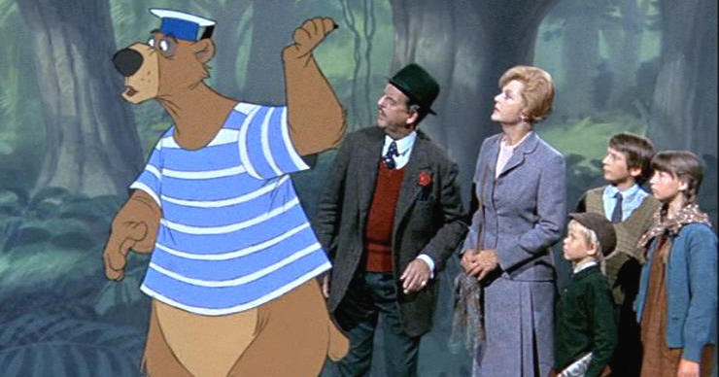**Live action and animation**

**Animation**

**Live action**

Describe what you see. How does it make you feel?



Do you think it was filmed on location or was there a stage set?

How did the music or sounds make you feel?

**Nervous**

**Scared**

**Angry**

**Surprised**

**Happy**

**Sad**

What is the purpose of the film?

**Inform**

**Entertain**

**Educate**

**Persuade**



What questions do you have about the film?





How do you know?

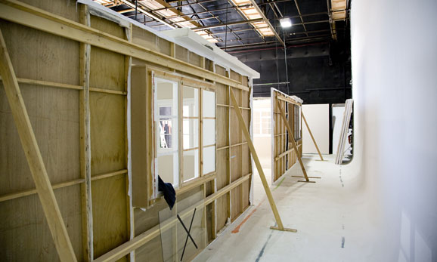

Film set

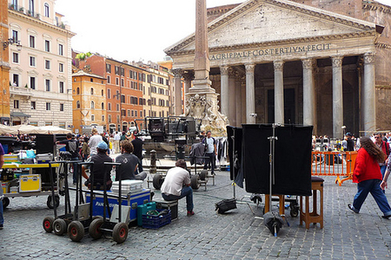

On location

Describe what you hear