Preserving the Heritage of the West:
The Setbacks and Resurgence of the California Condor

Sarah Abercrombie
Senior Division
Historical Paper
Words: 2,491

One of the most awe-inspiring soaring kings of the Western sky is the California condor (Gymnogyps californianus) with its potential 11-foot wingspan and bald, wrinkly head (see appendix A). These birds’ population numbers decreased and all types of people sought to “save” the birds from extinction. Humans have made progress in bringing the California condor populations to higher numbers, but actions and methods from the 1980s to the early 2000s have produced a population that have many obstacles that threaten the species. However, these accomplishments and misfortunes can be a building block for the preservation of our environment and species in the future.
The Condors’ Cultural Significance to Native Americans
Many of the Native American tribes that lived in "condor country" had the bird as part of their culture through oral legends, ceremonies, dances, traditions and rock paintings. In California, there were sixty tribes that had a combined total of sixty-five different words for the condor. Depending on the tribe, some groups believed that the condor was an ancestral chief, healer, sorcerer, messenger, or a finder of lost objects while other tribes saw the condor as a kidnapper, robber, or killer. The Yuman tribe tells a story about how a condor had an ancient village on Catalina Island that was full of women who had been captured by the condor. The tribe that had the most elements of the condor in their culture was the Chumash. They have several cave paintings that depict condors and tribe members in condor regalia (see appendix B). The Chumash tribe was highly advanced in astrology and named a constellation (Cassiopeia) after the condor due to its resemblance to the bird. The condor was believed to have the ability to find lost objects, read minds and was also a sorcerer. A Chumash legend tells of a boy who stole a condor egg from a nest, boils it and gets the ability to find lost objects from a stone that was placed on the egg.
Because of their beliefs in the power and sacredness of the condor, aspects of the bird were used in ceremonies. Many tribes used condor feathers to heal the sick and some made straws out of condor bones to suck the sickness from their patients. Condor feathers and skin were made into regalia and the most common forms of regalia included capes, dance skirts and mokis, which were long, tubular coverings of condor feathers. The moki had different names depending on the tribe but were worn by "condor impersonators" in ceremonies that could only be seen by select tribe members due to the immense power of the ceremony. Many Southern California tribes participated in a sacrifice of condors and golden eagles as a way to commemorate the death of a chief or leader. This was one of the only ceremonies where a condor was sacrificed and many tribes believed in the reincarnation of the condor, meaning that they were sacrificing the same bird every time the ceremony was held.
Native Americans' relationship with California condors was special because the bird was woven into many aspects of life for a large number of tribes in "condor country." The Natives had respect for the species and because of this respect, both human and bird benefitted. The Natives got their cultural and spiritual needs met with the existence of the condor and the bird was provided a rich and natural environment in which they could thrive. Both human and bird were in equilibrium. Unfortunately, this balance was disrupted by the arrival of the prospector to the area during the Gold Rush. The Natives were introduced to sickness and started to die at a fast rate. In addition, areas where the Natives lived were "gold rich" leading to relocation. Where they were relocated to had no condors, leading to the traditions, rituals, ceremonies and regalia related to the condor to die out. Today, little to no condor regalia or ceremonies are performed.
Condors Over the Ages
Throughout history, the condor has been a symbol of the West. In June of 1579, Francis Drake's boat the Golden Hind had a leak and he needed to stop on the California coast for repairs. Natives in canoes threw bundles of feathers, which were presumed to be from condors, onto Drake's boat. The Natives most likely thought Drake and the crew were ghosts and the feathers were part of a mourning ritual. The bird themselves were first spotted and observed in present-day Monterey, California by Antonio de la Ascencion in 1602. During the early 1800s, California condors had a cornucopia of carrion thanks to the large grazing cattle herds that came with the arrival of missionaries all along the Western Coast. When the cattle were slaughtered, essentially the whole carcass was left minus the hide and the prime cuts of meat. Sheep with high mortality rates also provided a food source for the condor. By 1830-1850, the hide trade had died down along with sheep populations meaning that food was more scarce than ten years prior. The California Gold Rush commenced in 1849, bringing large amounts of people to California causing huge amounts of California's wildlife to be killed, cooked and eaten. In addition, condor feathers were perfect for holding fine gold dust. Because of this, many prospectors hunted condors for their feathers. Condors food was becoming even more scarce. While the human population in the condors' regions was skyrocketing, condors were being killed or taken from the wild for scientific collection. From 1897-1899, a minimum of twenty condors and seven eggs were taken from the wild. These factors combined shrank the condor population significantly. It was estimated that only a few hundred condors were left at the end of the nineteenth century. All these human factors had negatively affected the condor with a result of decreased habitat and population numbers. At the time, humans paid no attention to how their actions could negatively impact the species.
By the 1940s, zoologists estimated that only around sixty condors remained. Dichlorodiphenyltrichloroethane (DDT) was also being sprayed in the condors' habitat to kill insects that were destroying crops. There was no direct link between dwindling condor numbers and their consumption of contaminated carcasses, but DDT could have assisted in the declination of condors' population numbers. As California became more populated, the food sources like cattle and wild animals continued to shrink in order for housing developments to grow. Because of this, the condors' habitat decreased, making food hard to come by. In the 1970s, biologists announced that only a few dozen condors remained in the wild. Thankfully, the birds were part of the first class (1967) of animals protected under the Endangered Species Preservation Act in 1966 which strived to formally protect animal species within their habitat. Humans were starting to look at the damages they had inflicted upon various species. The era of naturalistic and environmentalist ideology had ushered in an effort to learn from the mistakes that previous generations had made and attempt to make a better world for species to live in.
Controversy over Methods to Save the California Condor
During the early 1980s, groups across the nation became involved in the discussion of what would be the best method to save the species. The Fish and Wildlife Service (FWS), with the support of the San Diego Zoo proposed to take chicks, adult birds and especially unhatched eggs out of the wild and into captivity to zoos which would allow a breeding program to breed chicks that would be released into the wild. Groups like the Friends of the Earth (FOE) stated that the reproduction rate was fine but the mortality rate was the issue. Their proposition focused on, "reducing threats such as shooting and poisoning and harassment, and on the loss of habitat." Even with criticism, the FWS captured condors in the wild and brought them to either the Los Angeles Zoo or the San Diego Wild Animal Park. By 1987, the last remaining condor in the wild was brought into captivity. Although many opinions concerning the best plan of action were conflicting, many were willing to do whatever it took to “save” the species. Because this was one of the first reintroduction programs, those involved didn’t have previous knowledge or experience to help steer clear of the negative consequences their actions could pose on the species.
Condors' Numbers Rise
The capturing and breeding of condors proved to be successful in raising the condors' population numbers. From December 1996 to December of 2000, forty-seven condors were released in Northern Arizona alone. Out of those forty-seven condors, twenty-five of them were still living in the wild, four were returned to captivity, and eighteen were dead as of February of 2002. Those that were returned to captivity showed undesirable behaviors that could lead to death. From February 2002 to September 2006, forty-six condors were released in the same area. Thirty-seven of them survived in the wild while nine of them died. A total of twenty condors died between 2002-2006. Between 2007 and 2011, forty-one condors were released in Northern Arizona with eleven of them dying and three of them being returned into captivity, leaving twenty-seven still in the wild. There were seven producing pairs between 2003-2011 who produced an estimated fifteen chicks, seven of which survived past 2011. A total of twenty-eight condors died between 2007-2011. Between 2012 and 2016, forty-two condors were released, seventeen of which died between 2012 and 2016. The condor pairs rose to eleven, which produced fourteen chicks, four of which survived past 2016. A huge milestone for the program was that a wild-hatched condor produced young for the first time, however, between 2012 and 2016, fifty-eight condors died. As the data suggests, the number of condors dying had increased from 1996 to 2016. The excitement of having the condors’ population numbers increase had distracted scientists from one very important factor; quality control. The "race" to breed more condors quickly had created many issues that could compromise all of the work to save the species.
Setbacks for the California condor
Puppet Raising
Starting in the 1980s, chicks in captivity were raised by hand puppets that were supposed to mimic adult birds (see appendix C). It was hoped that by using hand puppets and keeping human exposure to a minimum, the condors would keep their natural fear of humans intact. When the puppet-raised condors were released into the wild, many of the condors were put back into captivity because they showed behaviors like having a heightened amount of interest in humans. For example, one condor died from drinking antifreeze on the highway. More puppet-reared condors were released and were, "prying shingles off buildings, destroying camping equipment and approaching people for food handouts." It was found that condors who were raised by real condor parents showed minimal or no human interest or incidents. When the puppeteers were raising the condor chicks, they were very gentle to the chicks, while actual condors are rougher and more aggressive with their chicks. Because of this difference in "parenting", puppet-raised condors did not have the social skills needed to interact with wild condors, encouraging them to have contact with humans. Some solutions to this concerning setback included having real condors raise captive chicks eventually eliminating puppet raising. Detrimental outcomes associated with raising condors with puppets lead to them posing a danger to the whole species. Real animal raising should be a necessity for future reintroduction programs.
Lead Poisoning
In modern hunting times, the largest threat to the condors' population recovery is lead poisoning. Deer and elk hunters leave behind most of the carcass, which is contaminated from bullets (containing lead) which may still be in the carcass. Scavenging animals then eat the carcass and get lead poisoning. Lead poisoning causes damage to the nervous system, which impairs motor function, causing weakness and debilitation. This leads to starvation, ultimately causing death. As more condors are released, there is more competition for food. This causes condors to travel farther for food, meaning they are less monitored, causing them to have a higher likelihood of getting lead poisoning. Because the reintroduction program looked specifically at raising population numbers, other contributing factors to make the species self-sufficient like food supplies were overlooked. This unfortunate oversight made people in general become more aware of their impact on the environment and how actions that seem harmless can turn out to have large consequences and repercussions.
To combat this threat to condor survival, the California legislature passed the Ridley-Tree Condor Preservation Act at the end of 2013. This Act required that hunters use non-lead ammunition in specific hunting zones. The non-lead ammunition (copper based) would be provided to hunters for free or a reduced price. By 2019, lead ammunition would be outlawed completely. Those violating the Act would be fined. One study showed, even with short intervals of non-exposure (as little as 100 days), the condors would have a higher chance of surviving contamination. Arizona opted for a voluntary, hunter-supported program to promote non-lead ammunition in 2003 that was successful (see appendix D). Over the last twelve years, the number of hunters using lead ammunition has dropped in designated condor areas from 50% to only 10%. The decline occurred even though there was a shortage of copper ammunition and it was more expensive. Hunters who received only information about condor lead poisoning were less likely to switch to non-lead ammunition compared to those who received information and a voucher to receive free copper ammunition. Hunters in both states were also encouraged to take their carrion with them after they hunted with lead ammunition. Efforts from groups like the Center of Biological Diversity are trying to have the Environmental Protection Agency ban lead ammunition nationwide. All of these combined efforts show promise in creating a self-sufficient condor population.
Conclusion
The journey of the California condor in the past 300 years was full of both triumphs and tragedies, including near extinction, captive breeding program, puppet raising and lead poisoning complications. The tragic near extinction of the condor brought into focus how impactful humans are to a species in their environment and reminded us that many generations have damaged the environment, but we can correct the errors, such as not using lead ammunition. Awareness of the human duty to be self-responsible and to care for our planet is a lesson that can be taken and applied to generations now and in the future. The triumph of the breeding program and tackling the potential tragedy of lead poisoning is additional encouragement that humans can be successful in preserving our Earth if we all work as a collective species. The accomplishments and misfortunes of the condor reintroduction program was a revealing experiment that gave scientists and environmentalists an idea of what procedures, actions and methods work or need to be adjusted to make future programs more successful.

Appendix A:
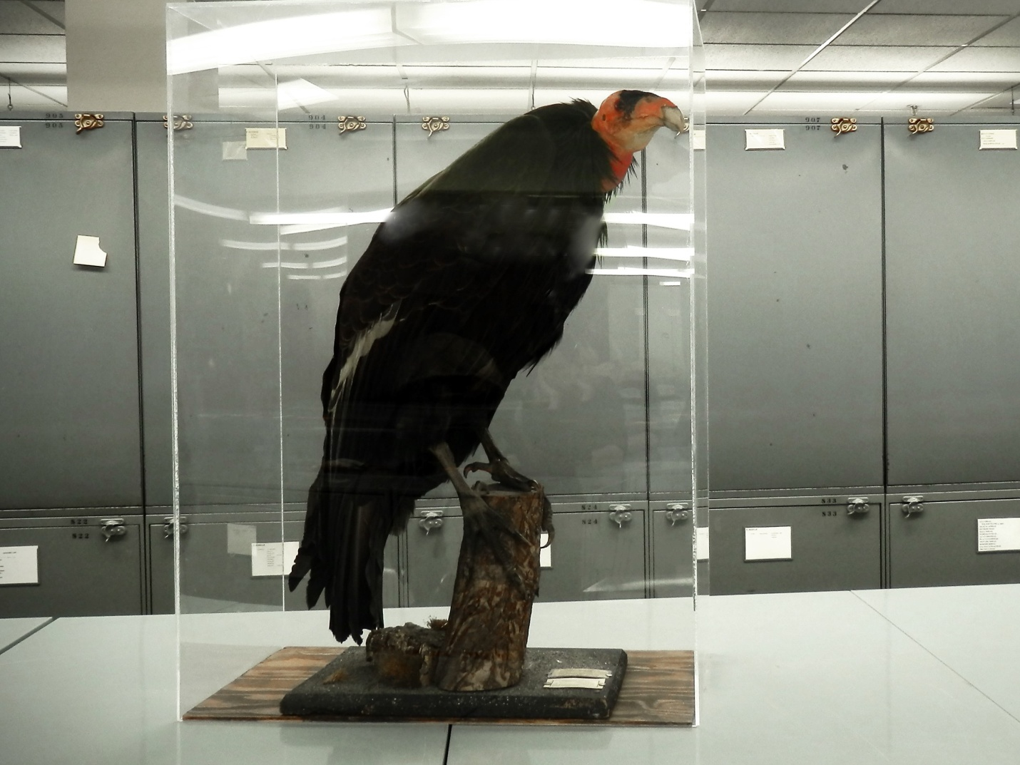

This photo shows a female California Condor taxidermy specimen collected April 10th, 1901. Taxidermy specimens were very popular with both private collectors and museums meaning a large number of condors were taken from the wild for scientific collection.

Baldeo, Mariah. Specimen Spotlight-- California Condor (Gymnogyps Californianus). Photograph. The Museum of Vertebrate Zoology at Berkeley. http://mvz.berkeley.edu.

Appendix B:
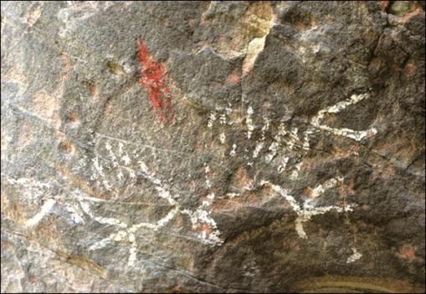
This photo shows a Chumash cave painting of a condor in flight in Condor Cave near Santa Barbara, California. The California condor had a significant role in Chumash culture along with other Native American tribes in the area.
Chumash Tribe Cave Painting of a California Condor in Flight. Photograph. Wings
of the Spirit: California Condor. 2009.

Appendix C:
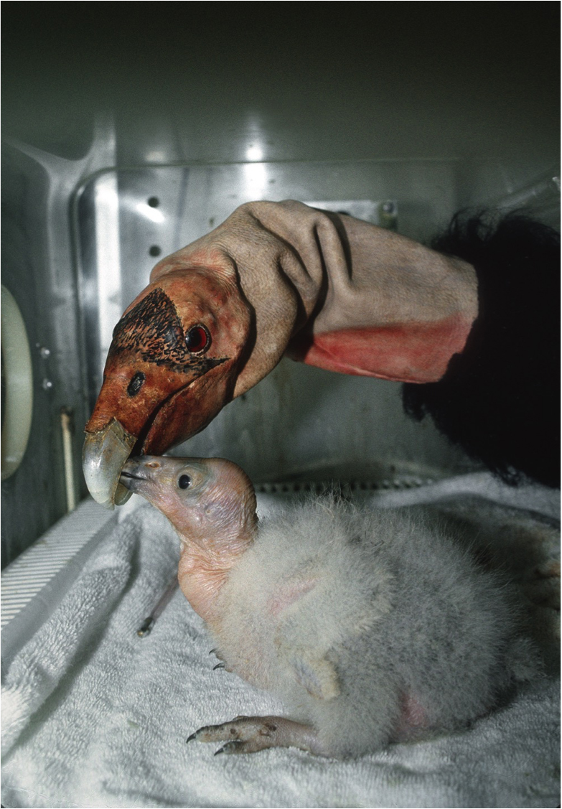

This photo shows a newly captured condor chick being fed by a condor puppet. The puppets were supposed to mimic actual adult condors and would prevent a large amount of human interaction between the chicks and keepers.

California condor puppet being fed by a condor puppet. Photograph. San Diego Zoo Timeline. http://www.sandiegozooglobal.org.
Appendix D:
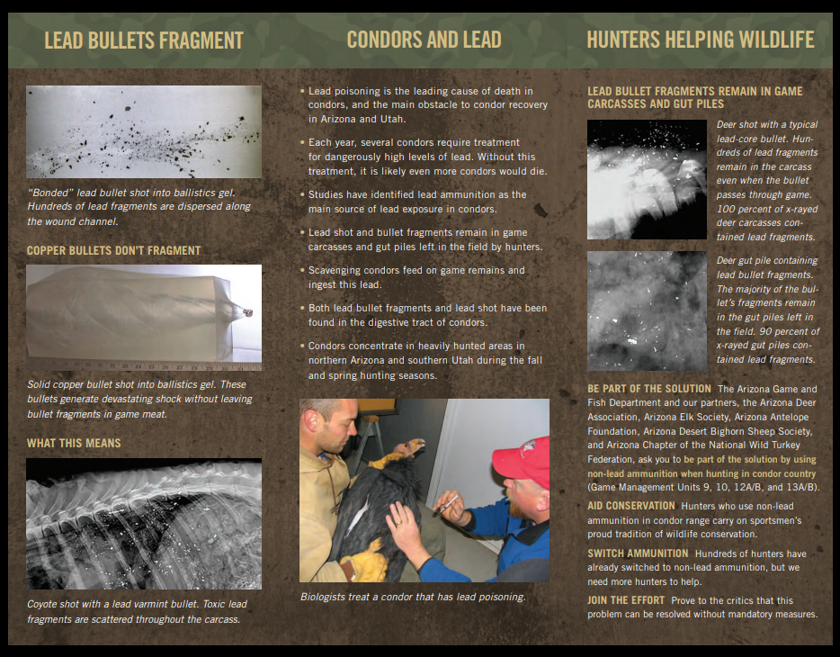
This brochure created by the Arizona Game and Fish Department informed hunters about the dangers posed to California Condors if they choose to use lead ammunition. Volunteers gave hunters these brochures in hopes that hunters will switch to non-lead ammunition.

Non-lead ammunition brochure. Image. Arizona Game and Fish: California Condor Recovery. http://www.azgfd.com.
Annotated Bibliography
Primary Sources
Berryhill, Tom, Senator. "AB-2392 Ridley-Tree Condor Preservation Act." California Legislative Information. Last modified April 3, 2008. http://leginfo.legislature.ca.gov.

This online source was a legislative bill presented to California legislators by Senator Tom Berryhill. The bill proposes a way which will reduce and eliminate lead poisoning caused by hunters using lead ammunition. The bill proposed providing copper ammunition to hunters and would fine those using lead ammunition in condor habitat. This bill showed me that California was concerned about the condor and scientists and legislators worked together in order to make the reintroduction program successful.

Secondary Sources

"Arizona Game and Fish believes voluntary non-lead ammo program more effective than a regulated ban for endangered condors." Arizona Game and Fish Department. Last modified June 30, 2014. http://azgfd.net.

This online article written by the Arizona Game and Fish Department described their voluntary non-lead program aimed at having hunters use non-lead ammunition and draws criticism against California's legislature to ban lead ammunition. This source gave me more insight into what states were doing differently to combat the issue of lead poisoning condors and the pros and cons to each states approach to the same goal.

Austin, William, Shawn Farry, Bill Heinrich, Jeff Humphrey, Elaine Leslie, Susan Mac Vean, Chad Olson, Sophie Osborn, Bruce Palmer, Chris Parish, and Micheal Small. "A Review of the First Five Years of the California Condor Reintroduction Program in Northern Arizona." U.S Fish and Wildlife Service. Last modified February 14, 2002. http://www.fws.gov.

This online source was a comprehensive review of the newly created reintroduction program in the Southwest between 1996 and 2001 written by the scientists from the U.S. Fish and Wildlife Service. The review had information about releasing the first captive-raised condors and how the condors were doing in the wild. This review discussed the successes and failures of the first batch of condors including their interest in humans and how their curiosity could be detrimental to the whole program. Also, possible solutions to these issues were proposed. This source showed me how complex the program is and gave me insight on the relationship between wild condors and humans.

Austin, William, Keith Day, Scot Franklin, Jeff Humphrey, W. Grainger Hunt, Chris Parish, Ron Sieg, and Kathy Sullivan. "A Review of the Second Five Years of the California Condor Reintroduction Program in the Southwest." U.S. Fish and Wildlife Service. Last modified April 2007. http://www/fws.org.

This online source was a comprehensive review of the whole condor reintroduction program in the Southwest from 2002 to 2006 written by the scientists from the U.S. fish and Wildlife Service. The review had information about the wild population numbers, the number of deaths, and the causes of death of the condors. This review was a valuable source because it showed the outcomes of the Service's work compared to 1996- 2002, gave me a larger picture of the early middle stages of the program and if the early released condors were surviving or not.

Austin, William, Keith Day, Angela Gatto, Jeff Humphrey, Chris Parish, Jane Rodgers, Ron Sieg, Brenda Smith, Kathy Sullivan, and Jeff Young. "A Review of the Third Five Years of the California Condor Reintroduction Program (2007-2011)." The U.S. Fish and Wildlife Service. Last modified May 2012. http://www.fws.gov.

This online source was a comprehensive review of the whole condor reintroduction program in the Southwest from 2003 to 2011 written by the scientists from the U.S. Fish and Wildlife Service. The review had information on how many condors were released, the number of producing pairs in the wild, the number of deaths in the wild, and their causes. This source showed me that the program was making progress because there were now condors who were producing young in the wild which was yet another large step toward the end goal of having a self-sustaining wild condor population.

Bakker, Victoria, Donald Smith, Holly Copeland, Joseph Brandt, Rachel Wolstenholme, Joe Burnett, and Myra Finkelstein. "Effects of Lead Exposure, Flock Behavior, and Management Actions on the Survival of California Condors ( Gymnogyps californianus)." EcoHealth 14 (March 2, 2017): 92-105.

This journal article discusses the effects of releasing more condors on monitoring and
preventing condors from getting lead poisoning. The articles states that as more condors are released, the competition for food becomes greater. The condors who have been out in the wild longer will go long distances to find food while younger, less experienced condors will eat at "food stations" set up by the Fish and Wildlife Service that have meat without harmful lead levels. Meanwhile, the older traveling condors have an elevated chance of getting lead poisoning because they are eating carrion in areas that are harder to monitor because they are out of "condor territory". This article showed me that releasing condors grow the population but threaten the lives of other condors at the same time.

Barraclough, Patti. "Saving California's Condors?" Environment 25, no. 5 (June 1, 1983): 1-3.

This source was a journal article that described the predicament the condor species was in the mid 1980s and the controversy about what course of action to take to save the California condor. This article talks about how the Fish and Wildlife Service wanted to take chicks out of the wild and breed them in captivity, but how the Service accidentally killed a chick, which made environmentalists question the Services program. This article informed me about condors in general and showed me that there could have possibly been different ways to promote and protect the species. Also, I learned that not all scientists and environmentalists were in support of the reintroduction program when it launched.

"The California Condor and Native American Cultures by Robert Mesta." Video file, 56:06. Youtube. Posted by Grand Canyon Association, January 26, 2010.

This video of an oral presentation by Robert Mesta, a wildlife biologist, discussed Native American tribes' relationships with the California condor. The lecture explains oral legends that include the condor, regalia made from the bird, and how the condor native relationship has changed over many centuries. This article was crucial for my paper because it gave me great insight and perspective into how complex and wonderfully woven in the species was into the culture and traditions of the many tribes in "condor country." I also learned more about how the gold rush was an unfortunate turning point in history that sealed the "deal" for condors to become almost extinct.

"California Condor Recovery." Arizona Game and Fish. Last modified 2017. http://azgfd.com.

This website was an overview of the hunter volunteer program headed by the Arizona Game and Fish Department aimed at encouraging hunters to take actions to reduce lead exposure to condors. The data from the website showed that the numbers of hunters who used non-lead ammunition and packed out their gutpile went up significantly between 2005 and 2017. This data showed me that there was more than one way to successfully reduce lead contamination and that hunters wanted to help save the condor even with it costing them more time and effort.

Chase, Loren, and Micheal J. Rabe. "Reducing Lead on the Landscape: Anticipating Hunter Behavior in Absence of a Free Nonlead Ammunition Program." PLoS One 10, no. 6 (June 1, 2015): 1-12.

This journal article was a study to see if giving hunters information on lead poisoning or information and a coupon for free or reduced price copper ammunition would promote hunters to take action to reduce their contribution to lead poisoning California condors. The study found that hunters who also received the coupon were more likely to use non-lead ammunition. This article showed me that because copper ammunition is more expensive, having hunters bypass the cost of copper ammunition is a good idea, but just giving hunters information on the condors' situation also makes a big impact on hunters and their actions (using non-lead ammunition and taking their lead bullet shot kill with them).

Cohn, Jeffery P. "Saving the California Condor." BioScience 49, no. 11 (November 1, 1999): 864-69.

This source was a journal article which looked at the whole reintroduction efforts starting from why the program was created and all of the steps taken to help the birds' populations grow. Specifically, the article discussed the Endangered Species Act, taking the condors into captivity, and why puppet raising was introduced and used. This article was crucial to my paper because it was an overview of the whole process to save the condors which gave me parts of the program to look more closely at like the controversy over taking condors into captivity and why and how the condor puppets were used. I learned that the program had a lot of different factors which caused its success but also some of its faults.

Cornell Lab of Ornithology. "California Condor." All About Birds. http://allaboutbirds.org.

This website was an overview of the California condor as a species. It discussed basic information about the species (habitat, behavior, food) and what groups were involved with their reintroduction into the wild. This source was very valuable because it was the foundation of information. When looking at other sources, having the knowledge of this source was key because it helped me understand more of why certain aspects of the reintroduction were successful or not and how actions in the reintroduction effected the condors in a certain way.

Emory, Jerry. "The Condor: A History of Decline." California Geographer 28 (January 1, 1988): 43-68.

This article in a journal examined why the condor almost went extinct. It described the early accounts of the California condor and the relationship between the condor and humans which ultimately lead to the condors' demise. This was an extremely important source because it explained how humans hurt the species, which gave me more insight into why certain proposals wouldn't work since they were part of what caused the condor population numbers to plummet. It also showed me how much of influence humans have to other species and how much potential humans have to harm animals around us with us not even thinking of the consequences they create for future generations.

Foster, John W. "Wings of the Spirit: The Place of the California Condor among Native Peoples of the Californias." ca.gov. Last modified 2009.

This website sponsored by the California Department of Parks and Recreation described the history of the California condor and how the species was connected to Natives in the area. All the artifacts including regalia, cave paintings, and items buried with Natives is specifically looked at and described. This source helped me learn and understand more about the many condor-related aspects in California Native tribes and how the condor was involved in many parts of the history of the west. The website had many pictures of regalia and cave paintings from tribes that showed me how amazing and remarkable the culture around the condor really was.

"Get the Lead Out." Center of Biological Diversity. Last modified March 2, 2017. http://www.biologicaldiversity.org.

This website created by the Center for Biological Diversity spotlights their efforts to have a nationwide ban on lead ammunition and their battle with the Environmental Protection Agency. This website opened my eyes to the fact that other animals suffer with lead poisoning from ammunition too, the issue of using lead ammunition was more extensive than I realized and that groups across the nation are looking towards the programs in California and Arizona for an example to base their own programs on to eliminate lead contamination in other species besides the California condor.

Green, Rhys E., W. Grainger Hunt, Christopher N. Parish, and Ian Newton. "Effectiveness of Action to Reduce Exposure of Free-Ranging California Condors in Arizona and Utah to Lead from Spent Ammunition." PLoS ONE 3, no. 12 (December 1, 2008): 1-10.

This journal article was a study that looked at where condors had a higher chance of having elevated lead levels and the effects of different lead levels over time. The study showed that condors in areas where deer hunting was prevalent were more likely to get lead poisoning and that condors with high levels over long periods of time were more likely to die compared to condors with long term low lead levels or those with high levels for a short period of time. This study showed me that deer hunting was a large issue which was why states were trying to get specifically deer hunters to use non-lead ammunition and that condors who were in the wild longer had a higher chance of dying because they had exposure to high lead levels the longest, making the number of earlier released condors make more sense.

Johnson, C., T. Kelly, and B. Rideout. "Lead in Ammunition: A Persistent Threat to Health and Conservation." EcoHealth 10, no. 4 (December 1, 2013): 455-64.

This source was an article which looked at the overall relationship between condors and lead ammunition. The article discusses why lead ammunition is so dangerous and sometimes fatal for California condors, how condors become poisoned by lead and how humans must take action in reducing using lead ammunition. This article showed me how widespread lead poisoning is in condor populations and I learned how grisly effects and symptoms condors experience and eventually die from.

Kaplan, Matt. "Puppet Parents Raise Troubled Condors." Nature International Weekly Journal of Science. Last modified August 7, 2007. http://nature.com.

This was an online article which looked at how puppet raising condors in captivity would affect the birds once they were released into the wild. It turns out that gentle puppets produced condors that were more interested in humans than their own species. Having chicks raised by real condors is necessary. This article was a great example of how the reintroduction program, like anything, would have trial and errors and could be information that could help other species' reintroduction programs in the future. The article made me aware that puppet raising was a threat to having the condor population be self-sustainable.

Kibbey, Hal. "Faulty practices threaten success of California condor program, says new report." University of California Berkeley Campus News. Last modified July 25, 2000. http://berkeley.edu.

This online article discussed how puppet-raising created condors that were tame, approached humans, and were teaching wild-raised condors the bad habits. The article proposes that those condors with bad behaviors should be put back into captivity because the "bad" birds pose a threat to the species and only parent-raised condors be released into the wild. From this article, I got insight into how much of a danger and influence puppet-raised condors are to the species, the bad habits puppet-raised condors possess and that action concerning the puppet-raised birds and the practice of puppet raising must be taken soon before too much damage is done.

Meretsky, Vicky, Noel F. R. Snyder, Steven R. Beissinger, David A. Clendenen, and James R. Wiley. "Quantity Versus Quality in California Condor Reintroduction: Reply to Beres and Starfield." Conservation Biology 15, no. 5 (October 2001): 1149-451.

This journal article argues that condors cannot be a self-sustaining species with their current mortality rate, which is predicted to go up, because of lead poisoning and puppet-raised condors having the tendency to approach human civilization. The article states that the mortality rate will increase due to the National Fish and Wildlife Service eliminating condor feeding stations (causing condors to eat lead ammunition killed carrion) and puppet-raised condors teaching their bad behaviors to the next generation of condors. This article suggests that the priority of the program should be on producing condor-raised condors. The article showed me that having parent raised condors is essential to having the condors be self-sustainable instead of exponentially dropping population numbers.

Smith, Brenda, Stephanie Braham, Chris Parish, Tim Hauck, Allen Zufelt, Keith Day, Greg Holm, Miranda Terwilliger, Cassity Bromley, John Spence, Natasha Kline, Jeff Young, Lisa Church, Danny Bulletts, Jr, Chad Smith, and Ruth Allard. "California Condor Recovery Program in the Southwest Fourth Review." U.S. Fish and Wildlife Service. Last modified November 2017. http://fws.gov.

This online source was an extensive review of the final stages of the reintroduction program in the Southwest from 2012 to 2016. This review had information about the number of condors released, how many died, how the original condors were doing in their latter stages of life, and that a wild-hatched condor had reproduced. The review put into perspective how far the program had come since its creation in 1996 and that condors would no longer be taken from the wild to be bred in captivity because the population had successfully grown. It also showed that the focus of the program had shifted from breeding condors to keeping the ones in the wild healthy and independent.

Takemura, Alison F. "How a Toxicologist Is Saving the California Condor With Science." Sierra: The National Magazine of the Sierra Club. Last modified September 2, 2017. http://sierraclub.org.

This online magazine article talks about a toxicologist whos efforts are helping to save the California condor. The article discusses how condors get lead poisoning, how condors are tested for lead poisoning and the solutions the toxicologist has worked on and supported, such as the California legislature that bans lead ammunition in designated condor areas. This article gave me basic information about lead poisoning and solutions, which lead me to further research regarding lead poisoning in condors. I also had a better understanding of solutions from knowledge about how condors get lead poisoning.

Patti Barraclough, "Saving California's Condors?," Environment 25, no. 5 (June 1, 1983): 1.
Cornell Lab of Ornithology, "California Condor," All About Birds, http://allaboutbirds.org
"The California Condor and Native American Cultures by Robert Mesta," video file, 56:06, Youtube, posted by Grand Canyon Association, January 26, 2010.
John W. Foster, "Wings of the Spirit: The Place of the California Condor among Native Peoples of the Californias," ca.gov, last modified 2009.
"The California," video file.
Ibid.
Foster, "Wings of the Spirit," ca.gov.
Jerry Emory, "The Condor: A History of Decline," California Geographer 28 (January 1, 1988): 45-55.
"The California," video file.
Emory, "The Condor," 49-55
Ibid.
Cohn, "Saving the California," 865.
Barraclough, "Saving California's," 1
Cohn, "Saving the California," 865.
William Austin et al., "A Review of the First Five Years of the California Condor Reintroduction Program in Northern Arizona," U.S Fish and Wildlife Service, last modified February 14, 2002, http://www.fws.gov.
William Austin et al., "A Review of the Second Five Years of the California Condor Reintroduction Program in the Southwest," U.S. Fish and Wildlife Service, last modified April 2007, http://www/fws.org.
William Austin et al., "A Review of the Third Five Years of the California Condor Reintroduction Program (2007-2011)," The U.S. Fish and Wildlife Service, last modified May 2012, http://www.fws.gov.
Brenda Smith et al., "California Condor Recovery Program in the Southwest Fourth Review," U.S. Fish and Wildlife Service, last modified November 2017, http://fws.gov.
Ibid.
Cohn, "Saving the California," 865.
Austin et al., "A Review," U.S Fish and Wildlife Service (1st).
Hal Kibbey, "Faulty practices threaten success of California condor program, says new report," University of California Berkeley Campus News, last modified July 25, 2000, http://berkeley.edu.
Matt Kaplan, "Puppet Parents Raise Troubled Condors," Nature International Weekly Journal of Science, last modified August 7, 2007, http://nature.com.
Vicky Meretsky et al., "Quantity Versus Quality in California Condor Reintroduction: Reply to Beres and Starfield," Conservation Biology 15, no. 5 (October 2001): 1451.
Alison F. Takemura, "How a Toxicologist Is Saving the California Condor With Science," Sierra: The National Magazine of the Seirra Club, last modified September 2, 2017, http://sierraclub.org.
C. Johnson, T. Kelly, and B. Rideout, "Lead in Ammunition: A Persistent Threat to Health and Conservation," EcoHealth 10, no. 4 (December 1, 2013): 3-4.
Victoria Bakker et al., "Effects of Lead Exposure, Flock Behavior, and Management Actions on the Survival of California Condors ( Gymnogyps californianus).," EcoHealth 14 (March 2, 2017): 1.
Takemura, "How a Toxicologist," Sierra: The National Magazine of the Seirra Club.
Tom Berryhill, Senator, "AB-2392 Ridley-Tree Condor Preservation Act," California Legislative Information, last modified April 3, 2008, http://leginfo.legislature.ca.gov.
Rhys E. Green et al., "Effectiveness of Action to Reduce Exposure of Free-Ranging California Condors in Arizona and Utah to Lead from Spent Ammunition," PLoS ONE 3, no. 12 (December 1, 2008): 8.
"Arizona Game and Fish believes voluntary non-lead ammo program more effective than a regulated ban for endangered condors," Arizona Game and Fish Department, last modified June 30, 2014, http://azgfd.net.
"California Condor Recovery," Arizona Game and Fish, last modified 2017, http://azgfd.com.
Loren Chase and Micheal J. Rabe, "Reducing Lead on the Landscape: Anticipating Hunter Behavior in Absence of a Free Nonlead Ammunition Program," PLoS One 10, no. 6 (June 1, 2015): 1-5.
"Get the Lead Out," Center of Biological Diversity, last modified March 2, 2017, http://www.biologicaldiversity.org.

