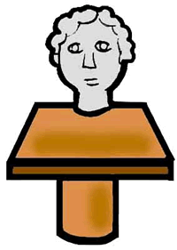

Name: ________________________

Artwork Analysis Sheet

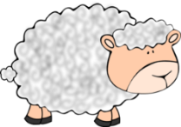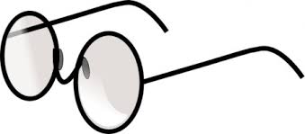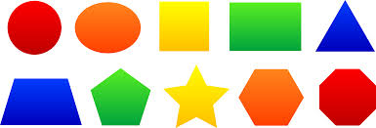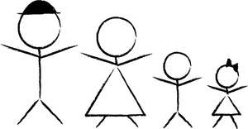

Do you think the artwork tells a story? If so, what is the story?

What questions would you ask the artist?

What do you see?

What details are in the foreground? Background?

What is the main subject of the artwork? People? Objects? Landscape?

Describe the artwork. What colors and shapes do you see? What is the texture?

Does this artwork remind you of a place you’ve been, or people you’ve met?

What do you think is happening in this artwork?

**Objects**

**People**

**Landscape**