Name: _____________________________

How do you think the object feels? Circle all that apply

Artifact/Object Analysis Sheet

What is the object made out of? Circle all that apply

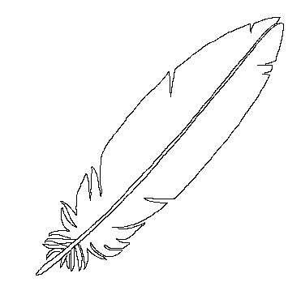

**Light**

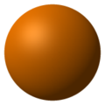

**Smooth**

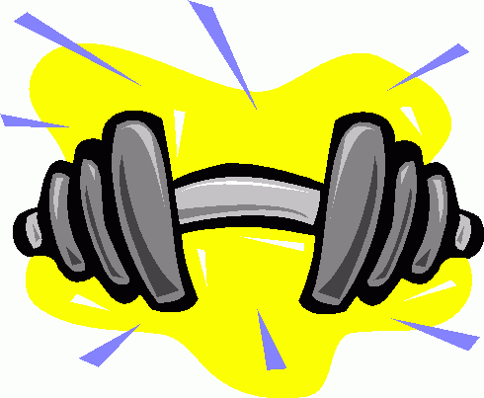

**Heavy**

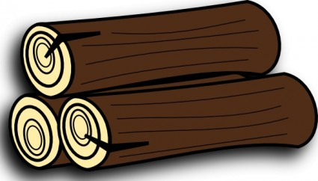

**Wood**

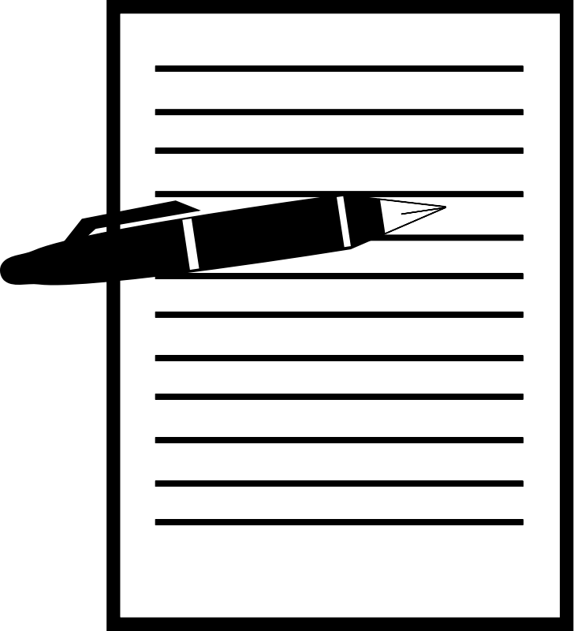

**Paper**

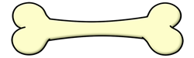

**Bone**

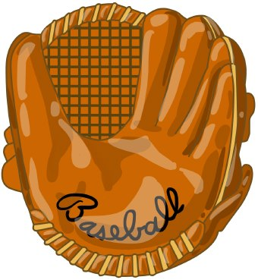

**Leather**

What size is the object?

**Big**

**Medium**

**Small**

Could it still have a purpose today?

Who do you think would have used the object?

What do you think the object was used for?

What does the object tell us about the time period when it was made and used?

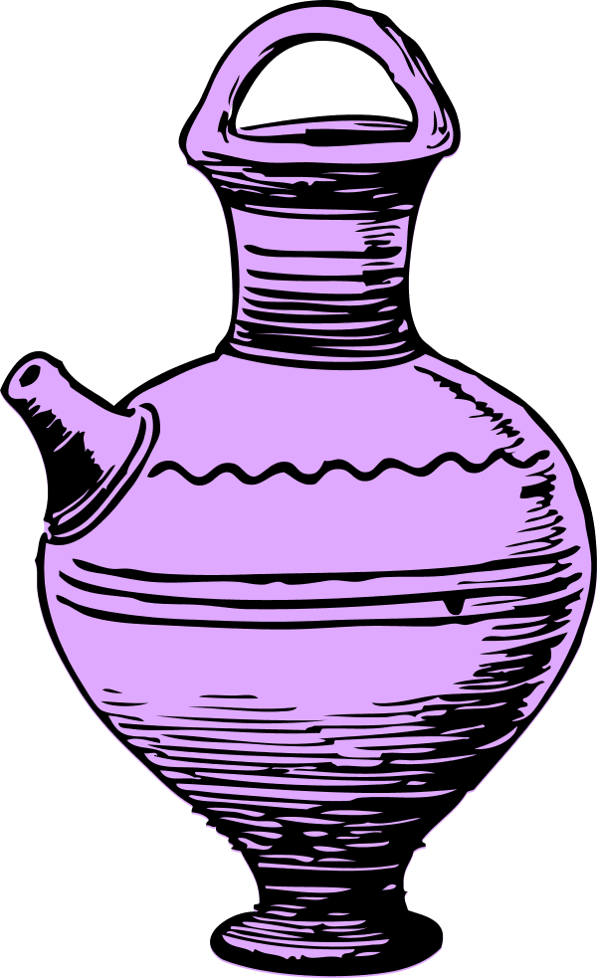**Ceramic/Pottery**

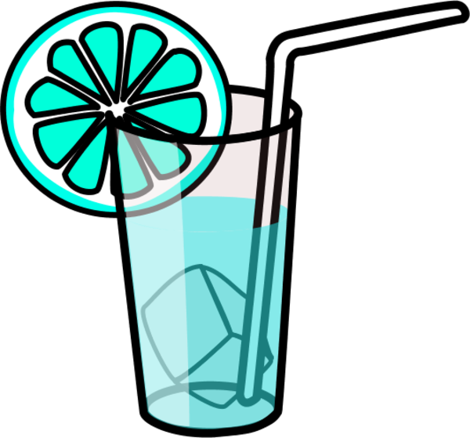

**Glass**

What questions do you have?

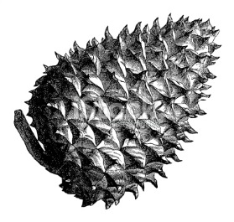

**Rough**

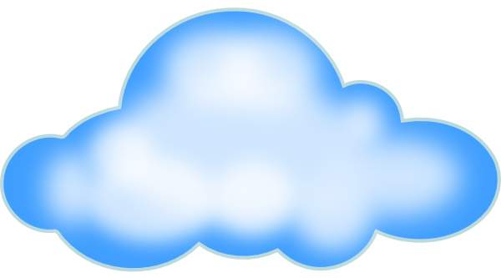

**Soft**

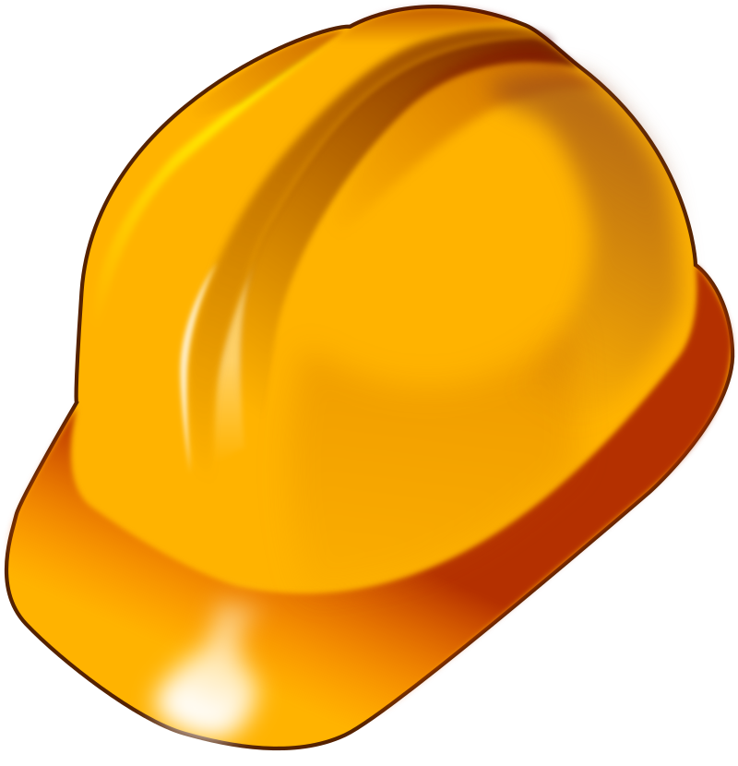

**Hard**

What is the shape of the object?

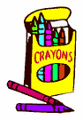

What color is the object?

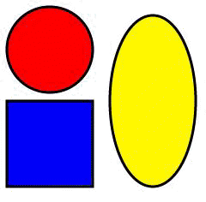

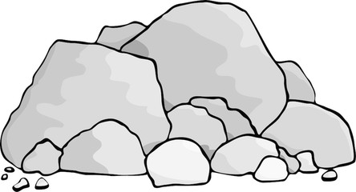

**Rock/Stone**

**Other**

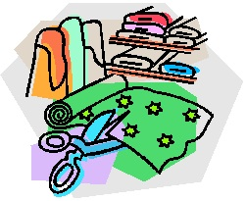

**Fabric/Cloth**

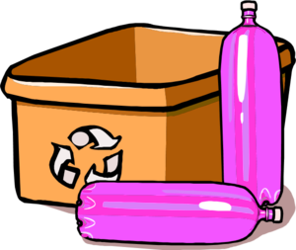

**Plastic**

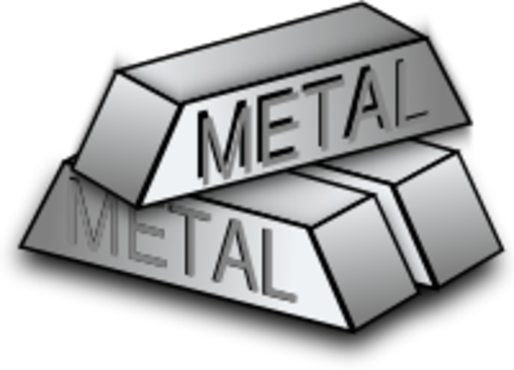

**Metal**