“A Look Over the Mountain”:
The Triumph of Denver's Five Points Neighborhood

Luke Ortiz-Grabe
Senior Division
Historical Paper
Paper Length: 2,611 Words

“Let us look over the mountain determined that we shall work together to remove any obstacle on the Road to Freedom remembering the future in America must be founded firmly on the laws of God and dedicated wholly to the dignity of man.”
-Malvin R. Goode, “A Look Over the Mountain,” Speech, July 2, 1965

The Five Points neighborhood was the epicenter of African-American culture in Denver, Colorado from the early to mid-twentieth century. Redlining policies, de facto segregation, and Ku Klux Klan political influence were some of the factors that contributed to isolating African American within Five Points. Racism, informal Jim Crow practices, and patterns of residential segregation limited, constrained, impeded, or prohibited Blacks from moving into many Denver neighborhoods, resulting in Five Points becoming their refuge. African Americans actively supported Black-owned businesses within their neighborhood and created a “city within a city” where they could live hospitably. Five Points’ cultural developments, such as the Juneteenth celebration and an extensive jazz presence, became defining features of the neighborhood’s identity. African Americans now contend with the gentrification of Five Points. Determined to “look over the mountain,” residents have preserved the vibrant history and character of the neighborhood. It is their triumph.

The Early History of Five Points
Five Points, located just north of downtown Denver, was named for the boundary points of the vertices formed at the intersection of 26th Avenue, 27th Street, Washington Street, and Welton Street (See Appendix A). The neighborhood grew out of economic necessity and increasing population pressures. The City and County of Denver designated Five Points for a Stout Street Herdic Coach Line station by the same name despite the opposition the moniker provoked for having an appellation associated with a New York City neighborhood notorious for gang activity. Denver’s Five Points formed during a period of economic growth from the early 1870s to the early 1890s. The mixed residential and industrial neighborhood had working-class Americans as well as European immigrant residents, such as Germans, Jews, and Irish. Throughout the late nineteenth century, thriving businesses in Five Points contributed to economic development as they became integral to Denver’s manufacturing enterprises, such as the Niederhut Carriage Company in 1883. In the late 1800s, the Niederhut Company reached its apex in the Denver area. The company specialized in pre-automobile transportation.
In 1893, economic growth halted when President Grover Cleveland called a special session of Congress to repeal the Sherman Silver Purchase Act of 1890 in order to stop the drain on U.S. gold reserves. This led to a collapse in silver prices and silver mining, and an accompanying disaster in state-wide economic activity. Silver mining fueled the economy in Colorado’s early years. Thus the collapse of silver mining due to the termination of the government’s authorization of silver bullion proved catastrophic to the state’s economy. Eventually, the economy recovered. Meanwhile, modes of transportation developed allowing residents to live farther away from the industrial centers, which led to the establishment of neighborhoods such as Capitol Hill. As more affluent residents could afford the transportation required to reside further away from industrial centers, this diminished the socio-economic status of Five Points. By the early twentieth century, Blacks, many of which were railroad workers, needed affordable housing options, leading to the transformation of Five Points into an epicenter for African-American residency and identity in Denver.
The Golden Age of Five Points
From the early 1920s to the late 1950s, Black culture flourished in Five Points. African Americans residents created a unique identity that made this era the “Golden Age” of Five Points. By the 1920s, more than ninety percent of African-American Denver residents lived in Five Points and the adjoining Whittier neighborhood. Five Points became home to African-American professionals, businesses, and communities that produced a vibrant cultural heritage. Neighbors heard locally established musicians in Five Points “jammin’ the beat.” Whittier Elementary School and Manual High School opened in 1886 and 1894, respectively, providing Black youth access to education.
Dr. Clarence Holmes, a Five Points resident and African-American professional, was a key local progressive figure. Dr. Holmes was the president of the Denver Cosmopolitan Club, an interracial and interfaith organization that worked to foster bonds between minority communities in Denver. It had some success in the partial unification of Denver’s social communities with people from varying backgrounds gathering to discuss urban problems and pursue progress in civil rights (See Appendix B). Holmes was one of the few licensed dentists to serve the Black community. He connected African Americans to healthcare, helping patients access practices that did not discriminate based on skin color.
Along with other African-American activists, Holmes worked to establish a National Association for the Advancement of Colored People (NAACP) branch in Colorado in 1914, bringing Five Points into the national progressive movement for civil rights. In the early-twentieth century, Blacks made up almost a third of the population in the states of the “solid South” where organizations such as the NAACP were imperative for progress in civil rights. Similarly, African-American Denver residents established an NAACP branch to aid in upholding their rights in Five Points. The effort succeeded in providing them a platform to advance their civil rights locally and to connect and interact nationally. Similarly, Dr. W.E.B. Du Bois, one of the founders of the NAACP in 1909, called for a national conference to counter racial inequality and the disenfranchisement of African Americans, as well as to gain equal rights. As African Americans experienced de jure or de facto segregation, and sometimes both, their struggle transcended Denver as it merged with the national Progressive movement for civil rights and civil liberties.
African-American activists in Five Points also endeavored to open a Young Men's Christian Association (YMCA) branch on 2800 Glenarm Place. The YMCA served as a “town hall” providing recreational, athletic, educational, and vocational training programs for Blacks in Denver. With aid from the NAACP, the YMCA in Five Points blended spirited African-American culture with ardent political activism. The Glenarm YMCA was a common meeting place for the Denver NAACP that helped blend culture, athletics, morals, and activism (See Appendix C). NAACP events included sundry aspects of Black identity. Church choirs, teas, picket signs, sidewalk gatherings, and jazz musicians were familiar to Five Points residents. The triumph of the NAACP against restrictive informal Jim Crow practices eventually led to the spread of African-American events into other areas of Denver. On July 29, 1961, the NAACP held its first annual Freedom Fund Ball at a place where Blacks had been previously banned: The Denver Hilton Hotel.
As Five Points assumed a prominent role in Denver, celebrations of Black culture sprouted up in the neighborhood. An example was Juneteenth. In 1953, Otha Rice, a jazz club owner and Five Points resident, pioneered the Juneteenth festival. Originally started to commemorate the official end of de jure slavery in the United States, Juneteenth manifested African-American identity and brought Five Points residents together. African Americans gathered, vendors sold goods, parades acclaimed local talent, jazz musicians forged the musical character of Five Points, and ceremonies commended those working to benefit the community. These social gatherings celebrated black culture and defied discrimination in Five Points.
A feature of the Golden Age of Five Points was jazz with its treasure trove of talent. Residents often described Five Points as the “Jazz Mecca” or the “Harlem of the West,” a sobriquet coined by Beat author Jack Kerouac, for its connection to jazz in a Black enclave similar to that of Harlem in New York City. Jazz musicians found places to play such as Rice’s Tap Room and Oven, a two-story taproom with an attached jazz and blues club, that had weekly jazz nights. The Rossonian represented the pinnacle of jazz in Five Points. In 1912, Robert Baxter hired architect George Bettcher to design the Baxter Hotel on 2642 Welton Street. The triangular design and Beaux-Arts molding immediately made the hotel a neighborhood landmark (See Appendix D). With Baxter’s death, the hotel shifted hands to Alfred Ross and became the Rossonian in 1929, with the hotel emerging as the prime spot for Black social gatherings. From nationally-recognized musicians and entertainers such as Miles Davis, Louis Armstrong, Duke Ellington, Dizzy Gillespie, Nat King Cole, and Billie Holiday opening in jazz clubs, to the inspiring stories of up-and-coming teen jazz bands, the Rossonian represented Five Points’ affection for jazz and fondness for its prevalence.
Jazz also engendered a sense of commonality between Blacks and Whites in Denver. During the height of the Golden Age, Whites came to Five Points’ jazz clubs when famous musicians played. Jazz music in Denver had a way of bringing everyone together. When Whites visited, they found that African Americans were tolerant and shared their common affinity for jazz. The realization that African Americans were cordial helped to promote cultural pluralism and erode segregation.

Chicano Five Points
Though Black culture defines much of Five Points, it is not exclusive to the diverse neighborhood. Five Points has been and remains a place for social progress where minorities live, including a sizeable Chicano-Latino population. Mexican Americans grew up in Five Points, such as the illustrious Rodolfo “Corky” Gonzales, who was born at Denver General Hospital in 1928. Working as a farm hand while attending school, he graduated from Manual High School in 1944. Afterward, he began a boxing career where he competed for years before turning to politics in 1963. Most of his formal political bids were unsuccessful. Fortunately, Gonzales became an activist advocating for Chicanos, who comprised forty percent of the Five Points population during the latter half of the twentieth century. He founded the Crusade for Justice, a grassroots cultural center, located at 1567 Downing Street (See Appendix E).
The Crusade for Justice was also a civil rights organization and a social movement to empower Denver’s Chicanos. El Plan Espiritual de Aztlán, a manifesto promoting Chicano nationalism and activism, was adopted at the First National Chicano Youth Liberation Conference hosted by Gonzales in 1969 at the Crusade for Justice. Through sustained activism and struggle for Chicano rights, Gonzales inspired Chicanos to demand local and national recognition, pursue inclusivity, achieve educational mobility, resist Anglo discrimination, oppose injustice, protest denials of their civil rights, and assert ethnic and cultural identity. Though the Chicano community in Denver faced challenges and tragedies, such as the bombing of a Crusade apartment and subsequent police shooting in 1973, Chicanos engaged in self-expression, resistance, and political activism in order to triumph over discrimination.
Discrimination in Five Points
Though Five Points’ culture reflected Black and Chicano pride, the underlying issue of racism seeped into the neighborhood. Throughout the 1920s, the Ku Klux Klan (KKK) was influential in Denver, with some politicians, such as Denver Mayor Benjamin Stapleton, aligning with KKK identity. The KKK openly advertised in newspapers calling for new members to sign up. In 1924, the Imperial Wizard, Hiram Wesley Evans, visited Denver while the Klan hosted an initiation of five-thousand members. Public displays of intimidation were an indication of KKK presence in Denver as well as in Colorado. Dr. Holmes experienced burned crosses in his yard (See Appendix F). The KKK even held a “Klan Day” where spectators watched Klan members participate in events (See Appendix G). Colorado society in the 1920s was where the KKK could visibly express virulent racist and pernicious anti-Catholic views. In general, discrimination restricted Blacks to a few ambient neighborhoods, such as Skyland, Clayton, and Whittier. The residents of these neighborhoods created a concentration of African-American culture that was missing in most of Denver. Though the obstacles of segregation and KKK prejudice persisted close to Five Points, residents there nonetheless triumphed over discrimination by affirming cultural solidarity in a place where minorities lived amicably.
Culture Effaced Countered by Revival Movements
Though the Golden Age of Five Points was robust with its jazz clubs, community centers, and doughty African-American culture, it ironically abated with and following civil rights victories such as the Civil Rights Act of 1964 and the Fair Housing Act of 1968. African Americans were no longer victims of redlining practices, and residents who could afford to move out of Five Points into other neighborhoods, such as Northeast Park Hill and Cole, and the suburb of Aurora, did so. Over time, Five Points succumbed to economic decline, urban deterioration, crime, and illicit drug trafficking. The population decreased drastically, going from 25,000 in 1950 to 8,000 in 1990. Developers tore down whole blocks of historic housing to make room for complexes such as Curtis Park Homes and parking lots. Five Points culture nonetheless endured during years of hardship with the Juneteenth festival occurring annually and the Zion Baptist Church remaining to serve the community.
From the late 1980s onwards, residents have begun making strides toward the revival of Five Points. In 1988, Paul W. Stewart opened the Black American West Museum in the home of Justina Ford, a prominent doctor in Five Points in the early twentieth century. The Black American West Museum dedicates itself to preserving African-American history in Colorado throughout all periods, thereby demonstrating the sentiment of conservation and revival in the neighborhood. In 1990, Thomas J. Yates, a member of the American Woodmen, now known as Woodmen of the World, bought the Rossonian hotel with support from the Denver City Government. Yates hoped to bring the hotel back to its former glory; however, he ran out of money. Fortunately, Carl Bourgeois bought the Rossonian with a similar goal of revival. In 2002, construction on the Blair-Caldwell African-American Research Library began. It officially opened in 2003. The Blair-Caldwell library pays tribute to the African-American heritage of Five Points and is a resource of Black history with thousands of documents displaying the story of the neighborhood. Moreover, the Five Points Juneteenth continues to celebrate African-American heritage with a festival that has grown to 20,000 attendees annually (See Appendix H). Though Five Points has waxed and waned, sustained efforts have revived its heritage. It is an African-American urban triumph.

Looking “Over the Mountain”
Five Points has triumphed over challenges throughout its history. It began as an industrial neighborhood as enterprises took root there in the late nineteenth century. In time, Five Points became the epicenter of African-American culture in Denver. The NAACP, jazz clubs, the Glenarm YMCA, the Rossonian, and a thriving African-American presence made Five Points the oasis of the Black community in Denver. Minorities such as Bahamians and other Afro-Caribbeans established themselves in Five Points as well. The neighborhood became the home for thousands of Chicanos, Mexican Americans, Hispanics, and Latinos, where they engaged in self-expression, resistance, political activism, and an assertion of cultural identity. Though the era of jazz clubs faded, the legacy of Five Points remains. Residents triumphed over hardship once again with the revitalization of the neighborhood following its dissipation. Five Points is a progressive, multiethnic, and inclusionary neighborhood for many residents. Whites presently comprise the largest population there. Now, in the early twenty-first century, Five Points is back and has arrived again.
When Five Points residents “look over the mountain” of struggles, they see the dynamic cultural history of the past and dedicate themselves to acknowledging it and revitalizing its positive features. They embody Goode’s speech “A Look Over the Mountain” by taking on contemporary challenges. A dynamic blend of national and local scales of history have interacted in the story of Five Points. Residents bear witness to the legacy of the past's heritage in the present and in its cultural identity for the future. Their energetic spirit drives the neighborhood forward towards the renewal of African-American urban character combined with other multicultural, multiethnic identities.

Appendix A
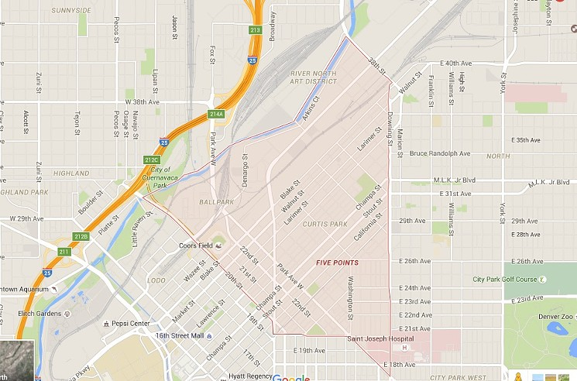

A map of the current boundaries of Five Points that illustrates the reason for the neighborhood’s name.

Davies, Bree "When to Just Say No to RiNo, and Other Inaccurate Denver Neighborhood Names," WestWord, last modified April 13, 2016, accessed April 9, 2019, https://www.westword.com/arts/when-to-just-say-no-to-rino-and-other-inaccurate-denver-neighborhood-names-7799513.

Appendix B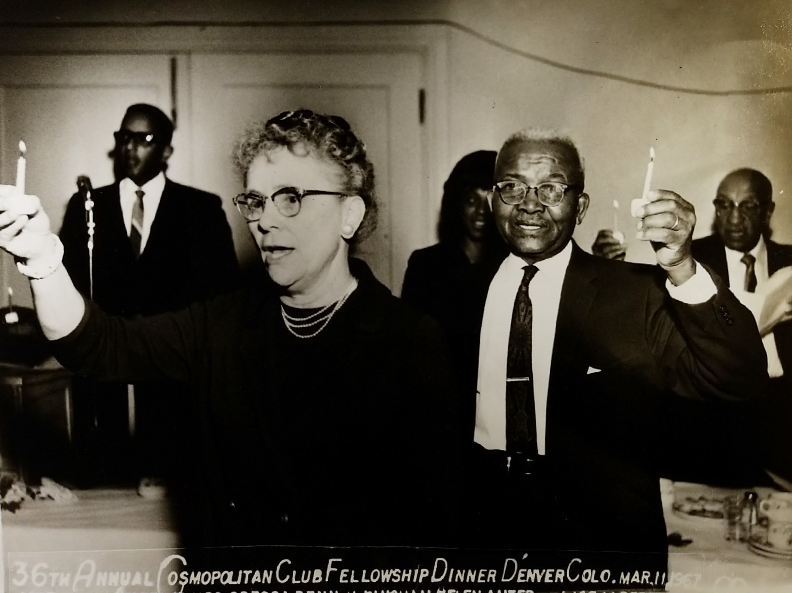

A commemoration held at the 36th Annual Cosmopolitan Club Fellowship Dinner.

36th Annual Cosmopolitan Club Fellowship Dinner 1967, 1967, photograph, Photobox One, Clarence and Fairfax Holmes Papers, Denver Public Library, Denver, Co.

Appendix C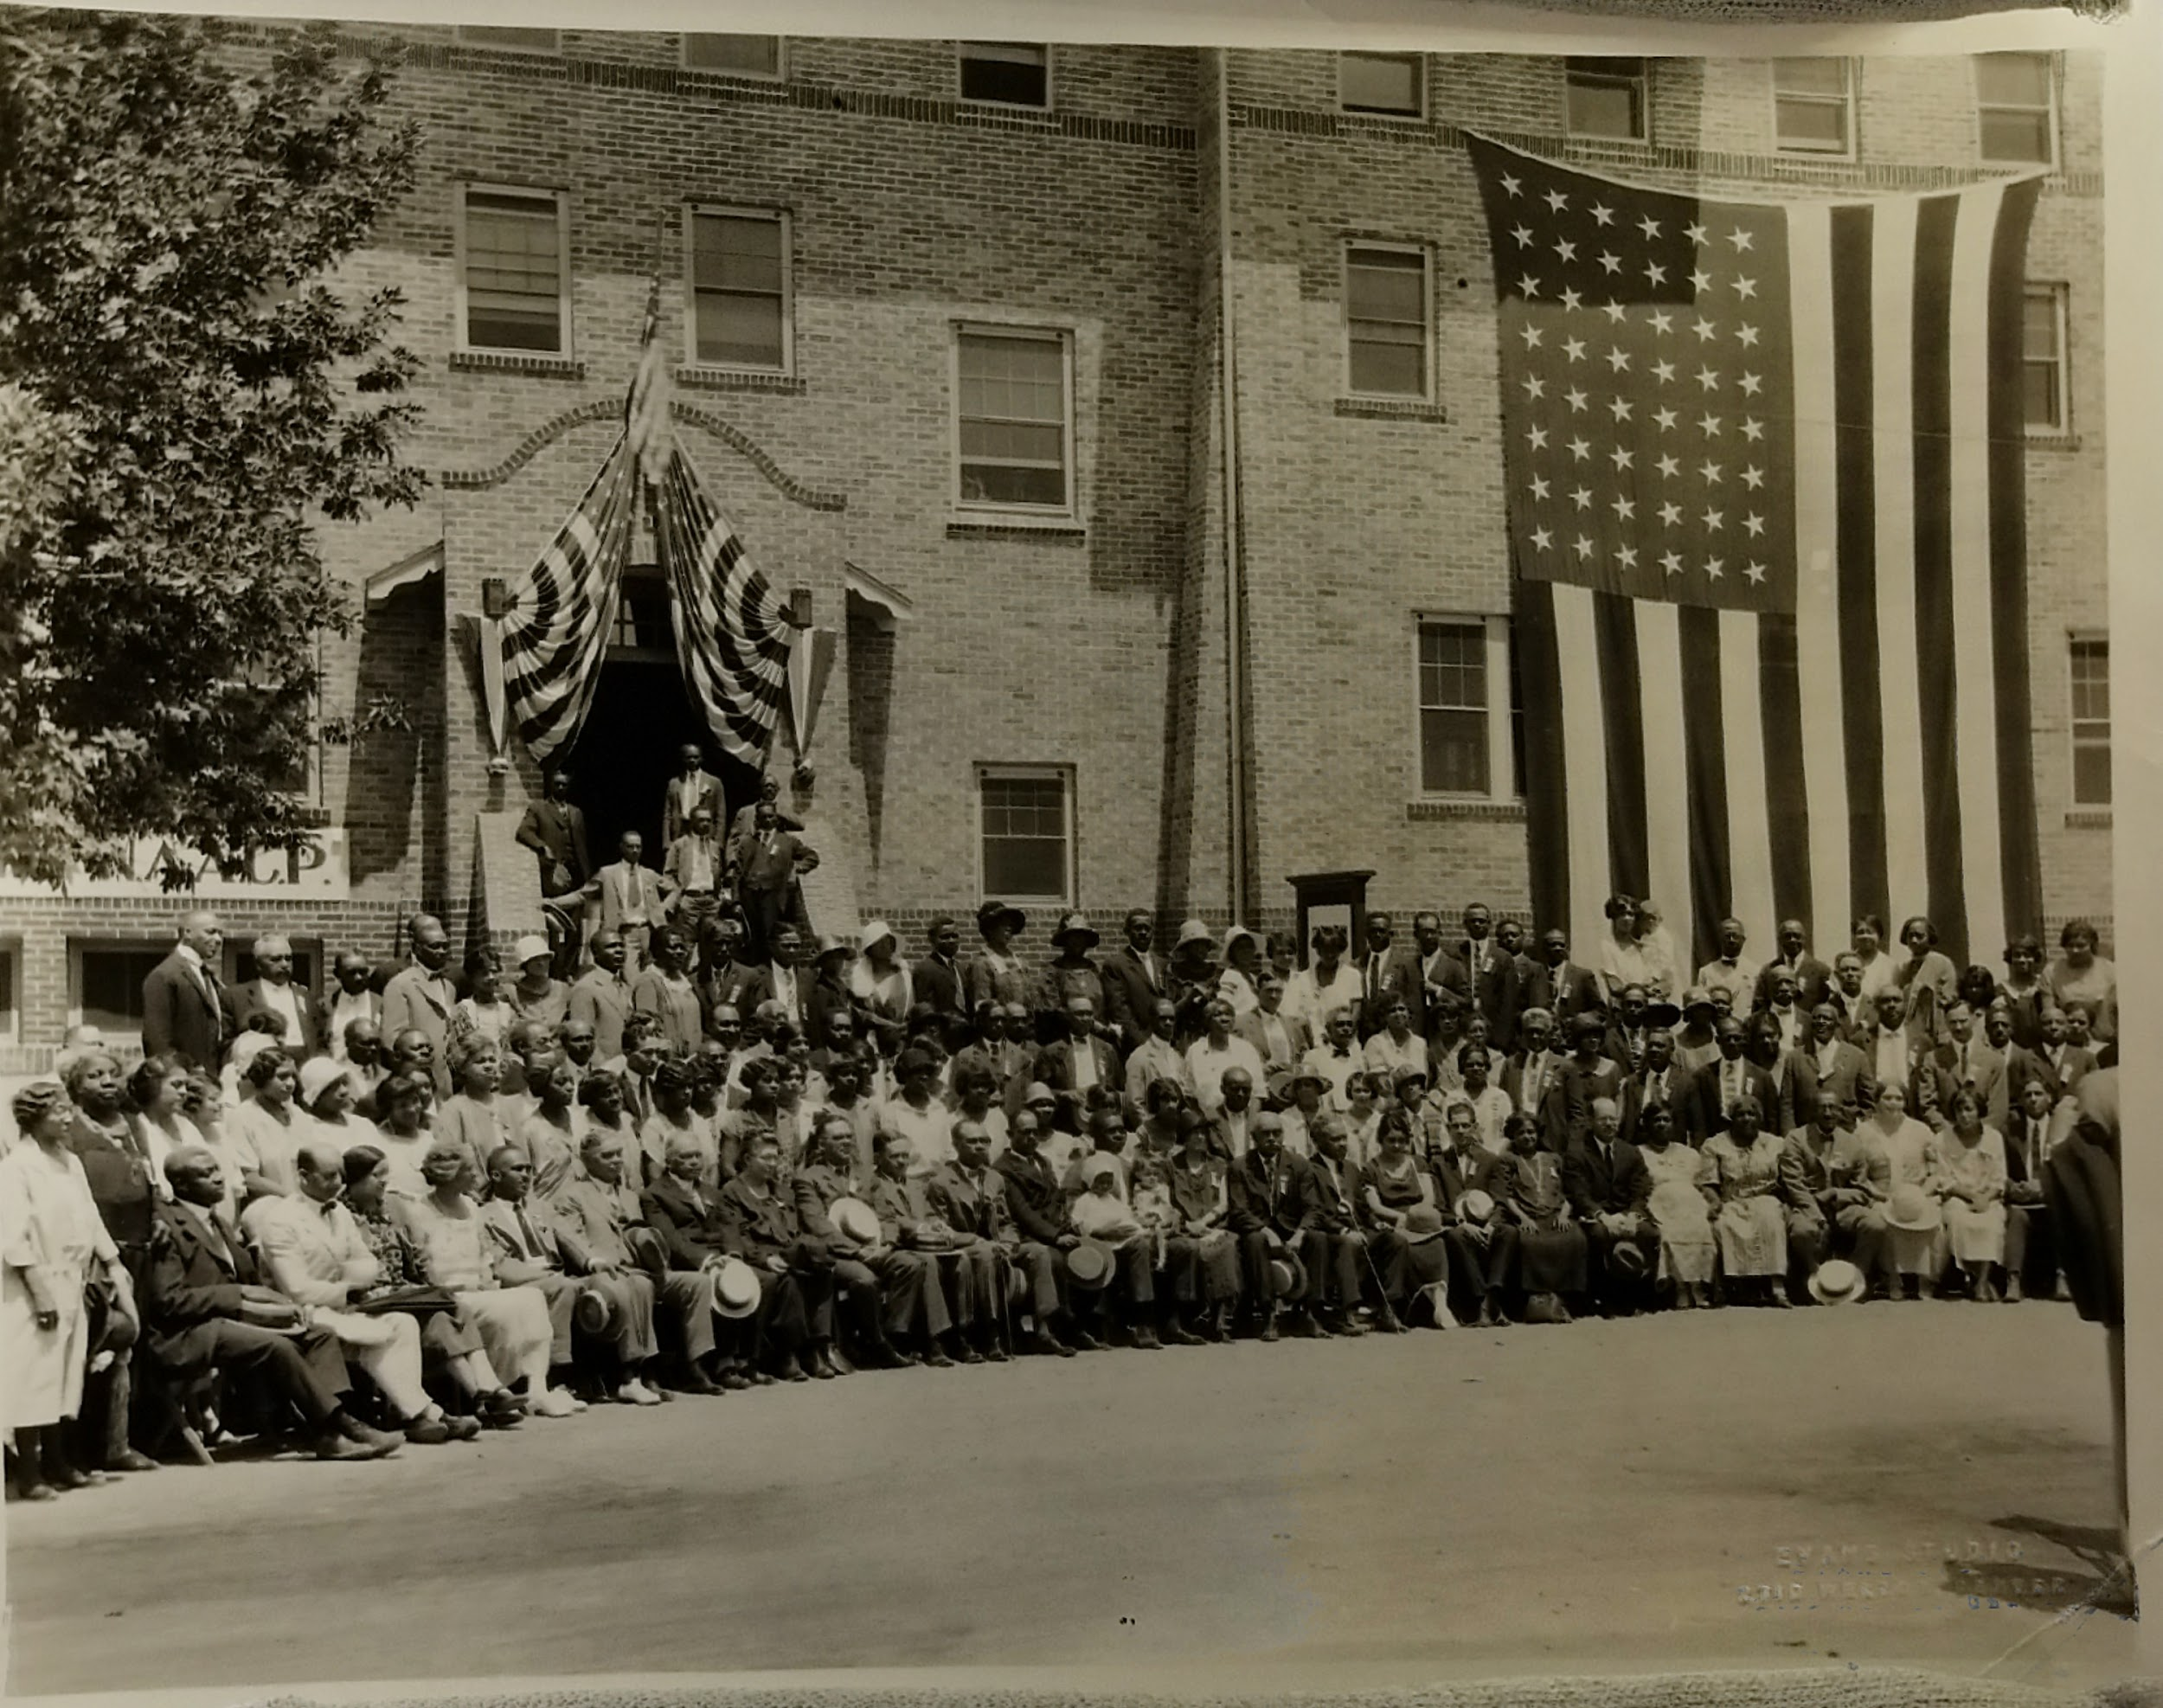

A photograph of the NAACP outside the Glenarm Branch of the YMCA after a meeting.

Clarence F. Holmes, Photograph of NAACP Denver in front of the Glenard Branch of the YMCA, June 26, 1926,
photograph, Photo-box 2, Clarence and Fairfax Papers, Denver Public Library, Denver, Co.

Appendix D
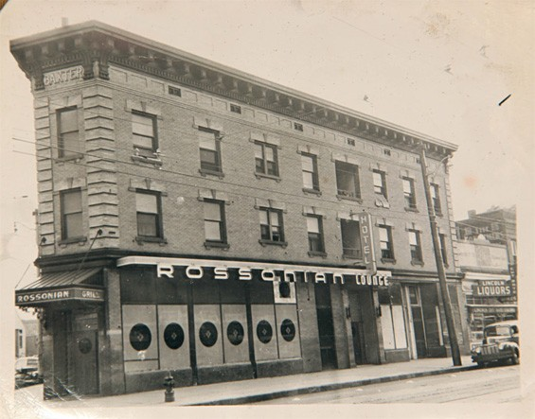
The triangular design and Beaux-Arts molding of the Rossonian Hotel and Lounge in 1945.

Jamie Siebrase, "With Developers Jazzed About Five Points, the Rossonian Hotel Could Soon Be Hopping Again," WestWord, last modified January 7, 2015, accessed April 14, 2019, https://www.westword.com/news/with-developers-jazzed-about-five-points-the-rossonian-hotel-could-soon-be-hopping-again-6279485.

Appendix E
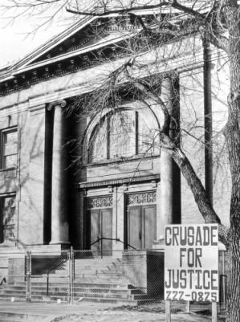

The front entrance to the Crusade for Justice building located on 1567 Downing Street.

Crusade for Justice Building, 1975, photograph, accessed April 13, 2019, http://digital.denverlibrary.org/cdm/ref/collection/p15330coll22/id/29869.

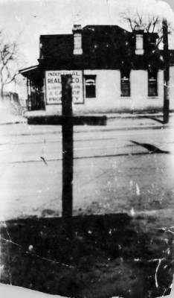
Appendix F

A burned cross the Ku Klux Klan left outside the office of Dr. Clarence Holmes.

Clarence F. Holmes, Dr. Holmes' Office and Burned Cross, 1925, photograph, http://cdm16079.contentdm.oclc.org/cdm/singleitem/collection/p15330coll22/id/28810/rec/11.

Appendix G
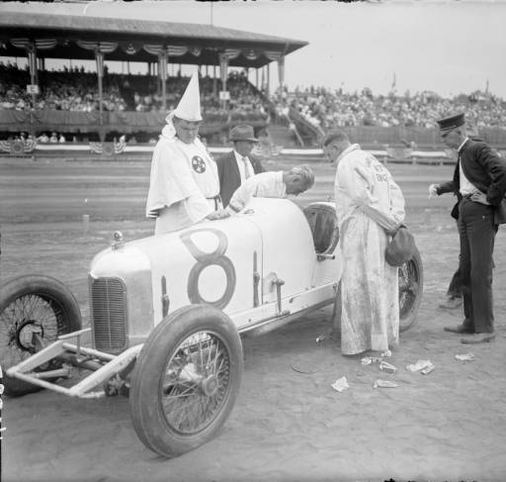

Ku Klux Klan members inspecting a car for “Klan Day” in Denver’s Overland Park.

Harry Mellon Rhoads, Klan Member at "Klan Day" at the Races at Overland Park, photograph, http://cdm16079.contentdm.oclc.org/cdm/singleitem/collection/p15330coll22/id/18418/rec/13.

Appendix H
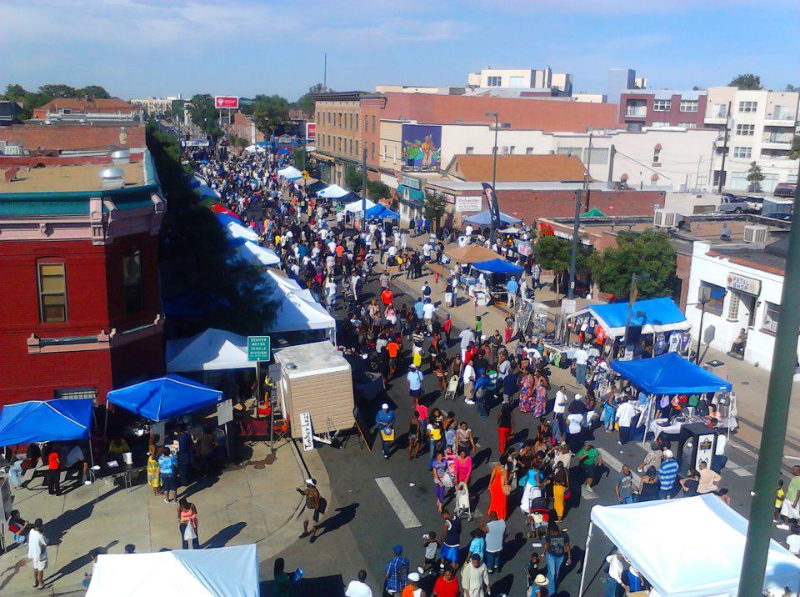

Vendors selling merchandise on Welton Street during the 2016 Juneteenth Festival.

Symone Roque, "The Juneteenth Music Festival Celebrates Culture through Music," 303 Magazine, last modified June 1, 2017, accessed February 24, 2019, https://303magazine.com/2017/06/juneteenth/.

Annotated Bibliography
Primary Sources
"27th Annual Juneteenth Celebration." 1993. Box 1. Otha Rice, Sr. Papers. Blair-Caldwell African-American Research Library, Denver, Co.
This informational guide described what occurred at a Five Points Juneteenth festival, and gave vivid descriptions of the activities present and a schedule of events that took place. I used this guide to describe what happened at the celebration. This guide taught me that the Juneteenth festivals did not change much over time, and kept the same aspects of Black culture alive in Five Points. This guide connects my paper to the theme of Triumph because it shows that African-American culture was an integral part of Five Points, triumphing over hardships for Blacks outside of the neighborhood.

36th Annual Cosmopolitan Club Fellowship Dinner 1967. Photograph. Photobox One. Clarence and Fairfax Holmes Papers. Denver Public Library, Denver, Co.
This photograph portrays a celebration of civil rights victories hosted by the Cosmopolitan Club and highlights the fight for civil rights in Five Points the club supported. I used this photograph to understand a typical celebration of victories the club hosted, and also the race of those involved. This photograph helped me understand how the club bridged the divide between Blacks and Whites and how it improved interracial interactions. This photograph connects my paper to the theme of triumph because it shows that Blacks used the Cosmopolitan Club to triumph over segregation and unite with other minorities to progress civil rights.

Caffey, Pat. Dr. Clarence Holmes with Patient in Operating Room with Assistant Lucia Burrell at Desk. 1951. Photograph. http://cdm16079.contentdm.oclc.org/cdm/ref/collection/p15330coll1/id/1589.
This photograph portrays how Dr. Clarence Holmes arranged the waiting and operating room of his dental practice and the number of patients he had. It also shows that all the patients he had in the room at the time were African-American, indicating that the vast majority of his clients were Black. I used this picture to portray how African-American professionals treated mainly African-American clients since Black professionals were the only option for Five Points residents due to discrimination in health practices. This photograph connects my paper to the theme of triumph because it shows the triumph of an elevated connection in the community and the ability for Black professionals to make a living in Five Points.

Certificate to Dr. Holmes for membership campaign for the YMCA Glenarm Branch. 1935. Box 1. Clarence and Fairfax Holmes Papers. Denver Public Library, Denver, Co.
This certificate addressed to Dr. Holmes certifies his membership to the YMCA Glenarm Branch and elaborated on how important the YMCA was to the people of Five Points. This certificate also helped me understand the uses of the YMCA in Glenarm and the services that the branch offered to the residents of Five Points, including exercise, education, and recreational activities. I used this certificate to show how easy it was for a resident to get a membership to the YMCA, and why the YMCA was so crucial to the community of Five Points. This certificate connects my paper to this year's theme because it shows African Americans were able to triumph over the issue of the limited community resources available and created a community center that did great services to the African-American community.

Church choir and onlookers of an NAACP event in Five Points. Photograph. Photo-box 2. Clarence and Fairfax Holmes Paper. Denver Public Library, Denver, Co.
The Glenarm branch of the YMCA was the location where the NAACP housed many of its meetings. This photograph portrays an example of an NAACP meeting in the YMCA building. I utilized this photograph to explain the connection between the activism of the NAACP and the community of the YMCA. This photograph helped me understand the average size of an NAACP meeting and how cultural performances such as a church choir were used to make the sessions connect more to the Five Points community. This photograph connects my paper to the theme of triumph because it shows how the connection between social activism and culture of Five Points helped to triumph over the lack of rights for African Americans eventually.

Crusade for Justice Building. 1975. photograph. accessed April 13, 2019. http://digital.denverlibrary.org/cdm/ref/collection/p15330coll22/id/29869.
The Crusade for Justice building was one of the centers of the Chicano movement throughout the late twentieth century in Denver. Corky Gonzales fought for Chicano rights using the building and used it to triumph over discrimination. I used this photograph to understand where the Crusade for Justice building was located, how people could aid the movement by calling the phone number on the sign in front of the building. This photograph connects my paper to the theme of triumph because it illustrates some of the methods Gonzales used to unite Chicanos in order to triumph over discrimination.

Cleveland, Grover. "Message on the Repeal of the Sherman Silver Purchase Act." Address, August 8, 1893. American History From Revolution to Reconstruction and beyond. Accessed February 24, 2019. http://www.let.rug.nl/usa/documents/1876-1900/grover-cleveland-message-on-the-repeal-of-the-sherman-silver-purchase-act-august-8-1893.php.
Grover Cleveland, who was the 22nd and 24th president of the United States of America, realized that the Sherman Silver Purchase Act was significantly hurting the stock market in the country and decided to repeal it. This transcript of Cleveland's announcement of the repeal of the Sherman Silver Act helped me understand when Cleveland repealed the Act and how the repeal policies impacted the growth of the Five Points neighborhood. I used this announcement to illustrate how the Silver act Shifted Five Point's growth. This announcement connects my paper to the theme of triumph because the repeal lead to many African Americans moving into Five Points, creating a distinct Black community in the neighborhood.

Davies, Bree. "When to Just Say No to RiNo, and Other Inaccurate Denver Neighborhood Names." WestWord. Last modified April 13, 2016. Accessed April 9, 2019. https://www.westword.com/arts/when-to-just-say-no-to-rino-and-other-inaccurate-denver-neighborhood-names-7799513.
I utilized the picture attached to this document to outline where Five Points compared to other Denver neighborhoods. I also used this image to outline the major streets that run through Five Points, and how the neighborhood derives its name from the intersection of those major streets. I classified this document as a primary source because I used a map, which is the part of the article that is a primary source, and not the content of the article, which is a secondary source. This picture is Appendix A in my paper and defines the boundaries of Five Points.

"Denver Elects B.F. Stapleton Mayor." The Moffat County Bell (Maybell, CO). May 18, 1923. 1. accessed April 13, 2019. https://www.coloradohistoricnewspapers.org/cgi-bin/colorado?a=d&d=MCB19230518-01.2.9&e.
This newspaper details the election of Benjamin Stapleton as mayor of Denver. I used this newspaper to discuss the timeframe of when Stapleton was mayor and the overall reaction from the local newspapers to his election. This paper helped me understand that there was no local resistance to Mayor Stapleton being part of the KKK, since it is not a significant part of the article, and the public would have mentioned his connection to the Klan if there was an opposition to his election. This paper shows the prevalent racism and KKK activity during the 1920s in Denver that Five Points residents triumphed over.

Denver Post (Denver, Co). "Denver Civilian Heroes Honored by Club." 1945.
This article from a Denver Newspaper written when the Cosmopolitan Club was a prominent political entity in Denver portrays the recipients of an award celebrating civil rights victories. This articled aided my understanding of what the Cosmopolitan club stood for and its impact on the Five Points residents and the fight for rights within the community. I used this article in my paper to portray how Five Points connected itself to other marginalized communities in the Denver area, and the methods the Cosmopolitan Club used to progress the idea of African-American rights outside of Five Points. This article joined my paper to this year's theme because the club helped African Americans triumphed over struggles and connected the community to the larger progressive struggle outside of Five Points.

Dr. Holmes' Office and Burned Cross. 1925. Photograph. http://cdm16079.contentdm.oclc.org/cdm/singleitem/collection/p15330coll22/id/28810/rec/11.
This photograph portrays a burned cross in front of the office of Dr. Holmes that the Ku Klux Klan put there so they could use it as an intimidation technique. I used this photograph to better understand the actions of the KKK in Colorado throughout the 1920s, to discuss the methods of intimidation used by the KKK in my paper, and to talk about how the openness of racism during the 1920s created a society that discriminated against African Americans. This source connects my paper to the theme of triumph because it shows the discrimination African Americans were able to avoid by staying inside of Five Points mostly.

"Five Points Population Statistics." Shift Research Lab. accessed February 24, 2019. http://denvermetrodata.org/neighborhood/five-points.
Going into the twenty-first century, the demographics of Five Points shifted, and the majority of residents in Five Points are now White. I used these population statistics to understand the neighborhood's racial shift over time, and how, despite a sizeable White population, Black heritage continues to be a large part of the neighborhood. These statistics connect my paper to the theme of triumph because African Americans triumphed over the effacing of their culture during the 1960s to the 1980s, and continue to revive the culture despite there not being a substantial Black population in the community.

"Give Statistics on 'Solid South." Box 2. Clarence and Fairfax Holmes Papers. Denver Public Library, Denver, Co.
These statistics cut out from an unknown newspaper at the time show that the "solid South" states in the United States had a significant African-American Population. This newspaper cutout helped me understand that Clarence Holmes was very invested in the state of African Americans across the country since this newspaper cutout was located in the personal items part of the Clarence and Fairfax Holmes papers. I used this cutout to outline the demographics relating the African Americans at the time and as an explanation for why organizations such as the NAACP had become so prevalent in Five Points. This cutout connects my paper to what was happening in the South during the Golden Age of Five Points and how much African Americans had an impact in that area.

Goode, Malvin R. "A Look over the Mountain." July 2, 1965. Box 2. Clarence and Fairfax Holmes Papers. Denver Public Library, Denver, Co.
Malvin Goode was one of the first African-American news correspondents in the United States, making him a hugely influential person within the Black Community. His ability to effectively convey the struggle of African Americans in a manner that everyone could relate to was known by many in the African-American community. When Goode came to Denver to give a speech at the NAACP ball in 1965, his speech titled "A Look over the Mountain" summarized the feeling of Blacks in Denver perfectly. I used this speech to outline the sentiment of looking over the challenges in place that the African Americans of Five Points embody a. The determination that African Americans had to triumph over challenges put in their way is the basis of Goode's speech, and but also the basis for the African-American sentiment in Five Points.

Holmes, Clarence F. "The appointment book to Clarence Holmes' dentistry practice." Box 1. Clarence and Fairfax Holmes Papers. Denver Public Library, Denver, Co.
This appointment book outlined the number of patients that were to Dr. Holmes' practice and how the majority of his clients were African Americans that lived and worked in Five Points. I used this appointment book to show how African Americans were able to use Holmes' practice to fulfill their health needs despite the issue of discrimination in the community. This appointment book connects my paper to the theme of triumph because it shows triumph over the issue of being restricted to Five Points by having African-American professionals in their community, providing the community with services and the professionals a place to open their practices.

Howell, Duane. "Five Honored in Racial Relations." The Denver Post (Denver, Co), March 6, 1964.
This article from the Denver Post elaborates on the triumphs of the Cosmopolitan Club and how the club reached past the boundaries of Five Points to seek out support from other communities. I used this article to portray how the majority of Denver citizens felt about the discrimination prevalent in their state, and how relating the discrimination between minority groups improves the support for discrimination for all communities. I used this article to connect my paper to the theme of triumph because of the triumph over discrimination using connections outside from outside neighborhood.

Martin, A. C. Whittier Elementary School Students. 1927. Photograph. http://cdm16079.contentdm.oclc.org/cdm/ref/collection/p15330coll22/id/33798.
Though Denver Public Schools still segregated their schools when Five Points was at its prime, there was still a school that supported the youth of the neighborhood and allowed for African Americans to have an education. I used this photograph to understand the racial makeup of schools in Five Points and how that school, in turn, supported the community. This photograph connected my paper to the theme of triumph because the fact that African Americans in Five Points had a school where their children could get educated was a triumph over the efforts to prevent the African-American community from succeeding.

Newspaper announcement for a KKK meeting in Denver. October 1924. photograph box 2. Clarence and Fairfax Holmes. Denver Public Library, Denver, Co.
The Ku Klux Klan was extremely prevalent throughout the Denver society in the 1920s. This newspaper announcement showed that the KKK advertised their meetings to the general population and that there was not a strong voice of opposition. I used this announcement to better understand the tactics the KKK used to recruit members into the Klan, and the effect the Klan had on the African-American lives in Five Points since the newspaper announcement was in the personal files of Clarence Holmes. This announcement connects my paper to the racism around Five Points, and how the neighborhood was relatively safe for Blacks compared to other regions.

The New York Times (New York City, NY). "From Texas; Important Orders by General Granger. Surrender of Senator Johnson of Arkansas. A Spattering of Rebel Officials." July 7, 1865, 1. Accessed February 24, 2019. https://www.nytimes.com/1865/07/07/archives/from-texas-important-orders-by-general-granger-surrender-of-senator.html.
Though Lincoln outlawed in the United States at the end of the Civil War, it took about four years after Congress ratified the amendment for slavery practices to be eradicated in the United States, since it persisted in Texas for quite some time. I used this newspaper article to understand the founding of the Juneteenth celebration and why the event has such a significant impact on the African-American community in America. This newspaper article connects my paper to the theme of triumph because it shows the founding of Juneteenth, which African Americans ultimately used increase the community feeling in their neighborhood, triumphing over discrimination surrounding Five Points.

Niederhut Carriage Company. 1895. Photograph. http://cdm16079.contentdm.oclc.org/cdm/ref/collection/p15330coll1/id/1665.
After President Cleveland repealed the Sherman Purchase Act, the focus of Five Points shifted to manufacturing consumer goods such as carriages that were extremely popular in the time. This picture shows the very beginning of the Niederhut Carriage Company and how small scale production influenced the neighborhood of Five Points. I used this photograph to understand the development of industry in the very beginning of Five Points, and how the decline of that industry along with transportation developments led to the Black presence in Five Points.

Niederhut Carriage Company. 1900. Photograph. http://cdm16079.contentdm.oclc.org/cdm/ref/collection/p15330coll1/id/1657.
Once there was a full shift in Five Points industry from silver production to sectors such as carriage making, the Niederhut Carriage Company continues to grow into a tremendously large and influential company. This photograph illustrates the growth of the Carriage Company and its even higher prevalence in the Five Points community. I used this photograph to understand how large the industries of Five Points had grown in such a short amount of time, and how those enterprises caused the ultimate shift to Black presence in Five Points.

Oswald Garrison. A Call for a National Conference to Discuss Racial Inequality. February 1909. accessed April 11, 2019. http://www.loc.gov/exhibits/naacp/founding-and-early-years.html#obj2.
While the NAACP developed in Five Points, it connected to a larger NAACP organization across the United States. I used this announcement calling for a national conference to discuss racial inequality and to compare the events concerning civil rights in the entire United States to just what was happening in Five Points. This announcement connects my paper to the theme of Triumph because it allowed me to show how Five Points' civil rights movement contributed to the national movement and how the NAACP created triumphs for Blacks all over the U.S.

Photograph of NAACP Denver in front of the Glenard Branch of the YMCA. June 26, 1926. Photograph. Photo-box 2. Clarence and Fairfax Papers. Denver Public Library, Denver, Co.
This photograph portrayed the mix of the NAACP and the YMCA Glenarm branch and the effect it had on the Five Points neighborhood. The portrayal of the NAACP members in front of the Glenarm branch in the photograph helped me elaborate on the connection between the YMCA and the NAACP in Five Points and how the neighborhood used that connection to improve the rights of African Americans. This photograph connects my paper to this year's theme because it shows the triumph of the connection of activism and culture over the problem of discrimination and that African Americans were able to thrive despite discrimination and problems.

"Presentation Card for the First Annual NAACP Freedom Fund Ball." July 29, 1961. Box 2. Clarence and Fairfax Holmes Papers. Denver Public Library, Denver, Co.
NAACP Balls were commonplace in other places with a prevalent NAACP such as New York City. However, those celebrations did not come to Denver for quite some time. This presentation card illustrates that the Freedom Fund Ball had finally come to Denver and that many members of the NAACP had attended, including Dr. Holmes, one of the founding members of the NAACP. This card helps connect my paper to the theme of triumph because it shows the triumph of the NAACP over discrimination with the Freedom Fund Ball taking place at a major hotel in Denver, where discrimination was prevalent for many years.

Record of Rice's Tap Room, such as the contents inside the restaurants and the activities that happened there. September 1964. Box 1. Otha Rice, Sr. Papers. Blair-Caldwell African-American Research Library, Denver, Co.
This record elaborated on the involvement of jazz in Five Points, and the amenities patrons had in jazz clubs. I used this record to elaborate on what a typical jazz club in Five Points was like, and the common activities that took place there. This record of Rice's Taproom and Oven connects my paper to the theme of triumph because it shows that jazz contributed to the creation of a unique enclave in Five Points with its own events, something that countered and triumphed over the goals of segregation and discrimination.

"Response to the founding of the NAACP Branch of Denver." Box 2. Clarence and Fairfax Holmes Papers. Denver Public Library, Denver, Co.
This letter responds to the founding of the NAACP and demonstrates how the NAACP first took shape in Denver, and the effect the shaping had on the African-American population in Five Points. I used this letter to understand better when African Americans in Denver founded the NAACP branch for the state of Colorado and how political activism would soon work to improve the lives of Blacks. This letter connects my paper to the theme of Triumph because the creation of an NAACP branch in Colorado was a significant step to triumph over discrimination for African Americans in Five Points and bettered the community as a whole.

Rhoads, Harry Mellon. Klan Member at "Klan Day" at the Races at Overland Park. Photograph. http://cdm16079.contentdm.oclc.org/cdm/singleitem/collection/p15330coll22/id/18418/rec/13.
This photograph illustrates a "Klan Day", where prominent members of the Ku Klux Klan would come and participate in sports while garnering support for the Klan. I used this photograph to elaborate on the prevalence of the Klan in Colorado and to describe a regular event for the Klan. I also expressed how easy it was for the KKK to garner support and how racism and discrimination were so open in Colorado. This photograph allowed me to describe the openly racist policies because it shows how common Ku Klux Klan activity was in the Front Range and their effect on the political and social community there.

Rocky Mountain Legacy: Jazz in Five Points. Public Broadcasting System. Accessed February 24, 2019. https://www.pbs.org/video/rmpbs-specials-rocky-mountain-legacy-jazz-five-points/.
Jazz was arguably one of the most critical components to the culture of Five Points, and this document uses Five Points residents who lived through the jazz era of the Five Points This documentary had residents elaborate on their memories of Five Points, how jazz impacted their childhood and even had performers recount their experience in Five Points. I used this source to talk about the jazz history of Five Points using the first-hand outlook to construct the argument of my paper. This documentary connects my paper to the theme of triumph because Five Points was a haven for performers facing discrimination and represented triumphs with the development of a unique heritage with major jazz components in Five Points.

Rodolfo Gonzales. Boxing Record Book for Rodolfo Gonzales. 1946, Box 1. Rodolfo "Corky" Gonzales Papers. Denver Public Library, Denver, Co.
Corky Gonzales was a prominent boxer before shifting his focus to the Chicano movement and progressing Latino rights in Colorado. This record book of his boxing matches shows his wins and losses against his opponents, the location where he boxed, and other personal information such as his weight, height, and age. I used this book to understand his success during his boxing career and connected it to the brief section about Gonzales’ life before activism.

Siebrase, Jamie. "With Developers Jazzed About Five Points, the Rossonian Hotel Could Soon Be Hopping Again." WestWord. last modified January 7, 2015. accessed April 14, 2019. https://www.westword.com/news/with-developers-jazzed-about-five-points-the-rossonian-hotel-could-soon-be-hopping-again-6279485.
The photograph attached form this article shows the Rossonian Hotel in 1945, which was during the Golden Age of Five Points and when jazz was at its height in the neighborhood. I used the picture to understand the beaux-arts architecture on the outside, and the iconic triangular design of the building that made it so recognizable. I classified this article as a primary source since I only utilized the picture, which is a primary source, and not the commentary in the article, which is a secondary source. This photograph connects my paper to this year's theme because it elaborates on the significant jazz presence in the neighborhood and how the development of enjoyable activities for Blacks triumphed over the goals of discrimination. I also used it to discuss how jazz attracted people of all races, triumphing over segregation.

"Subpoena of Craig Bowers. Mayoral Opponent Running against Gonzales in 1967." April 9, 1968. Box 1. Rodolfo "Corky" Gonzales Papers. Denver Public Library, Denver, Co.
After running for Mayor, Corky Gonzales sued his opponent for violating a Denver campaign law. I used this subpoena to understand the many losses Gonzales suffered during his political campaigns and his actions in response to losing those bids. This subpoena document connects my paper to the theme of triumph because Gonzales was able to triumph over his losses in politics and turn to social activism with the Chicano movement.

Staver, Barry. "Police Report Bomb Incidents." The Denver post (Denver, Co), March 19, 1973, 3.
The Crusade of Justice building was at the center of many scandals in the Five Points community, with a police raid and shooting all happening in connection with the building. This newspaper article details a bombing of the Crusade for Justice building that caused a considerable scandal between the Denver police and the members of the Chicano movement. I used this paper to illustrate the tragic events that the Chicano movement triumphed over and to understand the racial tension between law enforcement and Chicano activists.

Smith, Leroy. "Coors Salutes The 5-Points Business Association Juneteenth '85." 1985, Box 1. Otha Rice, Sr. Papers. Blair-Caldwell African-American Research Library, Denver, Co.
This informational guide from the Juneteenth festival elaborated on the events of the Juneteenth festival, where the funding for it came from, and its founding and a brief history, since the celebration had not been going on for a long time before this the Five Points Business Association published this guide. I used this guide to elaborate on the founding of the festival and to understand the activities of a typical Five Points Juneteenth celebration. This guide connects my paper to the theme of triumph because it demonstrates the cultural triumphs residents had despite opposition and discrimination outside the neighborhood. This guide also helped me express how the celebration contributed to making Five Points a Black enclave.

The Rocky Mountain News (Denver, Co). "Dr. Evans, Imperial Wizard of the Klan Pays Visit to Denver and Addresses Meeting." 1924.
With the prevalence of the Ku Klux Klan in Denver growing in the 1920s, it was only a matter of time before the Imperial Wizard came to visit and check on the KKK in Colorado. This newspaper article outlines the Imperial Wizard's first visit to Denver and the events that would coincide with his visit. I used this source to go even more into detail about the racism prevalent in Denver culture and how large the events had gotten with the KKK. This source shows the discrimination and the prevalence of racism in the Denver community had grown to an immense level in the 1920s and early 1930s with the presence of the KKK in Colorado.

Wilkins, Roy, and Clarence F. Holmes. "Final Installment for NAACP Notification." November 27, 1962. Box 2. Clarence and Fairfax Holmes Papers. Denver Public Libraries, Denver, Co.
Before Clarence Holmes and other activists first formed the NAACP in Five Points, residents were quite interested in getting a chapter established to progress the rights of themselves and their neighbors. This letter to Dr. Holmes outlines the importance of the establishment of the NAACP in the community and added confirmation that the NAACP planned to establish a chapter in Denver. I used this paper to elaborate on when the Activists established the NAACP in Five Points and how it impacted the Five Points community. This letter connects my paper to the theme of triumph because it elaborates on the triumph of the establishment of the NAACP in Denver and the beginning of the fight to end discrimination.

Secondary Sources
Basc, Madison. "Topics in History: Five Points: The Heart and Soul of Denver." Colorado Virtual Library. last modified February 11, 2019. accessed April 9, 2019. https://www.coloradovirtuallibrary.org/digital-colorado/colorado-historic-newspapers-collection/topics-in-history-five-points-the-heart-and-soul-of-denver/.
This article describes the history of Five Points from a revival standpoint, where the main focus of the article is the revival of African-American culture after the 1980s and how residents revived it. I used this article to understand the ways residents revived their community, such as with the progressing attempts to reopen the Rossonian, and the founding of the Black American West Museum and the Blair-Caldwell African-American Research Library. This article connects my paper to the theme of triumph because it illustrates the triumphs over the effacing of Black culture.

Denver Public Libraries. "Five Points-Whittier Neighborhood History." Denver Public Library History. Last modified August 26, 2016. Accessed February 24, 2019. https://history.denverlibrary.org/five-points-whittier-neighborhood-history.
This article summarizes about a hundred years of history all relating to the Five Points neighborhood and the African-American presence in Denver. The article spans about 150 years of Five Points history, and was essential to my understanding of the topic. I utilized this article to discover the specific topics that I needed to research about the Five Points neighborhood, to find archives full of primary sources that I could use to write my paper, and facts that I could only discover in the article that was beneficial in building my paper. This article connects my paper to the theme of triumph because it outlines the vast history of triumphs in the Five Points neighborhood.

Encyclopedia Staff. "Five Points." Colorado Encyclopedia. last modified December 10, 2018,\. accessed April 9, 2019. https://coloradoencyclopedia.org/article/five-points#Author.
This article discusses a brief history of the Five Points neighborhood with an African-American focus and illustrates the connection between the Golden Age and the revival of Five Points culture. I used this article to find more specific details about some events during the revival period, and to understand the connection across the different eras of Five Points history. This article connects my paper to the theme of triumph because it shows the triumph of revival over the effacing of culture in the 1960 to the 1980s and its connection to the Golden Age of African-American history in Denver.

Encyclopedia Staff. "'Zion Baptist Church.'" Colorado Encyclopedia. last modified August 31, 2017. accessed April 9, 2019. https://coloradoencyclopedia.org/article/zion-baptist-church.
The Zion Baptist Church is the oldest Black congregation in Denver and has been located in Five Points since 1911. I used this article to understand the effect of the church on the Five Points community, and how despite the cultural effacing of the 1960s to the 1980s, the church remained to serve the African-American population there. This article connects my paper to the theme of triumph because it illustrates how the Zion Baptist church triumphed over cultural effacing and continues to provide sermons to the Five Points community to this day.

"Glenarm Branch YMCA (Glenarm Recreation Center), Denver Colorado." Historic Structures. Last modified January 14, 2010. Accessed February 24, 2019. http://www.historic-structures.com/co/denver/glenarm_ymca.php.
This article goes into the specifics of how the Glenarm Branch of the YMCA benefited the community of Five Points and the specific services that it offered to the community. I used this article to learn more about how the YMCA impacted the Five Points community and how it changed along with the community. This article connects my paper to the theme of triumph because it shows how the YMCA offered a triumph over discrimination through its services, which improved the Black experience inside of Five Points.

Hadiya. "A Brief History of the Blair Caldwell Library." Denver Public Library. last modified August 3, 2016. accessed April 9, 2019. https://history.denverlibrary.org/news/brief-history-blair-caldwell-library#Photo/Swipe1553188562865.
Denver Public Libraries built the Blair-Caldwell Library to recognize African-American heritage in Five Points and to provide a plethora of resources to learn more about the extensive history of the neighborhood. I used this source to talk about the founding of the Blair-Caldwell library and how it has benefited the Black community there. This article connects my paper to the theme of triumph because it illustrates how the library triumphed over cultural effacing and now recognizes the vast history because of the sentiment of revival in the neighborhood.

Kasey Cordell. "Five Points: You Have Arrived." 5280 Magazine. October 2015. accessed April 11, 2019. https://www.5280.com/2015/09/five-points-you-have-arrived/.
Jack Kerouac was a famous Beat Author who first described Five Points as “The Harlem of the West”. This article from a Colorado magazine went into detail about the modern connections of Five Points and comparing modern Five Points to that of the Golden Age. The article also described demographic shifts in Five Points throughout the twentieth century and elaborated on Kerouac’s involvement in the Five Points jazz scene. I used this article to discuss Kerouac’s involvement in coming up with the name “The Harlem of the West,” and also used it to show demographic changes after the “Golden Age.” This article connected my paper to the theme of triumph because it showed the prevalence of Jazz getting national attention and the pleasant atmosphere it gave the neighborhood, which directly countered the goals of segregation and discrimination.

Phil Goodstein. "Five Points," in Curtis Park, Five Points, and Beyond: The Heart of Historic East Denver (Denver, CO: New Social Publications. 2014).
Phil Goodstein is a Denver historian who published an important research book, with a section that described the history of the Five Points neighborhood from a Black history standpoint. This book provided many facts about the Five Points neighborhood, such as the complete history of many businesses and events, exact addresses, and interesting facts such as the architecture on the Rossonian. I used this book to add detail to some of my sections about Five Points and to elaborate on things that were not in any of the other secondary sources. This book connects my paper to the theme of triumph because it elaborates on African-American culture in Five Points and how a thriving enclave triumphed over discrimination in the surrounding areas.

Roque, Symone. "The Juneteenth Music Festival Celebrates Culture through Music." 303 Magazine. Last modified June 1, 2017. Accessed February 24, 2019. https://303magazine.com/2017/06/juneteenth/.
This article goes into detail how music connects to the Juneteenth celebration and how the jazz history of five points continues to live on through the community and the event. I utilized this article to understand how the residents of Five Points remember jazz in their neighborhood and how the Juneteenth celebration offers them a taste of the past. This article connects my paper to the theme of triumph because it shows that though the Golden Age of Five Points has now passed, the Juneteenth celebration triumphs over that issue of the disappearance of culture and brings about its resurgence.

Malvin R. Goode, "A Look over the Mountain," July 2, 1965, Box 2, Clarence and Fairfax Holmes Papers, Denver Public Library, Denver, Co.
Redlining is the discriminatory practice of using racial and ethnic criteria to refuse residential and business loans within specific metropolitan areas. Mortgage lenders drew red lines around neighborhoods that they refused to offer loans to, and used factors such as race to identify neighborhoods they classified as “hazardous,” especially inner city ones; thereby injecting discrimintation into the practice to deny financial services or to charge minorities more than non-redlined neighborhoods.
De facto segregation, which can be due to race, happens "by fact" rather than by legal requirement. A Latin expression, de facto means "by fact." It refers to something that exists in practice but not necessarily ordered by law.
Denver Public Libraries, "Five Points-Whittier Neighborhood History," Denver Public Library History, last modified August 26, 2016, accessed February 24, 2019, https://history.denverlibrary.org/five-points-whittier-neighborhood-history.
Denver Public Libraries, "Five Points-Whittier," Denver Public Library History.
Denver Public Libraries, "Five Points-Whittier," Denver Public Library History.
Niederhut Carriage Company, 1895, photograph, http://cdm16079.contentdm.oclc.org/cdm/ref/collection/p15330coll1/id/1665.
Niederhut Carriage Company, 1900, photograph, available from http://cdm16079.contentdm.oclc.org/cdm/ref/collection/p15330coll1/id/1657.
Grover Cleveland, "Message on the Repeal of the Sherman Silver Purchase Act," address, August 8, 1893, American History From Revolution to Reconstruction and Beyond, accessed February 24, 2019, available from http://www.let.rug.nl/usa/documents/1876-1900/grover-cleveland-message-on-the-repeal-of-the-sherman-silver-purchase-act-august-8-1893.php.
Denver Public Libraries, "Five Points-Whittier," Denver Public Library History.
Denver Public Libraries, "Five Points-Whittier," Denver Public Library History.
Denver Public Libraries, "Five Points-Whittier," Denver Public Library History.
Rocky Mountain Legacy: Jazz in Five Points, Public Broadcasting System, accessed February 24, 2019, available from https://www.pbs.org/video/rmpbs-specials-rocky-mountain-legacy-jazz-five-points/.
A. C. Martin, Whittier Elementary School Students, 1927, photograph, available from http://cdm16079.contentdm.oclc.org/cdm/ref/collection/p15330coll22/id/33798.
Duane Howell, "Five Honored in Racial Relations," The Denver Post (Denver, CO), March 6, 1964.
"Denver Civilian Heroes Honored by Club," Denver Post (Denver, CO).
Pat Caffey, Dr. Clarence Holmes with Patient in Operating Room with Assistant Lucia Burrell at Desk, 1951, photograph, available from http://cdm16079.contentdm.oclc.org/cdm/ref/collection/p15330coll1/id/1589.
Clarence F. Holmes, "The appointment book to Clarence Holmes' dentistry practice.," Box 1, Clarence and Fairfax Holmes Papers, Western History and Genealogy Archives, Denver Public Library, Denver, CO.
Roy Wilkins and Clarence F. Holmes, "Final Installment for NAACP Notification," November 27, 1962, Box 2, Clarence and Fairfax Holmes Papers, Western History and Genealogy Archives, Denver Public Libraries, Denver, CO.
"Given Statistics on 'Solid South," Box 2, Clarence and Fairfax Holmes Papers, Western History and Genealogy Archives, Denver Public Library, Denver, CO.
Clarence F. Holmes, "Response to the founding of the NAACP Branch of Denver," Box 2, Clarence and Fairfax Holmes Papers, Western History and Genealogy Archives, Denver Public Library, Denver, CO.
Denver Public Libraries, "Five Points-Whittier," Denver Public Library History.
Oswald Garrison, :A Call for a National Conference to Discuss Racial Inequality,” February 1909, accessed April 11, 2019, available from http://www.loc.gov/exhibits/naacp/founding-and-early-years.html#obj2.
Certificate to Dr. Holmes for membership campaign for the YMCA Glenarm Branch, 1935, Box 1, Clarence and Fairfax Holmes Papers, Western History and Genealogy Archives, Denver Public Library, Denver, CO.
"Glenarm Branch YMCA (Glenarm Recreation Center), Denver Colorado," Historic Structures, last modified January 14, 2010, accessed February 24, 2019, available from http://www.historic-structures.com/co/denver/glenarm_ymca.php.
Clarence F. Holmes, Photo of NAACP Denver in front of the Glenarm Branch of the YMCA, June 26, 1926, photograph, Photo-box 2, Clarence and Fairfax Papers, Western History and Genealogy Archives, Denver Public Library, Denver, CO.
Church choir and onlookers of an NAACP event in Five Points, photograph, Photo-box 2, Clarence and Fairfax Holmes Paper, Western History and Genealogy Archives, Denver Public Library, Denver, CO.
"Presentation Card for the First Annual NAACP Freedom Fund Ball," July 29, 1961, Box 2, Clarence and Fairfax Holmes Papers, Western History and Genealogy Archives, Denver Public Library, Denver, CO.
Leroy Smith, "Coors Salutes The 5-Points Business Association Juneteenth '85," 1985, Box 1, Otha Rice, Sr. Papers, Blair-Caldwell African-American Research Library, Denver, CO.
"From Texas; Important Orders by General Granger. Surrender of Senator Johnson of Arkansas. A Spattering of Rebel Officials," New York Times (New York City, NY), July 7, 1865, 1, accessed February 24, 2019, available from https://www.nytimes.com/1865/07/07/archives/from-texas-important-orders-by-general-granger-surrender-of-senator.html.
"27th Annual Juneteenth Celebration," 1993, Box 1, Otha Rice, Sr. Papers, Blair-Caldwell African-American Research Library, Denver, CO.
Kasey Cordell, "Five Points: You Have Arrived," 5280 Magazine, October 2015, accessed April 11, 2019, available from https://www.5280.com/2015/09/five-points-you-have-arrived/.
“Record of Rice's Tap Room, such as the contents inside the restaurants and the activities that happened there,” September 1964, Box 1, Otha Rice, Sr. Papers, Blair-Caldwell African-American Research Library, Denver, CO.
Phil Goodstein, "Five Points," in Curtis Park, Five Points, and Beyond: The Heart of Historic East Denver (Denver, CO: New Social Publications, 2014), 150.
Jamie Siebrase, "With Developers Jazzed About Five Points, the Rossonian Hotel Could Soon Be Hopping Again," WestWord, last modified January 7, 2015, accessed April 14, 2019, available from https://www.westword.com/news/with-developers-jazzed-about-five-points-the-rossonian-hotel-could-soon-be-hopping-again-6279485.
Goodstein, "Five Points," 151.
Rocky Mountain Legacy: Jazz in Five Points, Public Broadcasting System.
Rocky Mountain Legacy: Jazz in Five Points, Public Broadcasting System
Denver Public Libraries, "Five Points-Whittier," Denver Public Library History.
Denver Public Libraries, "Five Points-Whittier," Denver Public Library History.
Rodolfo Gonzales, “Boxing Record Book for Rodolfo Gonzales,” 1946, Box 1, Rodolfo "Corky" Gonzales Papers, Western History and Genealogy Archives, Denver Public Library, Denver, CO.
"Subpoena of Craig Bowers, Mayoral Opponent Running against Gonzales in 1967," April 9, 1968, Box 1, Rodolfo "Corky" Gonzales Papers, Western History and Genealogy Archives, Denver Public Library, Denver, CO.
Crusade for Justice Building, 1975, photograph, accessed April 13, 2019, available from http://digital.denverlibrary.org/cdm/ref/collection/p15330coll22/id/29869.
"Subpoena of Craig Bowers, Mayoral Opponent Running against Gonzales in 1967," April 9, 1968, Box 1, Rodolfo "Corky" Gonzales Papers, Western History and Genealogy Archives, Denver Public Library, Denver, CO.
Barry Staver, "Police Report Bomb Incidents," The Denver Post (Denver, CO), March 19, 1973.
"Denver Elects B.F. Stapleton Mayor," The Moffat County Bell (Maybell, CO), May 18, 1923, 1, accessed April 13, 2019, available from https://www.coloradohistoricnewspapers.org/cgi-bin/colorado?a=d&d=MCB19230518-01.2.9&e.
Newspaper announcement for a KKK meeting in Denver, October 1924, Photo box 2, Clarence and Fairfax Holmes, Western History and Genealogy Archives, Denver Public Library, Denver, Co.
"Dr. Evans, Imperial Wizard of the Klan Pays Visit to Denver and Addresses Meeting," The Rocky Mountain News (Denver, C)), 1924,
Clarence F. Holmes, Dr. Holmes' Office and Burned Cross, 1925, photograph, available from http://cdm16079.contentdm.oclc.org/cdm/singleitem/collection/p15330coll22/id/28810/rec/11.
Harry Mellon Rhoads, Klan Member at "Klan Day" at the Races at Overland Park, photograph, available from http://cdm16079.contentdm.oclc.org/cdm/singleitem/collection/p15330coll22/id/18418/rec/13.
Rocky Mountain Legacy: Jazz in Five Points, Public Broadcasting System.
Denver Public Libraries, "Five Points-Whittier," Denver Public Library History.
Denver Public Libraries, "Five Points-Whittier," Denver Public Library History.
Madison Basc, "Topics in History: Five Points: The Heart and Soul of Denver," Colorado Virtual Library, last modified February 11, 2019, accessed April 9, 2019, available from https://www.coloradovirtuallibrary.org/digital-colorado/colorado-historic-newspapers-collection/topics-in-history-five-points-the-heart-and-soul-of-denver/.
Encyclopedia Staff, "Five Points," Colorado Encyclopedia, last modified December 10, 2018, accessed April 9, 2019, available from https://coloradoencyclopedia.org/article/five-points#Author.
Encyclopedia Staff, "Five Points," Colorado Encyclopedia.
Encyclopedia Staff, "'Zion Baptist Church,'" Colorado Encyclopedia, last modified August 31, 2017, accessed April 9, 2019, https://coloradoencyclopedia.org/article/zion-baptist-church.
Basc, "Topics in History," Colorado Virtual Library.
Basc, "Topics in History," Colorado Virtual Library.
Goodstein, "Five Points," 162.
Goodstein, "Five Points," 162.
Goodstein, "Five Points," 163.
Hadiya, "A Brief History of the Blair Caldwell Library," Denver Public Library, last modified August 3, 2016, accessed April 9, 2019, availabe from https://history.denverlibrary.org/news/brief-history-blair-caldwell-library#Photo/Swipe1553188562865.
Symone Roque, "The Juneteenth Music Festival Celebrates Culture through Music," 303 Magazine, last modified June 1, 2017, accessed February 24, 2019, available from https://303magazine.com/2017/06/juneteenth/.
"Five Points Population Statistics," Shift Research Lab, accessed February 24, 2019, available from http://denvermetrodata.org/neighborhood/five-points.

