 



**Breaking Barriers**

**in History**

*National History Day 2020*



**Don Felipe Baca (1829-74):** Baca **broke barriers** as one of the first settlers of the Purgatoire River valley in Baca County, Colorado.

**Justina Ford (1871-1952**): Ford **broke barriers** as Denver’s first licensed African American doctor.

JF



BS

**Owl Woman (1810-47):** Also known as Mistanta, she **broke barriers** by spearheading and maintaining good relations between settlers and the Plains Indians.



OW



PG



MS



NM

**Nathan C. Meeker (1817-79):** Meeker **broke barriers** by establishing the Union Colony, an agricultural cooperative in present day Greeley. He also championed suffrage in Colorado.

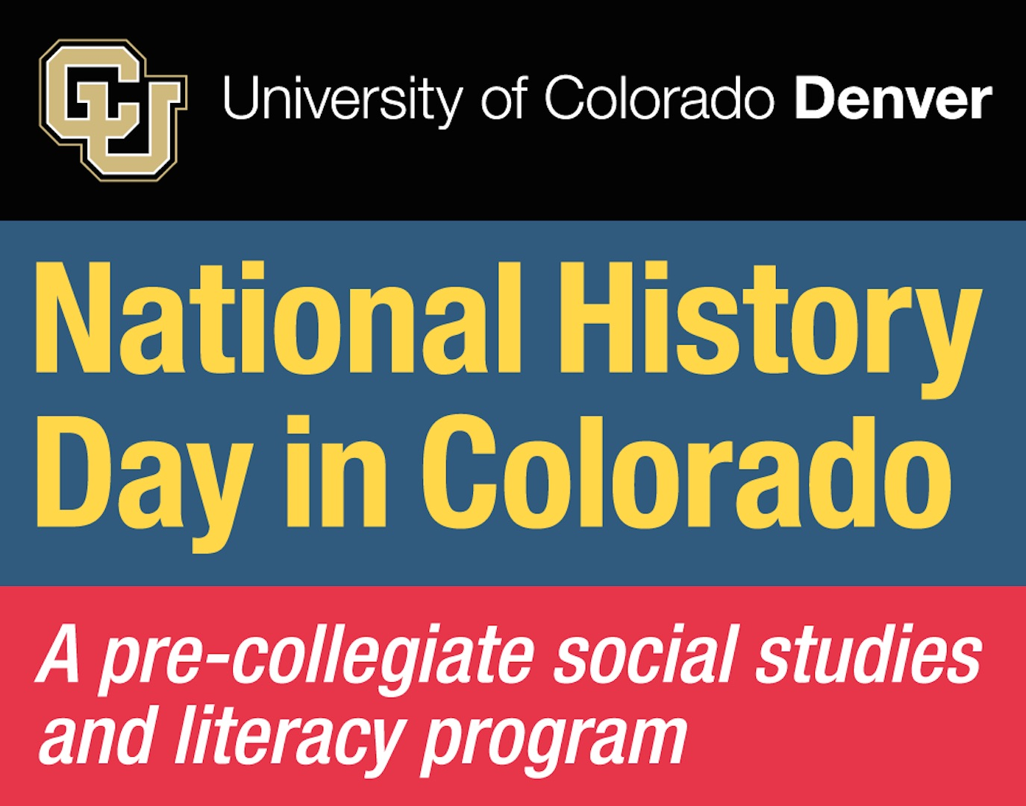

**Bob Sakata** (1926-): Sakata**,** a Japanese American, **broke barriers** by establishing himself as one of the nation’s most respected produce farmers, after spending WWII in an internment camp in Utah.

**Temple Grandin (1947-)**: Grandin **broke barriers** as a pioneer in the study of animal behavior. She was also one of the first people to share her insights as an individual on the autism spectrum.

TG



TG

To learn more about**Breaking Barriers in History***,*

visit *nationalhistorydayincolorado.org* and *nhd.org.*

Scan the QR codes on the back for more info on these History Heroes.

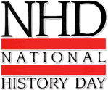

**It’s a plane…**

**It’s the**

***History Heroes!***

FB

**It’s a bird…**

**Minnie Reynolds Scalabrino (1865-1936):** Scalabrino **broke barriers** as a female journalist and devoted her life to the fight for suffrage.

**Pam Grier (1949-):** Born and educated in Colorado, Grier **broke barriers** by becoming one of the first African American women to star in an action film.

BS

OW