Registrations/Coupon Visual Guide

1. 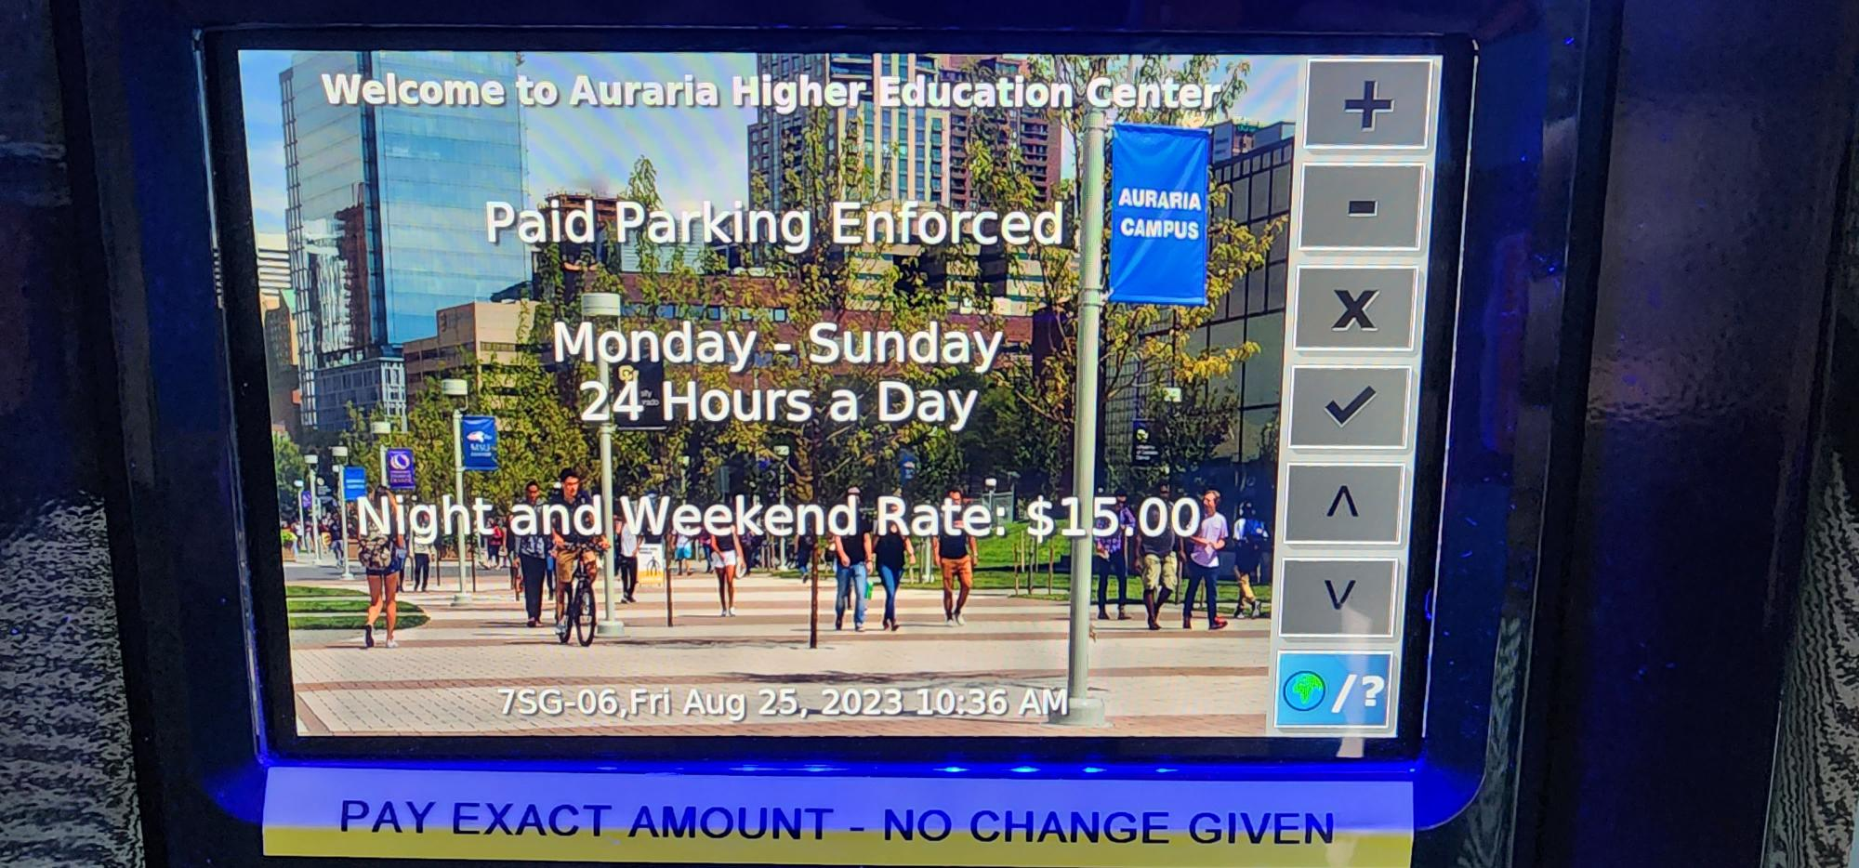Activate the machine by pressing any button, once activated the machine will show the current rate of campus payment, press the green check button or check button on screen to move on
2. 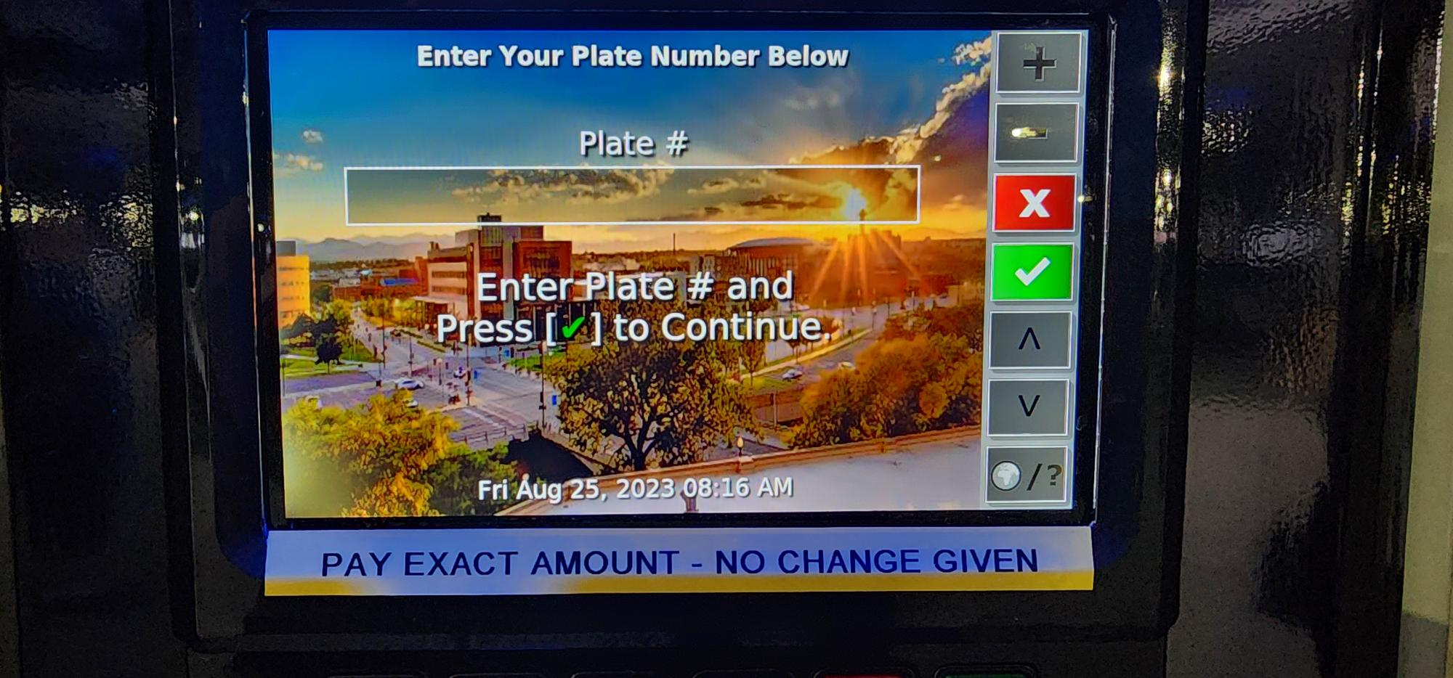Enter the license number in the field and press the green check button or check button on screen to move on
3. The screen will display the rate structure again for the lot the customer is parking in, press the 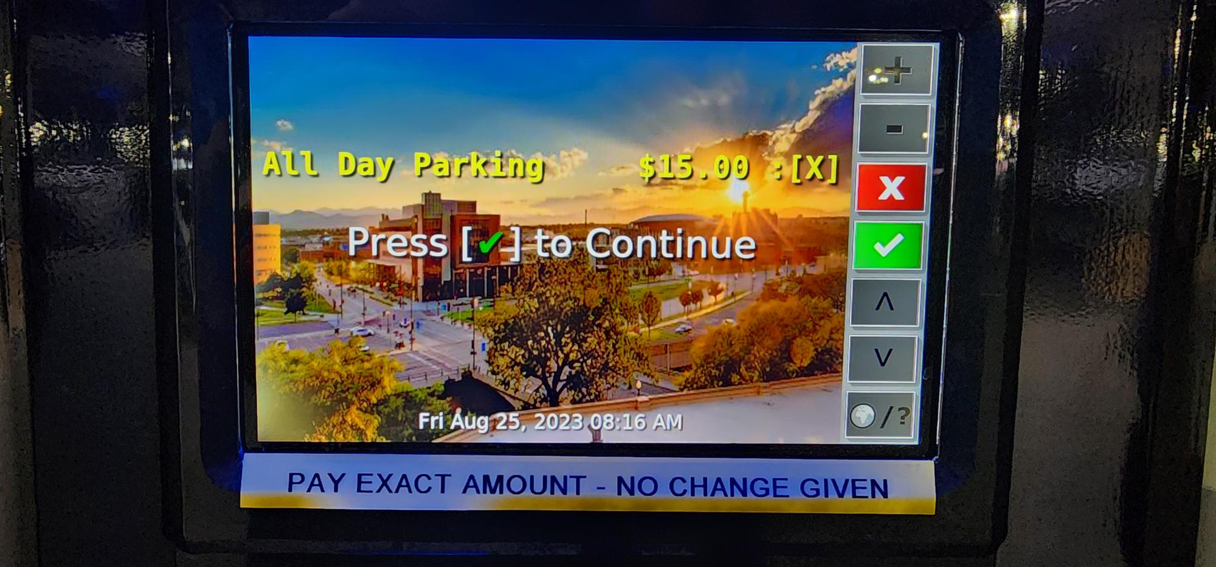green check button or check button on screen to move on
4. 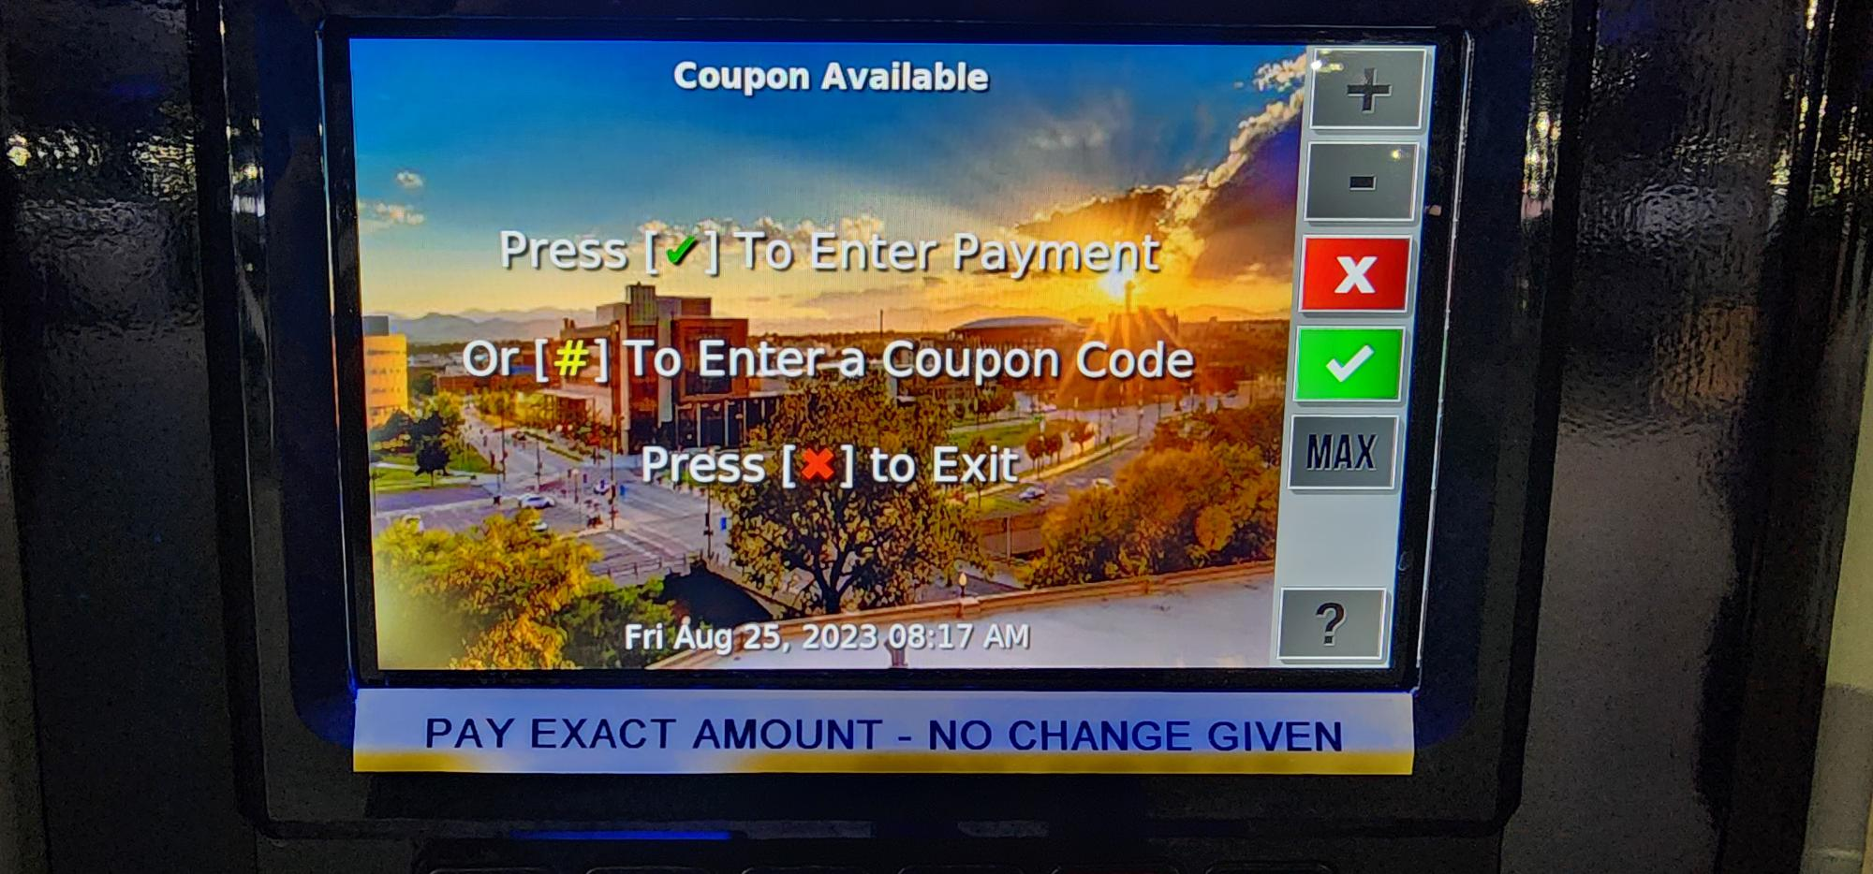The screen will ask if the customer wants to verify payment of the rate or if there is a coupon that needs to be utilized; for registered vehicles or if using a coupon code, press the (#) button
5. 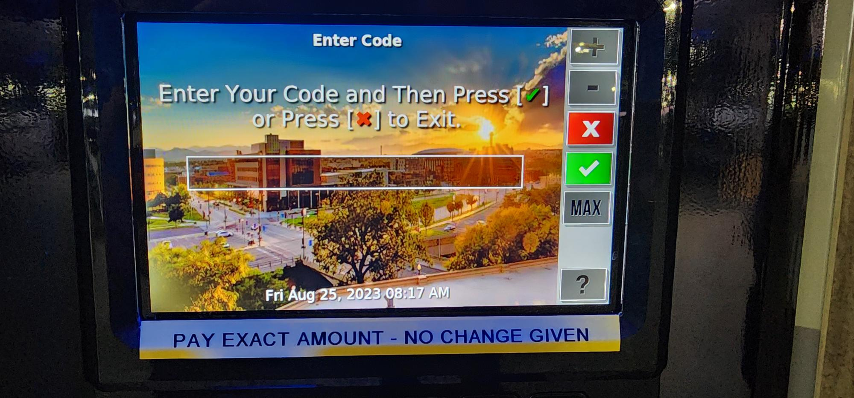For registered vehicles enter the same license plate number in the field and press the green check button or check button on screen to move on; for coupon code use, enter the coupon code and press the green check button or check button on screen to move on.
6. 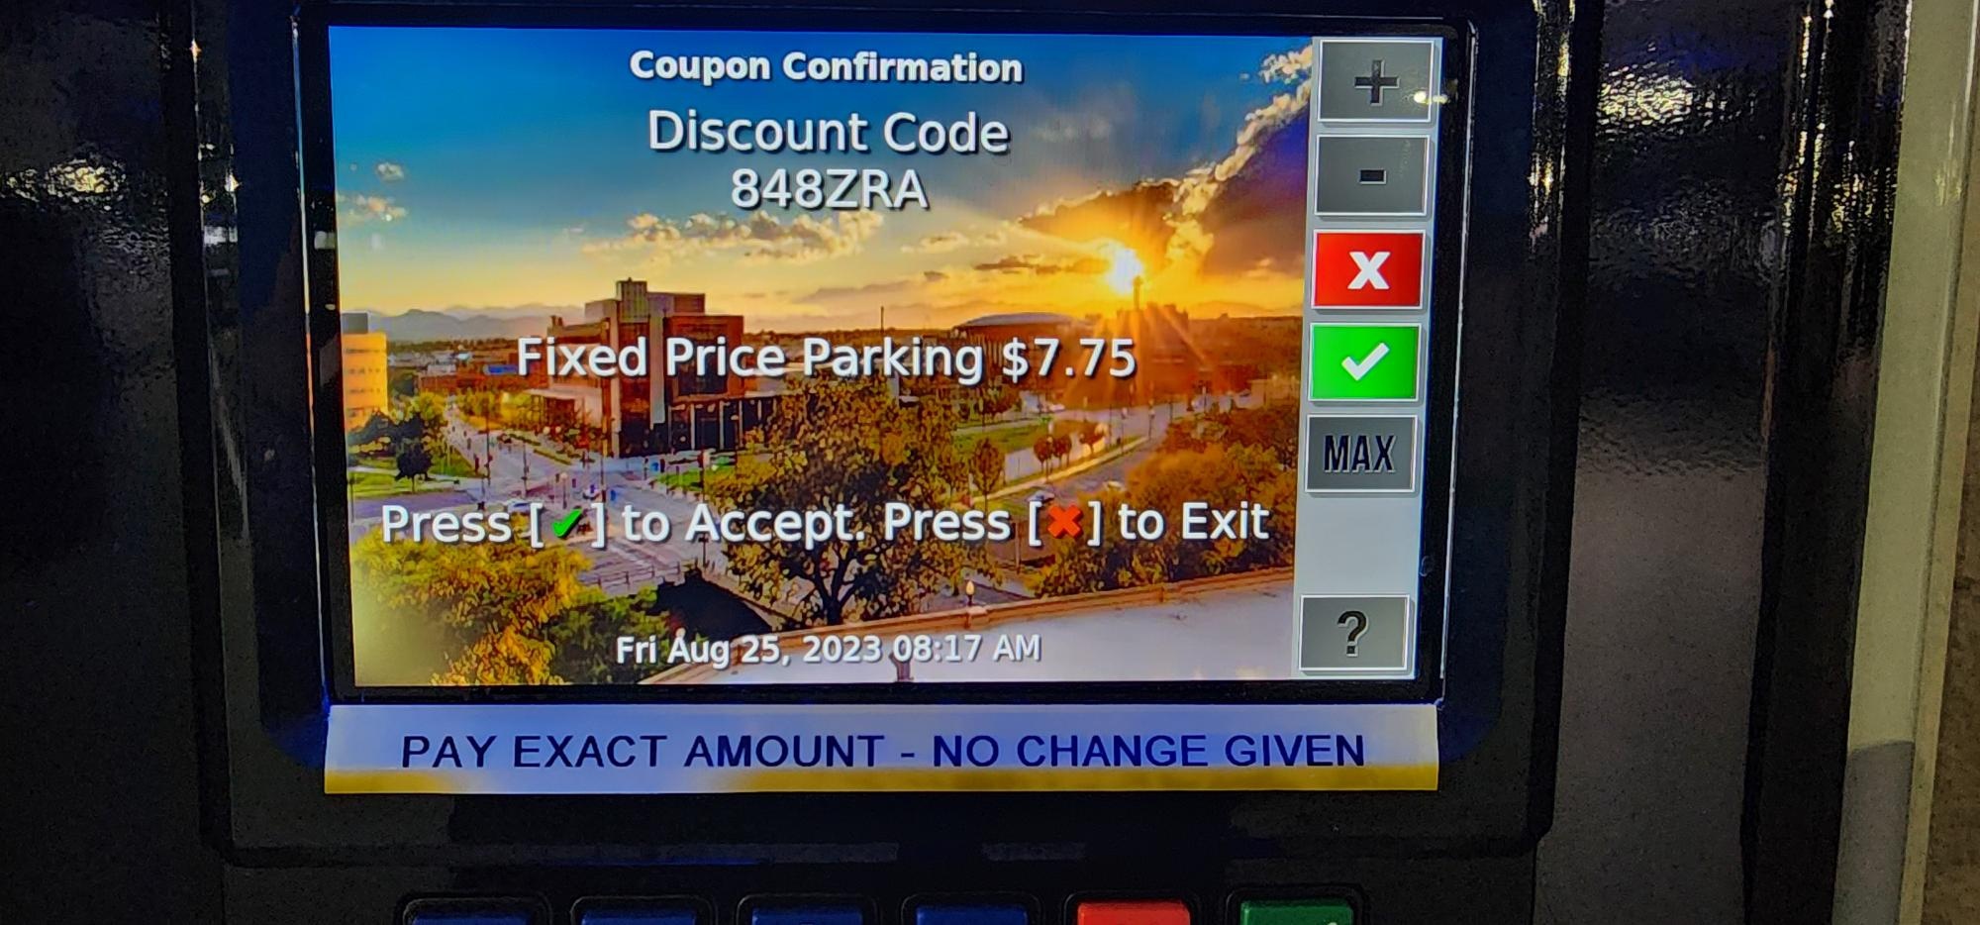If a coupon code has been entered, the screen will display the total discount rules for the coupon code (i.e. 100% Discount, for free codes); for registered vehicles the fixed price of the lot the customer parks in and the license plate as the code will be displayed, press the green check button or check button on screen to move on to the normal payment process.

**TEST123**