Don’t Miss the Next Installment of High-Elevation Five-Needle White Pines: Science and Management Webinar Series
Held the 3rd Tuesday of each month from 12-1 PM MST
On September 20th, Jeremy Johnson will present: Forest Health: Blending Genetics and Phenomics to Combat a Non-native Disease in a Changing Climate
Register for the webinar series at: https://whitebarkfound.org/webinar-series/ (you only need to register once). Or, click on the flyer below!
Did you miss the first webinar? You can watch the recording on the WPEF YouTube site here:
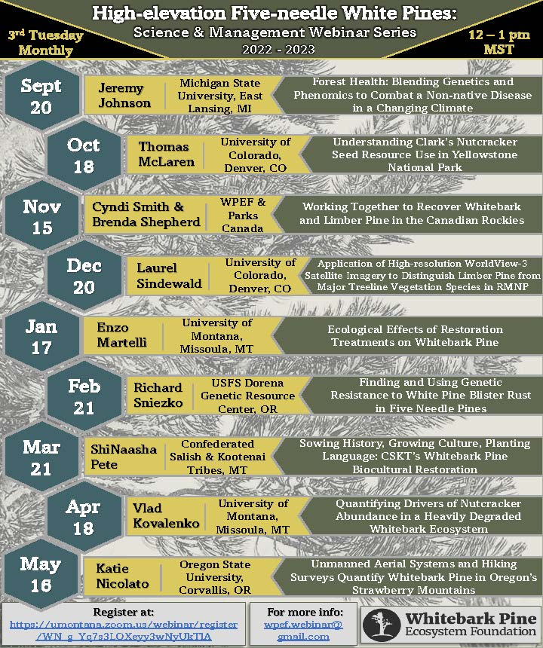
WPEF Webinar Series Recordings

