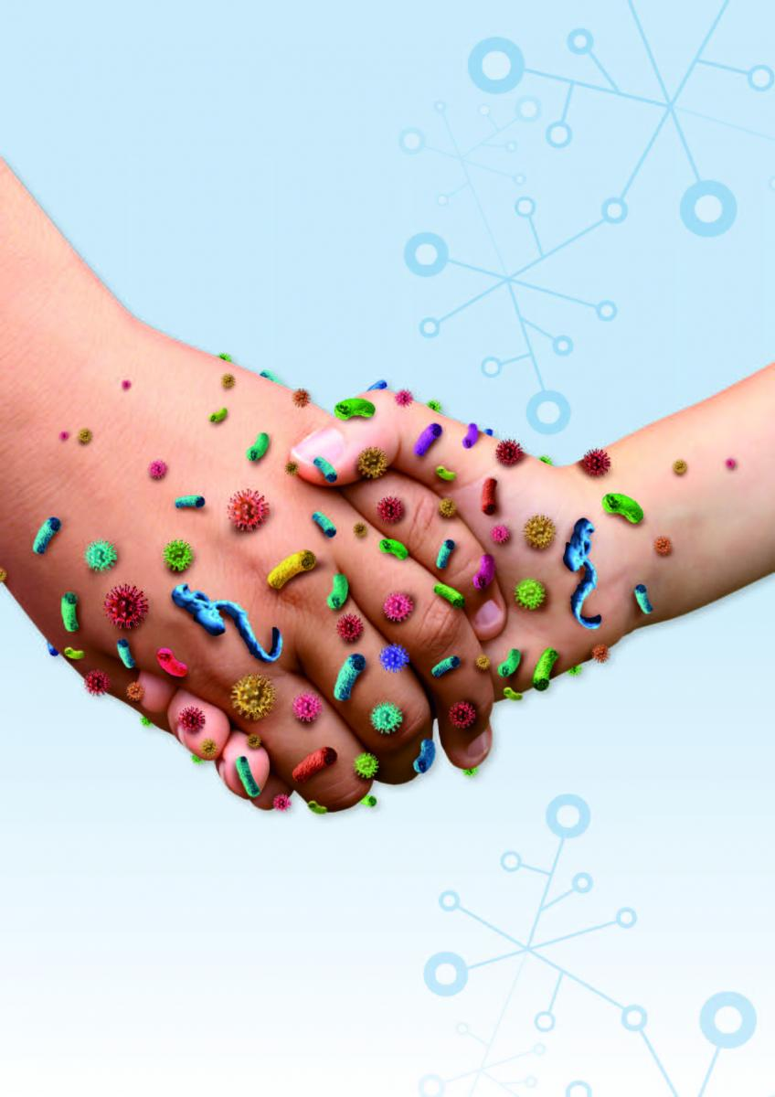
Diffusion:
How Diseases, Ideas & Other Things Spread
PBHL 3999-E01
Instructor: jimi adams
Spring 2023 (online)

Description:
How do infectious diseases spread through a population? How do novel ideas become popular, or fade away? How do we learn the behaviors we engage in? This class will investigate the various ways that these types of things spread through a population. We’ll explore the similarities and differences between things like infectious diseases, ideas, and behaviors in how science has studied & understands each.
Questions – jimi.adams@ucdenver.edu

