System communications and Email accessibility

In today’s digital age, email is one of the most common methods of communicating information to a wide range of readers. However, communications that lack accessibility prevent readers from accessing and reading essential content. Creating accessible emails not only provides access to readers with disabilities, it also improves the overall readability for all readers.

Text Readability
- Text should be clear and easy to read.
- Font size of 12 points or larger.
- San-serif fonts are more suited to electronic formats (Arial, Calibri, Verdana or Franklin Gothic Book).
- Avoid difficult fonts, fancy script, or decorative fonts with curly edges.
- Ensure there is enough contrast between the foreground color and background color.
- Provide adequate “white space” surrounding the text.

Avoid Sending Image Only Emails
Two major drawbacks:
- Text on image will not be accessible to readers who have visual impairments or rely on screen readers or braille writers.
- Images will likely be blocked by readers and the email client, especially when plain text format is used.

Best practices:
Provide a text-based equivalent to the information contained in the image. Type all the relevant information in a text format, then add the image that includes Alt Text.

Color Contrast

Ensure there is adequate color contrast between the text color and background color. The high contrast makes text easier to read for everyone. Some individuals with color blindness or low vision may struggle to detect the presence of text at all if contrast is low. Consult a color checker tool (WebAim has a handy color contrast checker) to determine the color contrast.
Avoid positioning text over images.
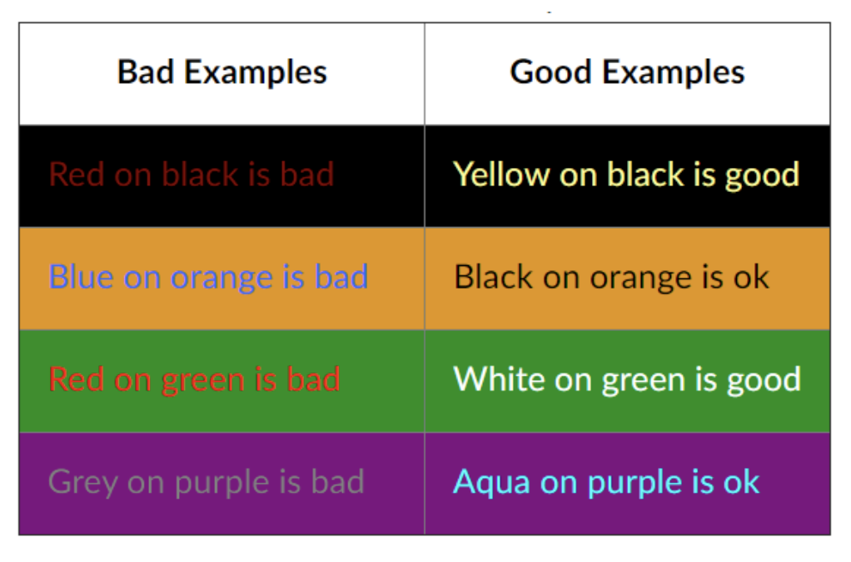

Headings

- Provide structure and make email more accessible.
- Make it easier to modify existing formatting.
- Accessible to assistive technologies such as screen readers.
- Heading Styles (Heading 1 through Heading 6) in order, in logical sequence. Do not skip heading levels, i.e. Heading 2 then Heading 4.
  - Heading 1: Document Title (one time only)
  - Heading 2: Major subsection titles
  - Heading 3: Further subsection titles, and so forth
  - Normal: Text or paragraph

Dashes and Hyphens

Screen readers do not know what the – symbol represents (minus, hyphen, en dash or em dash) so screen readers will not read it. It is always a good practice to spell the word and spell out any abbreviations or make a reference to your abbreviation when used for the first time.
For example:
- May 8th, 2022 from 3:30 - 5:00pm. The screen reader reads three, thirty five. Recommend May 8th, 2022 from 3:30 to 5:00pm.
- Final exams May 14 - 20, 2022, screen reader reads May 1420, 2022. Recommend May 14 to 20, 2022.
- Homework assignment pages 200 – 281 for tonight’s reading material. Recommend pages 200 to 281.
- Grading scale 95 - 100%, screen reader reads 95100%. Recommend 95 to 100%.

Link Text

Avoid pasting in a full URL unless you intend for readers to memorize the URL. Instead, embed your link on text that describes the link destination. Make sure the link text is descriptive and unique; avoid link text like “read more” or “click here”.

Bad example: https://www.ucdenver.edu/offices/office-of-information-technology/accessibility
Good example: OIT’s accessibility website

Images and Alt Text

Provide an alternative text description for any image content in your email. The alt text description will not appear on the page but will be available to users who require a screen reader to access information. The method for adding alt text will be different for each email client. However, the principles are the same: provide a description (no longer than necessary) that identifies the meaningful parts of the image. Meaning is often context dependent. If there is text in the image, transcribe it exactly. When authoring a description:

- Consider context. An image may already be partially or completely described by the surrounding text (captions are a good example). If so, avoid redundancy.
- Be accurate. Determine the meaning or purpose of the image and write the description accordingly,
- Be concise. Aim for 100 characters or less.
- Do not include “image of…” or “graphic of…” in your description.
- Decorative graphics do not require a description. Use the spacebar to enter an empty description instead.
- Complex images such as charts, graphs or infographics require longer descriptions. Long descriptions should be linked separately rather than included as alt text.
- Caption images when appropriate or you think added information may be useful to the audience.. Provide a text description visible on the page. If using this method the caption can be inserted within the content of the email or below the image.

Avoid using animated images with rapidly-flashing content, which can trigger seizures in certain individuals.

Avoid using images with low resolution or insufficient contrast.

Avoid visually complex images.

To add alt text within Microsoft Office 365:
- Right-click on the image, select Edit Alt Text.
- Add a detailed description of the image, and why the image is important to your message.

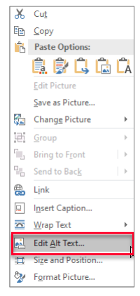

Attachments

When adding attachments to an email, the files attached must also be accessible. Always review files beforehand to ensure they meet accessibility requirements.
- The name of an attached file needs to be clear and directly related to the content of the file. Generic file names can be misleading to readers and reduce the credibility of the material being provided. Properly named attachments provide readers a greater sense of security and will increase the likelihood that a reader will open the attached file.
- When attaching a video ensure that a transcript or captions are provided.
- When linking to a video within an email provide attachments for transcripts and captions, if they are not included withing the video platform.

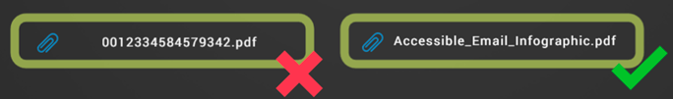

Accessibility Checker

Within the Office 365 Outlook Client, go to the “review” tab and then select “check accessibility.”
