ALUMNI

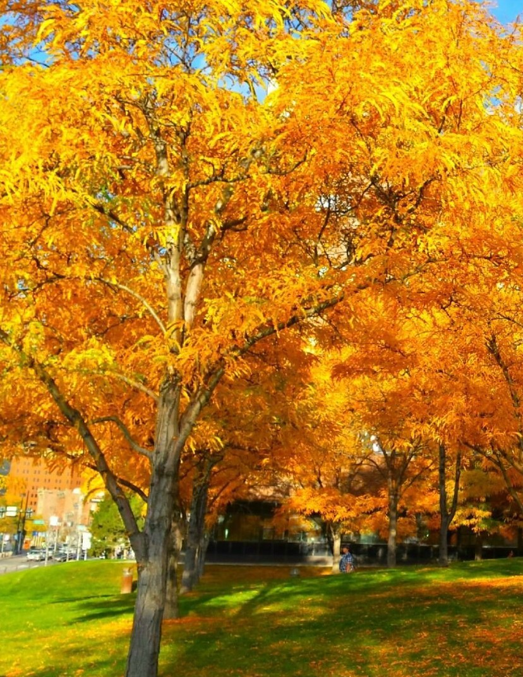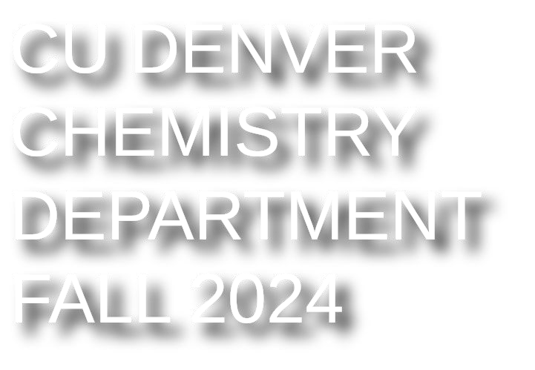

NEWSLETTER

## **A Word from the Chair**

## Dr. Hai Lin, Professor of Chemistry

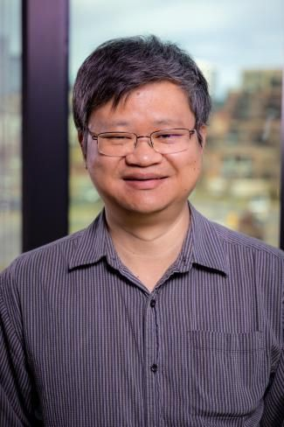After being a faculty member in the Chemistry Department for ~19 years, I began serving the department as the Chair in spring 2024. I am grateful to the support and trust from my colleagues, and I look forward to working with them closely to move the department forward.

The department has undergone significant changes over the last two decades. Many devoted colleagues (Drs. Bob Damrauer, Doug Dyckes, John Lanning, Larry Anderson, Mark Anderson, Margaret Bruehl, and Vannesa Fishback) retired. Meanwhile, many enthusiastic new faces have appeared. Under the leadership of former chairs (Drs. Doug Dyckes, Mark Anderson, Haobin Wang, and Scott Reed), the department has grown substantially in almost every aspect. For example, the number of tenure/tenure-track faculty members has been nearly doubled (from 7 to 13). We launched a biochemistry undergraduate degree in 2018 and saw the number of biochemistry majors increase rapidly from zero to ~200 in just a few years. A lot more students now participate in research, and the number of peer-reviewed publications per year has climbed from less than 5 to about 20. Two decades ago, receiving a major external grant from a federal funding agency (such as NSF and NIH) was uncommon, while today, almost every faculty member has one or more such grants to support his/her research program.

The department continues to excel because it has a team of outstanding faculty and staff. Many current faculty members are recipients of prestigious national honors and recognitions, including NSF Career Awards (Drs. Haobin Wang and Hai Lin), Dreyfus Scholars (Drs. Hai Lin, Jeff Knight, and Marino Resendiz), Cottrell Scholars (Drs. Hai Lin and Liliya Vugmeyster), and Fulbright Scholar (Dr. Jeff Knight). Dr. Doris Kimbrough holds the departmental record for the largest total amount of external grants ($18.5 million), while Dr. Haobin Wang has the highest number of citations (>11,000 as April 2024, according to Google Scholar). I am proud of what has been achieved by all our faculty and staff members, who work diligently and tirelessly to provide the best educational experience for our students.

Since the publication of the last Alumni Newsletter in fall 2021, a lot has happened in the department. In this issue of newsletter, we have listed the college/university awards, national recognitions, external grants, and publications received/published by or our faculty and students over the last two academic years. Please see the following pages for details.

We also have exciting updates from our alumni (broadly defined), who are doing excellent work after graduation. For instance, our former MS student and TA, Agnieszka Kendrick (MS Chemistry 2010), became an Assistant Professor at the Salk Institute for Biology Studies. She uses advanced imaging tools like cryogenic electron microscopy (cryo-EM) combined with single-molecule and live-cell imaging methods to investigate how molecular motors transport cargo needed for proper cellular function. Our former student, Brenda Moll (BS Chemistry 2018), has been promoted to System Engineer Staff in Lockheed Martin and works as Technical Assistant to VP Chief Engineer of LM Space Engineering and Technology. Last fall, Assistant Professor Mia Smith from the Anschutz Medical campus, who was a long-time TA for the department and did post-bac research in Dr. Hai Lin’s group, came back to visit the department. She gave a seminar “From Acids/Bases to Autoimmunity via Animals,” where she talked about her career journey “from Chemistry TA to Professor of Immunology.” (We are eager to learn about how our alumni are doing; please share with us your news!)

The Chemistry Department will continue and further advance its mission in the future. A team of general and organic chemistry faculty (Drs. Doris Kimbrough, Priscilla Burrow, Marta Maron, and Damian Dunford) are actively exploring ways to restructure and reform the curricula for the lectures and labs. One of these reforms is to pilot new “Senior TA” positions, which should improve the lab teaching and learning for these large-enrollment lab courses. Furthermore, a new graduate certificate, “Data Science and Chemistry,” has just been approved by the university’s Graduate Council and is now available to our students starting fall 2024. (Thanks to the hard work of Drs. Woonghee Lee and Jeff Knight!) Situated at the interface between chemistry and modern computational algorithms and applications in data science, this certificate will equip students and professionals with the skills to extract insights from chemical data, develop models, and solve complex problems, making them highly valuable in areas like drug discovery, materials science, and environmental chemistry. I envision that, with the faculty, staff, students, and alumni working closely together, we will move the department to a higher level in the future!

Thank you for reading and for your continued support to the department!

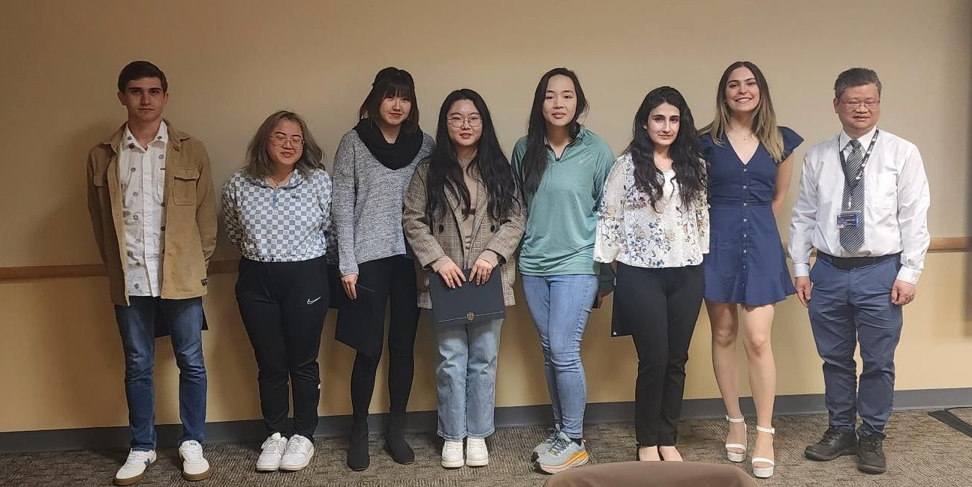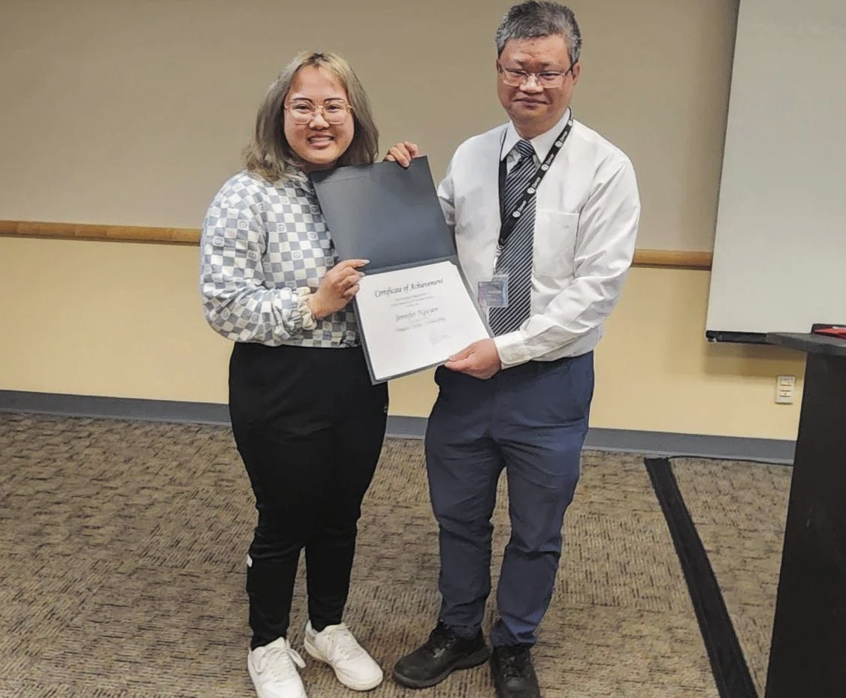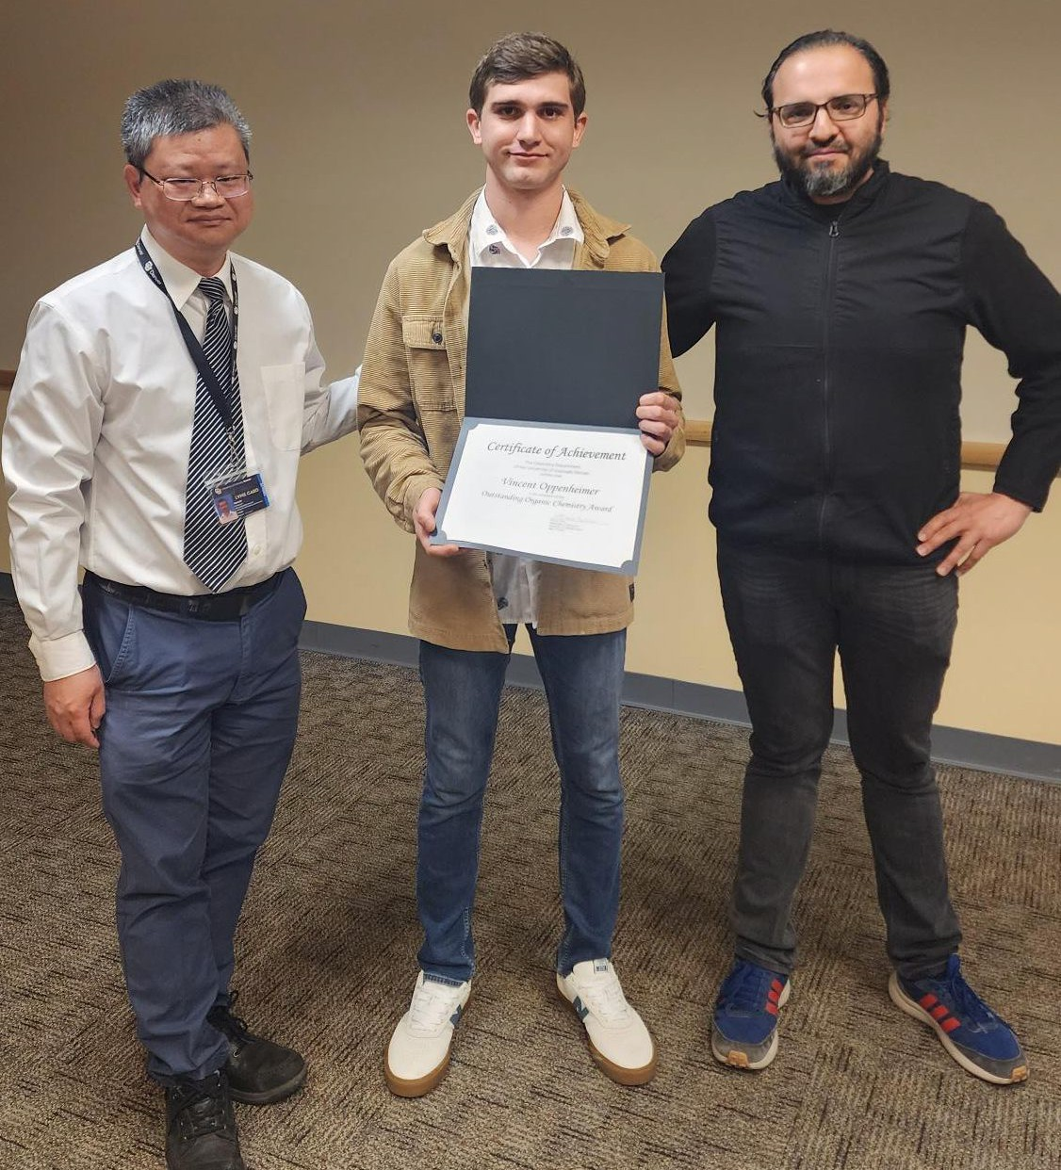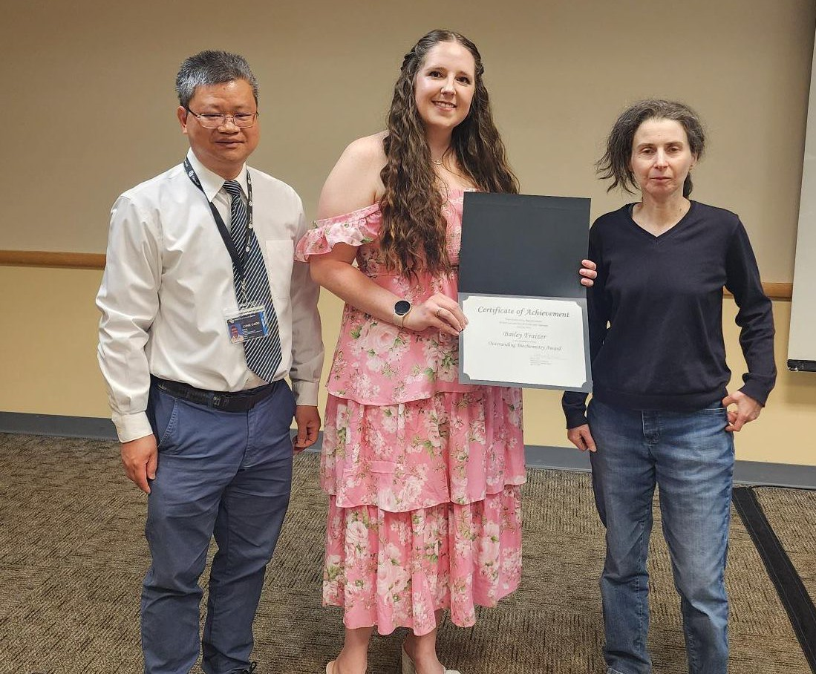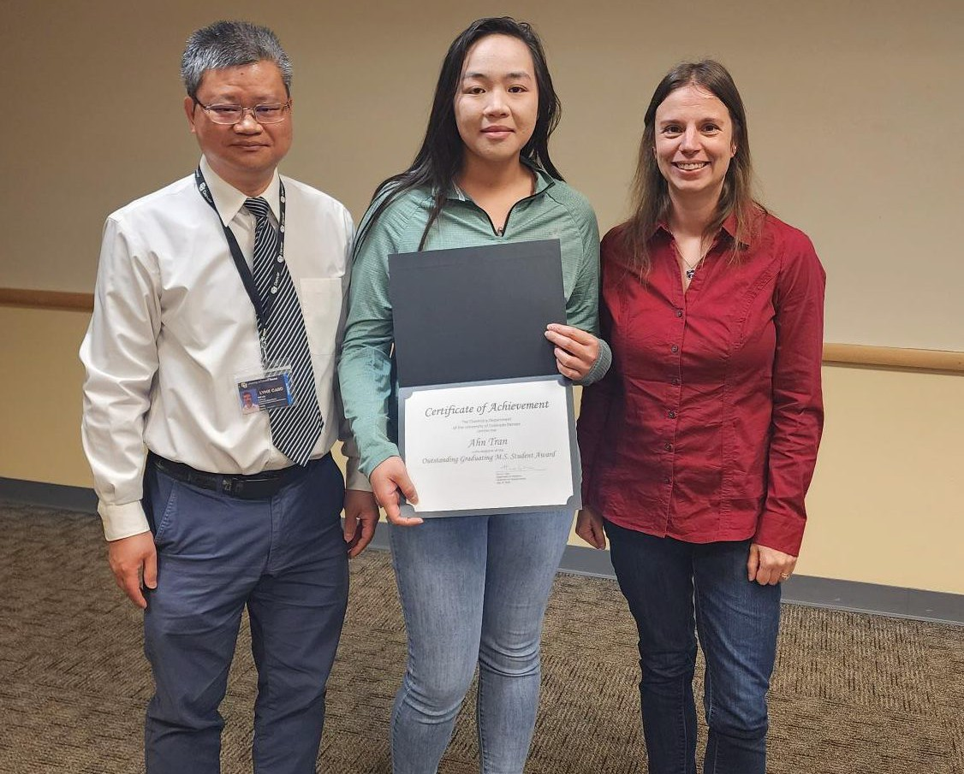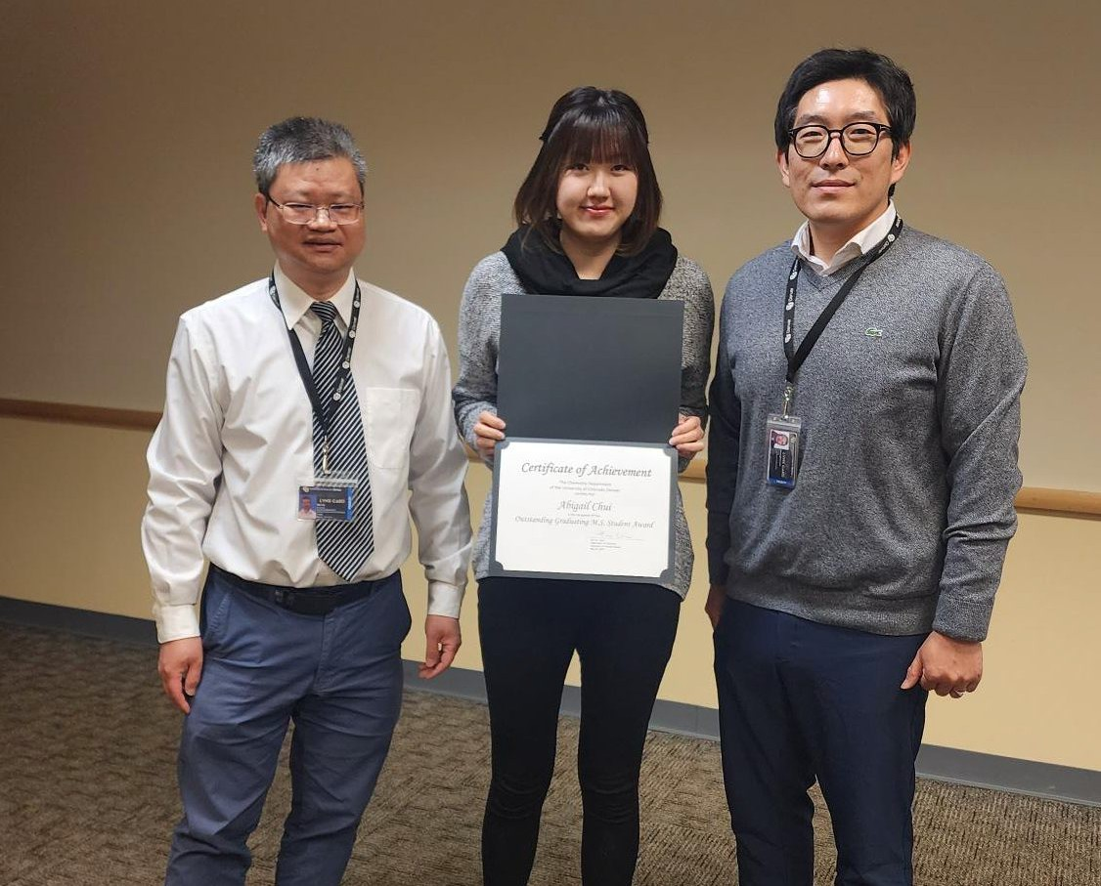

**Fall 2023 and Spring 2024 Graduating Students**

Jun-ik Ahn, Tariq Al-Jarah, Sakthi Asokan, Michael Patrick Bigham, Abigail Alyssa Chiu, Angela Chung, Konstandina Demitra Demos, Qingxuan Fei, Emily Nalin Grimes, Kirsten Marie Gwin, Courtney Leigh Helton, Dominick P Khong, Jumaquio Malicay, Mamoona W Malik, Drake Zane Mann, Stella Annick Martin, Ariel Eileen Matthews, Bradford Scott McKillip, Jennifer Le Nguyen, Daniel Vincent Conrad Oppenheimer, Dianasty Marie Palomino, Natalie Jean Schultz, Upasana Shrestha, Nydia Aleyna Stanfield, Anh Lan Tran, Mikayla White, Eric Scott Wooten, Luke Yarbrough

**Student Awards (Spring 2022 – Spring 2024)**

* + **Vincent C. Oppenheimer**, ACS Undergraduate in Analytical Chemistry, 2024
  + **Selia Abnoossi**, ACS Undergraduate in Inorganic Chemistry, 2024
  + **Vincent C. Oppenheimer**, ACS Undergraduate in Organic Chemistry, 2024
  + **Vincent C. Oppenheimer**, ACS Undergraduate in Physical Chemistry, 2024
  + **Qingxuan Fei**, Robert Damrauer Scholarship, 2024
  + **Jennifer Nguyen**, Douglas Dyckes Scholarship, 2024
  + **Julia Roma** and **Hai Pham,** Michael Milash Teaching Award, 2024
  + **Cassidy Calderon**, Outstanding General Chemistry Award, 2024
  + **Julianne Bannoura**, Outstanding Honors General Chemistry Award, 2024
  + **Vincent C. Oppenheimer**, Outstanding Organic Chemistry Award, 2024
  + **Selia Abnoossi**, Outstanding Inorganic Chemistry Award, 2024
  + **Vincent C. Oppenheimer**, Outstanding Analytical Chemistry Award, 2024
  + **Bailey Frazier**, Outstanding Biochemistry Award, 2024

**Student Awards (Spring 2022 – Spring 2024, cont.)**

* + **Vincent C. Oppenheimer**, Outstanding Graduating Chemistry B.S. Student, 2024
  + **Abigail Chiu** and **Anh Tran**, Outstanding Graduating Chemistry M.S. Student, 2024
    - **Abigail A. Chiu**, NSF Graduate Fellowship Honorable Mention, 2024
    - **Abigail A. Chiu**, CU-Denver Graduate Education Distinguished Master’s Thesis Award, 2024
    - **Abigail A. Chiu**, CLAS Outstanding MS Graduate, 2024
    - **Ariel E. Matthews**, Travel Award, Biophysical Society, 2024
    - **Jennifer Nguyen**, Travel Award, Rocky Mountain Advanced Computing Consortium symposium, 2024
  + **Nala Fakhro**, ACS Undergraduate in Analytical Chemistry, 2023
  + **Dominick Khong**, ACS Undergraduate in Inorganic Chemistry, 2023
  + **Haydee Ramirez**, ACS Undergraduate in Organic Chemistry, 2023
  + **Breanna Ahren**, ACS Undergraduate in Physical Chemistry, 2023
  + **Hai Pham,** Michael Milash Teaching Award, 2023
  + **Faith Montemayor**, Outstanding General Chemistry Award, 2023
  + **Haydee Ramirez**, Outstanding Organic Chemistry Award, 2023
  + **Dominick Khong**, Outstanding Inorganic Chemistry Award, 2023
  + **Nala Fakhro**, Outstanding Analytical Chemistry Award, 2023
  + **Vincent C. Oppenheimer**, Outstanding Biochemistry Award, 2023
  + **Kristina Jessen**, Outstanding Graduating Chemistry B.S. Student, 2023
  + **Emily Irlbeck**, Outstanding Graduating Chemistry B.S. Student, 2023
  + **Steven Ingersoll**, Outstanding Graduating Chemistry M.S. Student, 2023
    - **Steven Ingersoll**, CLAS Outstanding MS Graduate, 2023
    - **Faith Montemayor**, Travel Award, Society for the Advancement of Chicanos/Hispanics and Native Americans in Science, 2023
  + **Kalkidan Astatike**, **Emily Grimes**, and **Jennifer Nguyen**, Dreyfus Undergraduate Student Research Award, 2023
  + **Abigail A. Chiu**, Robert Damrauer Scholarship, 2022
  + **Jill Hoffman**, Douglas Dyckes Scholarship, 2022
  + **Aryana Rodgers**, Marti Barrett Scholarship, 2022
  + **Kristina Jessen**, **Alexander Plonski**, **Hoda Sherif**, and **Selina Vong**, Michael Milash Teaching Award, 2022
  + **Santiago Lanchipa Mejiayor** and **Aries Indenbaum**, Outstanding General Chemistry Award, 2022
  + **Kylie Ryan**, Outstanding Organic Chemistry Award, 2022
  + **Alexander Plonski**, Outstanding Inorganic Chemistry Award, 2022
  + **Cathy Tran**, Outstanding Analytical Chemistry Award, 2022
  + **Ana Carmona Castro**, Outstanding Biochemistry Award, 2022
  + **Shawn Schowe**, Outstanding Graduating Chemistry B.S. Student, 2022
  + **Nicholas Rotello Kuri**, Outstanding Graduating Chemistry B.S. Student, 2022
  + **Kyle Brown**, Outstanding Graduating Chemistry M.S. Student, 2022
    - **Cisloynny C. Beauchamp-Perez**, Scholastic Research Achievement Award, Biophysical Society, 2022
    - **Cisloynny C. Beauchamp-Perez**, Travel Award, Biophysical Society, 2022

**Faculty Awards (Spring 2022-2024)**

* **Woonghee Lee**, CU-Denver Early Career Award for Excellence in Research, 2024
* **Marino Resendiz**, CLAS Award for Overall Record of Excellence in Enhancing Diversity and Inclusion, 2024
* **Jung-Jae Lee**, CLAS Award for Excellence in Teaching by T/TT Faculty, 2024
* **Marta Maron**, CLAS Award for Excellence in Leadership & Service by IRC Faculty, 2024
* **Priscilla Burrow**, CLAS Award for Excellence in Teaching by IRC Faculty, 2024
* **Jefferson Knight**, CU-Denver Undergraduate Research Mentor of the Year, 2023
* **Emilie Guidez**, CLAS Award for Excellence in Teaching by T/TT faculty, 2023
* **Kyoung Nan Kim**, CLAS Excellence in Teaching Award for IRC Faculty, 2022
* **Jefferson Knight**, CLAS Award for Excellence in Teaching by T/TT faculty, 2022

**Dr. Omar M. Yaghi presented the 2024 Kohn-Damrauer Lecture**

The 2024 Kohn-Damrauer Endowed Chemistry Lectureship was delivered by Dr. **Omar M. Yaghi**, the James and Neeltje Tretter Chair Professor of Chemistry at the University of California, Berkeley. Dr. Yaghi, a pioneer in the field of reticular chemistry — a new branch of chemistry focused on constructing open frameworks by stitching molecular building blocks together with strong bonds — gave both a public lecture and a departmental seminar. These lectures inspired students to consider how chemistry can address society's most pressing issues.

Dr. Yaghi also participated in the students' poster session, engaging in discussions about their research and providing valuable insights. This interaction offered students ample opportunities to benefit from Dr. Yaghi's expertise.

Prof. Omar M. Yaghi was selected by a student committee consisting of **Kalkidan Astatike**, **Axel Espinoza**, **Ariel Matthews** (Chair), **Vincent Conrad Oppenheimer**, **David Soto**, and **Anh Tran**, under the guidance of faculty member Dr. **Xiaojun Ren** (Associate Professor of Chemistry).

Photo left to right: Dr. Hai Lin, Dr. Marino Resendiz, Kalkidan Astatike, Vincent Conrad Oppenheimer, Karen Pham, Dr. Omar Yaghi, Qingxuan Fei, David Soto, and Dr. Xiaojun Ren

Associate Professor of Chemistry, Dr. **Marino Resendiz** was awarded the 2023 Jean Dreyfus Lectureship for Undergraduate Institutions. Supported by this award, Prof. **Miguel A. Garcia-Garibay** (UCLA Chemistry & Biochemistry) was invited to deliver a Dreyfus lecture (organized by the Resendiz lab) and was hosted by a group of CU Denver students during the Fall of 2023.  Activities associated with this award included a public lecture, a chemistry lecture, and a poster session.  In addition, the funds allowed for awarding four Summer Research Fellowships to **Jennifer Nguyen** (Lin lab), **Ariel Matthews** (Knight lab), **Emily Grimes** (Resendiz lab), and **Kalkidan Astatike** (Ren lab).

**M.S. Student Abigail Chiu was recognized with an NSF GRFP Honorable Mention**

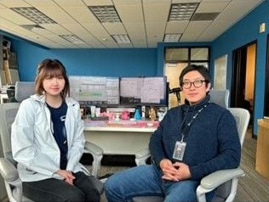

**Abigail Chiu**, a second-year master's student in Chemistry, has earned recognition with an honorable mention from the National Science Foundation's Graduate Research Fellowship Program (NSF GRFP). This prestigious program supports outstanding graduate students pursuing research-based master's and doctoral degrees in STEM fields. Abigail has achieved notable milestones in her academic journey, including successfully defending her master’s thesis and gaining admission to the Ph.D. program in Integrative and Systems Biology. She has thrived under the guidance of Dr. **Woonghee Lee** (Assistant Professor of Chemistry), focusing on developing computational software platforms for traditional herbal medicine and NMR metabolomics.

Photo: Abigail Chiu and Dr. Woonghee Lee in their computational research lab.

Abigail’s dedication to advancing scientific knowledge is evident through her research contributions, which include one co-first author paper, two co-authored papers, and a forthcoming sole first-authored paper. Abigail's excellence has been recognized with awards such as the CU Denver campuswide Graduate Education Distinguished Master’s Thesis Award. As a first-generation Asian American student, Abigail has shown resilience and determination in her academic pursuits. Her passion for diversity, equity, and inclusion is reflected in her outreach efforts and teaching assistantship roles, where she fosters an inclusive learning environment.

**Chemistry faculties and students presented in the 2023 ACS Rocky Mountain Regional Meeting**

A group of 14 students and three faculty members from the Chemistry department (Drs. **Liliya Vugmeyster**, **Marino Resendiz**, and **Woonghee Lee**) attended the 2023 ACS Rocky Mountain Regional Meeting in Laramie, Wyoming. They presented their research progress as posters and oral presentations. Their trips and activities were funded via a Dreyfus Teacher Scholar awarded to the Resendiz lab.



## **Interdisciplinary research published by faculties and students from Chemistry and Integrative Biology departments**

Drs. **Jefferson Knight** (Professor of Chemistry), **Christopher Miller** (Associate Professor of Integrative Biology), and **Hai Lin** (Professor of Chemistry) recently published a collaborative paper in the journal *Protein Science* on research conducted with Professional Research Associate **Nara Chon** (photo shown here, MS Chemistry 2018, first author) and recent graduate **Sherleen Tran** (BS Biology 2020). The paper is titled “*A conserved electrostatic membrane- binding surface in synaptotagmin-like proteins revealed using molecular phylogenetic analysis and homology modeling*.” Their research notably brings together computational and predictive approaches from the disciplines of evolutionary biology, biophysics, and biochemistry in a novel way to demonstrate how a particular family of proteins has evolved to interact with cellular membranes.

Link to paper: <https://doi.org/10.1002/pro.4850>

## **Alchemical Quantum Mechanics is a crazy idea that may actually work – Chemistry student and faculties published a novel computer modeling algorithm**

A collaboration between two chemistry research groups headed by Drs. **Emilie Guidez** (Assistant Professor of Chemistry, specializing in quantum chemistry) and **Hai Lin** (Professor of Chemistry, specializing in multiscale modeling) has led to an article published in the *Journal of Physical Chemistry A*, where student **Anh Tran** (photo shown here, MS Chemistry 2024) is the first author. The paper is titled “*Adaptive-partitioning multilayer dynamics simulations: 2. Implementations of the permuted- and interpolated adaptive-partitioning gradients*." The paper demonstrates an unconventional way to combine different quantum models, which the authors named alchemical quantum mechanics.

“Our idea was deemed crazy.” Dr. Guidez said, “Our first joint proposal to National Science Foundation was rejected, with reviewer’s comment that ‘the idea is too radical!’” “Fortunately, it was funded the second time,” Dr. Lin laughed, “and now we showed that it may actually work just fine!” The advancement in this study paves the road to more efficient algorithms for accurate computer simulations.

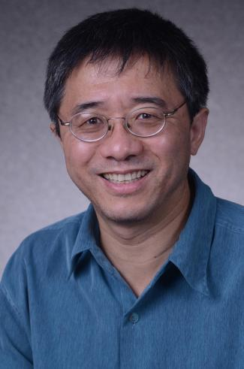

Link to paper: <https://pubs.acs.org/doi/10.1021/acs.jctc.1c00556>

## **Dr. Haobin Wang has been cited >11,500 times!**

According to Google Scholar, as June 2024, Dr. Haobin Wang (Professor of Chemistry) became the first current faculty member of the Chemistry Department who has been cited more than 11,500 times!

**“Charge is critical, but p*K*a matters, too!” – Chemistry student, staff, and faculty published interdisciplinary research**

A computer modeling team including student **Natalie Schultz** (photo shown here, MS Chemistry 2024), professional research assistant **Nara Chon** (MS Chemistry 2018), and Dr. **Hai Lin** (Professor of Chemistry), in collaboration with experimental structural biologist Dr. **Hongjin Zheng,** Associate Professor from the School of Medicine, published a paper in the *Journal of Chemical Information and Modeling* on their research about an ion transport protein called NarK. The paper is titled “*Anion pathways in the NarK nitrate/nitrite exchanger*."

Their research notably shed light on a long-standing puzzle: NarK stops functioning upon a seemingly harmless arginine-to-lysine mutation in the binding site, which perfectly preserves the positive charge needed for recruiting the negatively charged anion. Their modeling suggests that the mutation can trap the anion in the pore, disrupting the transport cycle. The study underscores p*K*a (a measure of how acidic a molecule is) of key residues in fine tuning the function of the protein. “Yes, charge is critical,” said Schultz, “but it is not the whole story, because p*K*a matters, too!” Link to paper: <https://pubs.acs.org/doi/10.1021/acs.jcim.3c00295>

**Dr. Scott Reed received NIH grant to develop cutting-edge chemoinformatic tools for understanding adverse drug reactions**

In fall 2023, Dr. **Scott Reed** (Professor of Chemistry) was awarded an NIH grant to develop cutting-edge chemoinformatic tools aimed at understanding genetic factors behind adverse drug reactions (ADRs). This pharmacogenomics project seeks specifically to illuminate genetic interactions that drugs and their metabolites may have, which could inadvertently cause "off-target" side effects.

The Reed team will analyze datasets on genetic variations and documented ADRs to pinpoint potential genetic causes of these reactions. They plan to establish methods to simulate how drugs interact with various proteins, potentially revealing new sources of side effects. Additionally, they aim to create online tools that not only identify specific ADRs but also visualize drugs, their metabolites and how they interact with different variants of proteins. These innovative tools will allow researchers to quickly test theories on the molecular origins of harmful side effects, fostering the development of safer and more effective medications. This project represents a significant stride towards mitigating drug-induced harm and enhancing pharmaceutical design.

**Dr. Marino Resendiz Received Grants from NIH**

In fall 2023, Dr. **Marino Resendiz** (Associate Professor of Chemistry) was granted a renewal of his R15 grant to pursue projects on the impact of 8-oxo-guanine on the structure of RNA. The NIH also granted a supplement award to purchase instrumentation associated with the same project.   In addition, the Resendiz group was awarded an R03 grant in spring 2024 to characterize and study the 5'-GUAC as an important sequence motif in RNA. Way to go!

**“When Quantum and Classical Mechanics join forces” – Dr. Hai Lin published a book**

Dr. **Hai Lin** (Professor of Chemistry) just published a book “*QM/MM Methods*” in the “ACS in Focus” series by the American Chemical Society (ACS). This book serves as an introductory text for graduate students and scientists who are new in the field of multiscale modeling and simulations.

The book aims to help researchers navigate through a “hybrid world” where quantum mechanics (QM) and classical molecular mechanics (MM) join forces to provide critical insights into chemical, physical, and biological processes in complex environments, such as enzymatic catalysis, ion solvation, and transport proteins. “I want to help readers enter the field with a good starting position,” said Dr. Lin, who is known for his pioneering works in novel QM/MM algorithms that reclassify atoms on-the-fly as quantum or classical, “empowering them to ask the right questions and select the right tools to address these questions.”

Link to book: <https://pubs.acs.org/doi/book/10.1021/acsinfocus.7e7030>

## **Dr. Woonghee Lee received an NSF grant to develop an artificial intelligence (AI)-assisted NMR platform**

In summer 2024, Dr. **Woonghee Lee** (Assistant Professor of Chemistry) received an NSF grant to further develop the state-of-the-art computational tool suite “POKY” to accelerate the automation of data analysis for biomolecular nuclear magnetic resonance (NMR) spectroscopy. Dr. Lee released the POKY software suite in 2021, which has been distributed to more than 10,000 users in more than 100 countries.

NMR spectroscopy is widely used in studying functions through structural conformations, dynamics, and allostery. However, complex data interpretation and the lack of automation have been barriers to the NMR applications.

Photo: Dr. Lee and his group’s students are enjoying ice cream.

With this new grant, Dr. Lee and his POKY team will provide an improved software environment for biomolecular NMR studies by developing and employing an integrated artificial intelligence (AI) platform around the POKY software suite.

## **Dr. Jung-Jae Lee received an NIH grant for cancer research**

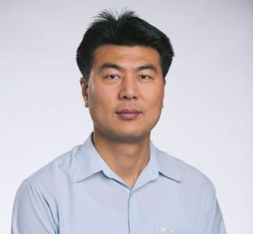

Dr. **Jung-Jae Lee** (Associate Professor of chemistry) was just awarded an NIH R15 grant. This grant will support the Lee group to advance cancer detection and improve surgical precision using innovative glowing nanoprobes inspired by fireflies. These nanoprobes are specifically designed to target head and neck cancers, with the goal of identifying tumors and lymph node metastases; they are more accurate than current imaging methods, which often fail to detect smaller cancers. Early studies in mice have shown promising results, demonstrating the ability to detect tumors at depths exceeding 4 cm with remarkable clarity. This cutting-edge technology will enhance surgical outcomes, reduce complications, and ultimately improve survival rates for cancer patients.

## **Dr. Susan Schelble was named an American Chemical Society Fellow**

Dr. **Susan M. Schelble**, was named one of the 37 new fellows of the American Chemical Society (ACS) at the Fall 2024 ACS National Meeting in Denver on August 19, 2024. Dr. Schelble was recognized as an impactful 31-year professor of organic chemistry and for mentorship of hundreds of chemistry majors in research and ethics at two different Hispanic-serving institutions in Colorado. She was also cited for her work as a vibrant 39-year member of ACS, serving the Colorado section and multiple national committees and divisions, with a legacy of enthusiastically recruiting and mentoring new councilors and officers of the society.

## **New graduate certificate in “Data Science and Chemistry”**

Starting Fall 2024, the Chemistry department is excited to launch the new “Data Science and Chemistry” graduate certificate program.

The ability to analyze and interpret the ever-growing volume of chemical data is a critical skill in high demand. In fact, job postings in this field have skyrocketed by 500% since 2019! This innovative certificate program addresses this need by equipping students and professionals with the tools to extract valuable insights from chemical data, develop predictive chemical models, and tackle complex chemical problems. This expertise will make graduates highly sought-after in areas like drug discovery, materials science, and environmental chemistry.

This certificate program aims to serve graduate students across CU campuses, as well as professionals seeking to upskill. Five different courses, totaling 13 credits, are provided for a broad and cohesive learning experience.

For more information, please visit: <https://clas.ucdenver.edu/chemistry/data-science-and-chemistry-certificate>. Students and professionals interested in this program are encouraged to contact the certificate program director, Dr. **Woonghee Lee**, at [woonghee.lee@ucdenver.edu.](mailto:woonghee.lee@ucdenver.edu)

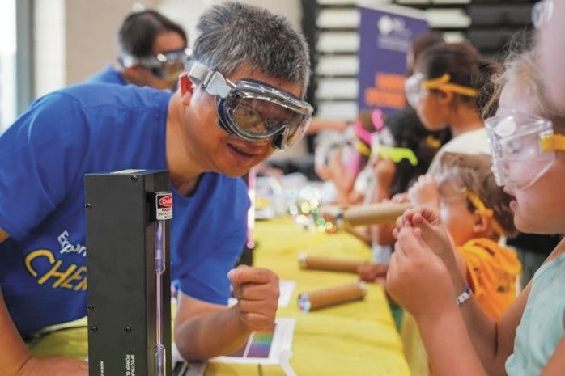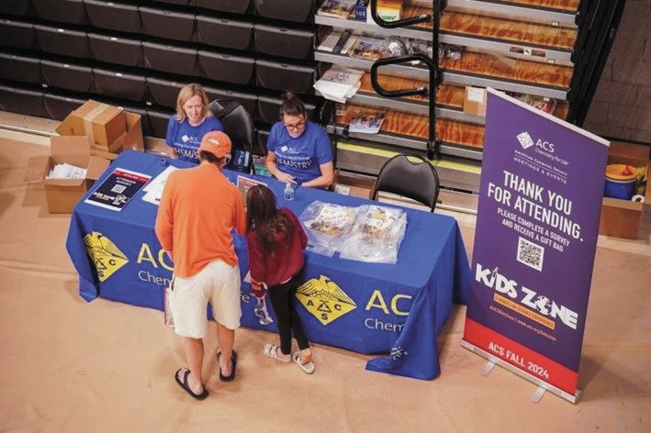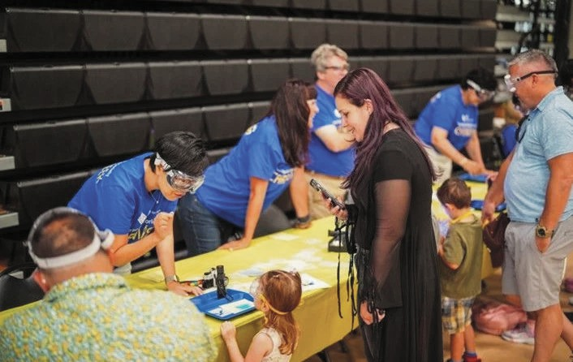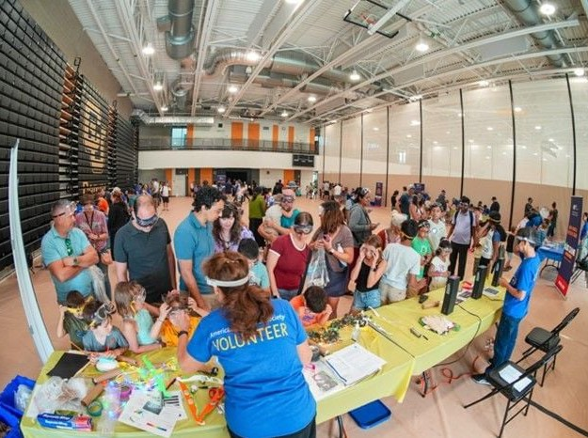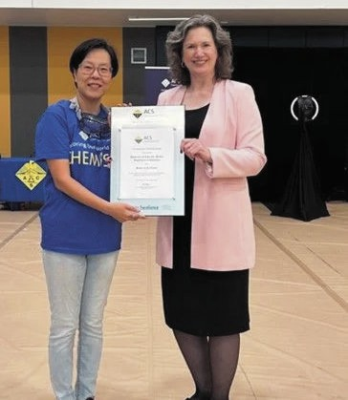

## **Chemistry Department celebrated success at ACS Kids Zone event**

The Chemistry Department recently played a pivotal role in the success of the American Chemical Society (ACS) Kids Zone event that was held on Saturday, 8/17/24 at CU-Denver’s Lola and Rob Salazar Student Wellness Center while the ACS National Meeting was being held at the Colorado Convention Center. This free public event, designed for school aged children and their families, featured interactive, facilitator-supported activities that allowed participants to experiment alongside real chemists. The event attracted approximately 300 participants, making it the second most attended event in the history of ACS Kids Zone. Local chemists, college chemistry students, and volunteer chemists from the ACS Committee on Community Activities worked together to inspire young minds and spark an interest in sciences.

Chemistry faculty members Drs. **Kyoung Kim**, **Marta Maroń**, **Susan Schelble**, and **Hai Lin** assisted in the organization of this event. They and many students and alumni of the chemistry department also volunteered at the event. In recognition of their outstanding support to the success of this event, the Chemistry Department was honored with a "Salute to Excellence" award by the ACS.

# **External Research Grants (Spring 2022 – Spring 2024)**

* **Jung-Jae Lee** (PI); Body heat activated, storable, near-infrared, self-illuminating nanopore for chemiluminescence imaging of cancer; National Institute of Health; 2024-2027
* **Woonghee Lee** (PI); Artificial intelligence-assisted integrative biomolecular NMT platform; National Science Foundation; 2024-2027
* **Marino Resendiz** (PI); Exploring the 5'-GUAC- sequence as an important RNA-motif; National Institute of Health; 2024-2026
* **Scott Reed** (PI); Identifying Genetic Contributions to Adverse Drug Reactions; National Institute of Health; 2023-2026
* **Marino Resendiz** (PI); 8-Oxo-7,8-dihydroguanosine in aptamer development and its impact on RNA structure; National Institute of Health; 2023-2026
* **Hai Lin** (PI); **Emilie Guidez** (co-PI); Adaptive multi-layer simulations of NarK transport protein; National Science Foundation; 2022-2025
* **Jung-Jae Lee** (PI); Body heat activated, storable, near-infrared, self-illuminating nanoprobes for in vivo optical imaging of cancer; Cancer League of Colorado; 2022-2023



# **Peer-Reviewed Publications (Spring 2022 – Spring 2024)**

* **Lin, H.**, “QM/MM Methods,” *ACS in Focus series*, **2024**, eISBN 9780841299504.
* Chon, N.L.; **Lin, H.** “Fluoride ion binding and translocation in the CLCF fluoride/proton antiporter: molecular insights from combined quantum-mechanical/molecular-mechanical modeling,” *Journal of Physical Chemistry B*, **2024**, 128, 2697-2706.
* Yan, S.; Wang, B.; **Lin, H.** “Reshaping the QM region on-the-fly: Adaptive-shape QM/MM dynamic simulations of a hydrated proton in bulk water,” Journal of chemical Theory and Computation, **2024**, 20, 3462-3472.
* Chon, N.L.; Tran, S.; Miller, C.S.; **Lin, H.**; **Knight, J.D.** “A conserved electrostatic membrane-binding surface in synaptotagmin-like proteins revealed using molecular phylogenetic analysis and homology modeling,” *Protein Science*, **2024**, 33, e4850.
* **Vugmeyster, L.**; Ostrovsky, D.; Fu, R. “Carbon-detected deuterium solid-state NMR rotating frame relaxation measurements for protein methyl groups under magic angle spinning,” *Solid State Nuclear Magnetic Resonance*, **2024**, 130, 101922.
* **Vugmeyster, L.**; Ostrovsky, D.; Rodgers, A.; Gwin, K.; Smirnov, S.L.; McKnight, C.J.; Fu, R. “Persistence of methionine side chain mobility at low temperatures in a nine‐residue low complexity peptide, as probed by 2h solid‐state NMR,” *ChemPhysChem*, **2024**, 25, e202300565.
* **Vugmeyster, L.**; Au, D.F.; Frazier, B.; Qiang, W.; Ostrovsky, D. “Rigidifying of the internal dynamics of amyloid-beta fibrils generated in the presence of synaptic plasma vesicles,” *Physical Chemistry Chemical Physics*, **2024**, 26, 5466-5478.
* Wi, S.; Li, C.; Pham, K.; **Lee, W.**; Frydman, L. “Short and long range 2D 15N–15N NMR correlations among peptide groups by novel solid state dipolar mixing schemes,” *Journal of Biomolecular NMR* **2024**, 78, 19–30.
* Rahimi, M.; Chiu, A.; Estefania Lopez Giraldo, A.; Yoon, J.-H.; **Lee, W.** “REDEN: Interactive multi-fitting decomposition-based NMR peak picking assistant,” *Journal of Magnetic Resonance* **2024**, 358, 107600.
* Yan, S.; Wang, B.; **Lin, H.** “Tracking the delocalized proton in concerted proton transfer in bulk water,” *Journal of chemical Theory and Computation*, **2023**, 19, 448-458.
* Tran, A.L.; **Guidez, E.B.**; **Lin, H.** “Adaptive-partitioning multilayer dynamics simulations: 2. implementations of the permuted- and interpolated adaptive-partitioning gradients,” *Journal of Physical Chemistry A*, **2023**, 127, 10320-10333.
* Chon, N.L.; Schultz, N.J.; Zheng, H.; **Lin, H.** “Anion pathways in the NarK nitrate/nitrite exchanger,” *Journal of Chemical Information and Modeling*, **2023**, 63, 5142-5152.
* **Lin, H.**; Zhang, Y.; Pezeshki, S.; Duster, A.W.; Wang, B.; Wu, X.-P.; Zheng, S.-W.; Gagliardi, L.; Truhlar D.G. “QMMM: A program for combined Quantum-mechanical and molecular-mechanical modeling and simulations,” *Computer Physics Communications*, **2023**, 295, 108987.
* Plonski, A.P.; **Reed, S.M.** “Assessing protein homology models with docking reproducibility,” *Journal of Molecular Graphics and Modelling*, **2023**, 121, 108430.
* **Reed, S.M.** “An active learning convolutional neural network for predicting river flow in a human impacted system,” *Frontiers in Water,* **2023**, 5, 1271780.
* Brown, K.; Chew, P. Y.; Ingersoll, S.; Espinosa, J.R.; Aguirre, A.; Espinoza, A.; Wen, J.; Astatike, K.; Kutateladze, T.G.; Collepardo-Guevara, R.; **Ren, X.** “Principles of assembly and regulation of condensates of polycomb repressive complex 1 through phase separation,” *Cell Reports*, **2023**, 42, 113136.
* Cruceta, L.; Sun, Y.; Kenyaga, J.M.; Ostrovsky, D.; Rodgers, A.; **Vugmeyster, L.**; Yao, L.; Qiang, W. “Modulation of aggregation and structural polymorphisms of β-amyloid fibrils in cellular environments by pyroglutamate-3 variant cross-seeding,” *Journal of Biological Chemistry*, **2023**, 299, 105196.
* **Vugmeyster, L.**; Rodgers, A.; Ostrovsky, D.; McKnight, C.J.; Fu, R. “Deuteron off-resonance rotating frame relaxation for the characterization of slow motions in rotating and static solid-state proteins,” *Journal of Magnetic Resonance*, **2023**, 352, 107493.
* Rodgers, A.; Sawaged, M.; Ostrovsky, D.; **Vugmeyster, L.** “Effect of cross-seeding of wild-type amyloid-β1–40 peptides with post-translationally modified fibrils on internal dynamics of the fibrils using deuterium solid-state NMR,” *Journal of Physical Chemistry B*, **2023**, 127, 2887-2899.
* **Vugmeyster, L**.; Nichols, P.J.; Ostrovsky, D.; McKnight, C.J.; Vögeli, B. “Slow methyl axes motions in perdeuterated villin headpiece subdomain probed by cross-correlated NMR relaxation measurements,” *Magnetochemistry*, **2023**, 9, 33.
* **Guidez, E.M**. “Quasi-atomic orbital analysis of halogen bonding interactions,” *Journal of Chemical Physics*, **2023**, 159, 194207.
* Zahariev, F.; Xu, P.; Westheimer, B.M.; Webb, S.; Vallejo, J.G.; Tiwari, A.; Sundriyal, V.; Sosonkina, M.; Shen, J.; Schoendorff, G.; Schlinsog, M.; Sattasathuchana, T.; Ruedenberg, K.; Roskop, L.B.; Rendell, A.P.; Poole, D.; Piecuch, P.; Pham, B.Q.; Mironov, V.; Mato, J.; Leonard, S.; Leang, S.S.; Ivanic, J.; Hayes, J.; Harville, T.; Gururangan, K.; **Guidez, E.**; Gerasimov, I.S.; Friedl, C.; Ferreras, K.N.; Elliott, G.; Datta, D.; Cruz, D.D.A.; Carrington, L.; Bertoni, C.; Barca, G.M.J.; Alkan, M.; Gordon, M.S. “The general atomic and molecular electronic structure system (GAMESS): Novel methods on novel architectures,” *Journal of Chemical Theory and Computation*, **2023**, 19, 7031-7055.
* Giraldo, A. E. L.; Werner, Z.; Rahimi, M.; **Lee, W**. “Breaking boundaries: TINTO in POKY for computer vision-based NMR walking strategies,” *Journal of Biomolecular NMR* **2023**, 77, 217–228.
* Soto, P.; Carter, A.R.; Deligkaris, C.; Gül, D.; Hamadani, K.; **Knight, J.**; Matulis, D.; Ozturk, T.N.; Rivera-Colón, Y.; Yates, E.A. “Perspectives on how 1.5 years of the COVID-19 pandemic have impacted biophysicists at Primarily Undergraduate Institutions.” *The Biophysicist,* **2022**, 3, 75-84.
* Anantharam, A.; **Knight, J.D.** eds.*Exocytosis: From Molecules to Cells.* **2022**,London: Biophysical Society/IOP Press.
* Pham, H.; Hunsley, M.; Yang, C.-H.; Wang, H.; **Reed, S.M**. “Demonstration of a stereospecific photochemical meta effect,” *Photochem*, **2022**, 1, 69-76.
* Phillips, C. N.; Choi, M.; Huynh, K. N.; Wang, H.; **Resendiz, M.J.E.** “Modification at the C2′-O-position with 2-methylbenzothiophene induces unique structural changes and thermal transitions on duplexes of RNA and DNA,” *ACS Omega*, **2022**, 7, 37782-37796.
* Moon, C.L.; Alnaas, A.A.; Cai, Y.; **Reed, S.M.**; Knowles, M.K. “Biochemically prepared C-reactive protein conformational states differentially affect C1q binding,” *BBA Advances*, **2022**, 2, 100058.
* Tan, H.; **Reed, S.M.** “Metabolovigilance: Associating drug metabolites with adverse drug reactions,” *Molecular Informatics*, **2022**, 41, 6, 2100261.
* Xia, H.-L.; Zhou, K.; Wu, S.; Ren, D.; Xing, K.; Guo, J.; **Wang, X.**; Liu, X.-Y.; Li, J. “Building an emission library of donor–acceptor–donor type linker-based luminescent metal–organic frameworks,” *Chemical science*, **2022**, 13, 8036-8044.
* Zhao, X.; Zhang, D.; **Wang, X.**; “Unraveling the mechanism of palladium-catalyzed base-free cross-coupling of vinyl carboxylates: dual role of arylboronic acids as a reducing agent and a coupling partner,” *ACS Catalysis*, **2022**, 12, 1809-1817.
* Yang, W.; Liu, L.; Guo, J.; Wang, S.-G.; Zhang, J.-Y.; Fan, L.-W.; Tian, Y.; Wang, L.-L.; Luan, C.; Li, Z.-L.; He, C.; **Wang, X.**; Gu, Q.-S.; Liu, X.-Y. “enantioselective hydroxylation of dihydrosilanes to si‐chiral silanols catalyzed by in situ generated copper (ii) species,” *Angewandte Chemie International Edition*, **2022**, 61, e202205743.
* Xu, X.; Hua, X.; Brown, K.; **Ren, X.**; Zhang, Z. “Mcm2 promotes stem cell differentiation via its ability to bind H3-H4,” *Elife*, **2022**, 11, e80917.
* Ingersoll, S.; Brown, K.; Ma, B.; **Ren, X.** “Quantifying the binding and target-search kinetics of transcriptional regulatory factors by live-cell single-molecule tracking,” *DNA-Protein Interactions: Methods and Protocols*, **2022**, 2599, 141-162.
* Aung, L.H.H.; Li, P.; Perez-Cruz, C.; Polacek, N.; **Resendiz, M.J.E.** “Oxidative Damage of RNA: Structure, Function, and Biological Implications-From Nucleotides to Short and Long RNAs in Chemistry and Biology,” *Frontiers in Molecular Biosciences*, **2022**, 9, 853725.
* Schowe, S.W.; Langeberg, C.J.; Chapman, E.G.; Brown, K.; **Resendiz, M.J.E.** “Identification of RNA fragments resulting from enzymatic degradation using MALDI-TOF mass spectrometry,” *Journal of Visualized Experiments*, **2022**, 182, e63720.
* **Vugmeyster, L**.; Au, D.F.; Smith, M.C.; Ostrovsky, D. “Comparative hydrophobic core dynamics between wild‐type amyloid‐β fibrils, glutamate‐3 truncation, and serine‐8 phosphorylation,” *ChemPhysChem*, **2022**, 23, e202100709.
* **Vugmeyster, L**.; Ostrovsky, D.; Greenwood, A.; Fu, R. “Deuteron rotating frame relaxation for the detection of slow motions in rotating solids,” *Journal of Magnetic Resonance*, **2022**, 337, 107171.
* Biddle, W.; Schwark, D.G.; Schmitt, M.A.; **Fisk, J.D.** “Directed evolution pipeline for the improvement of orthogonal translation machinery for genetic code expansion at sense codons,” *Frontiers in Chemistry*, **2022**, 10, 815788.
* Tittle, J.M.; Schwark, D.G.; Biddle, W.; Schmitt, M.A.; **Fisk, J.D.** “Impact of queuosine modification of endogenous E. coli tRNAs on sense codon reassignment,” *Frontiers in Molecular Biosciences*, **2022**, 9, 938114.
* Piper, M.; Van Court, B.; Mueller, A.; Watanabe, S.; Bickett, T.; Bhatia, S.; Darragh, L. B.; Mayeda, M.; Nguyen, D.; Gadwa, J.; Knitz, M.; Corbo, S.; Morgan, R.; **Lee, J-J**.; Dent, A.; Goodman, K.; Messersmith, W.; Schulick, R.; Chiaro, M.D.; Zhu, Y.; Kedl, R.M.; Lenz, L.; Karam, S.D. “Targeting Treg-expressed STAT3 enhances NK-mediated surveillance of metastasis and improves therapeutic response in pancreatic adenocarcinoma,” *Clinical Cancer Research*, **2022**, 28, 1013-1026.
* Hu, K.; **Lee, W**.; Montelione, G.T.; Sgourakis, N.G.; Vogeli, B. “Editorial: Computational approaches for interpreting experimental data and understanding protein structure, dynamics and function relationships.” *Frontiers in Molecular Biosciences*, **2022**, 9, 1018149.
* Roy, S.; Boral, S.; Maiti, S.; Kushwaha, T.; Basak, A. J.; **Lee, W.**; Basak, A.; Gholap, S. L.; Inampudi, K. K.; De, S. “Structural and dynamic studies of the human RNA binding protein RBM3 reveals the molecular basis of its oligomerization and RNA recognition,” *The FEBS Journal* **2022**, 289, 2847–2864.
* Smith, K. P.; **Lee, W.**; Tonelli, M.; Lee, Y.; Light, S. H.; Cornilescu, G.; Chakravarthy, S. “Solution structure and dynamics of the mitochondrial‐targeted GTPase ‐activating protein (GAP) VopE by an integrated NMR/SAXS approach” *Protein Science* **2022**, 31, e4282.
* Yang, M. J.; Kim, J.; Lee, Y.; **Lee, W.**; Park, C.-J. “NMR structure and biophysical characterization of thermophilic single-stranded DNA binding protein from *Sulfolobus* *Solfataricus*,” *International Journal of Molecular Sciences* **2022**, 23, 3099.
* Rahimi, M.; Lee, Y.; Nguyen, H.; Chiu, A.; **Lee, W.** “A toolset for the solid-state NMR-based 3D structure calculation of proteins,” *Journal of Magnetic Resonance* **2022**, 339, 107214.
* Dwarasala, A.; Rahimi, M.; Markley, J. L.; **Lee, W.** “ssPINE: Probabilistic algorithm for automated chemical shift assignment of solid-state NMR data from complex protein systems,” *Membranes* **2022**, 12, 834.
* Manthey, I.; Tonelli, M.; Ii, L. C.; Rahimi, M.; Markley, J. L.; **Lee, W.** “POKY software tools encapsulating assignment strategies for solution and solid-state protein NMR data,” *Journal of Structural Biology X* **2022**, 6, 100073.
* Milosevic, I.; **Knight, J.D.** “Exocytotic SNARE complex assembly, disassembly, and regulation.” In *Exocytosis: From Molecules to Cells*, A. Anantharam and J. Knight, eds. London: IOP Press/Biophysical Society, **2022**.

