How to Make Maps: An Introduction to the Theory and Practice of Cartography
Building a Manual Geographic Information System

Overview

In this exercise, you will practice building a basic suitability index, using overlays in a manual (on-paper) GIS. While most of this work these days is performed with software, the idea of this exercise is to prompt you to think about the logic behind these methods and the analytical power of maps.

One of the obvious powers of geographic information systems (GIS) is to combine multiple “layers” of different types of data to build new insights. Site suitability analyses use multiple layers of data to determine the best site for a particular activity, such as establishing a new wildlife refuge, locating new hospital facilities, opening a new store in a commercial chain, drilling for oil, or myriad others. If you were looking for a location on which to build campground, for instance, the criteria might include flat terrain, distance from houses or other buildings, and access to some form of plumbing, etc.

In this part of the assignment, you will manually work through a site suitability analysis, with the idea that you are aiming to find a good site for a new house. One the following page is a series of map grids that represent individual layers of data. Each grid contains some feature (such as restaurants, light rail stops, and parks). On the empty grid next to the one showing the mapped data, you should record a rating for how desirable each grid cell is, on a scale of 0 to 3.

I’ve used roads in the following example to demonstrate how to evaluate each feature. As you consider what you want from your ideal site, you can come up with a procedure for assigning a value to each location (grid cell, in this case), based on where the road is. Perhaps you plan on travelling a lot and easy access to a road is important… If this is the case, you can record your principle as “major roads are good – the closer, the better.”

Once you have the principle, you can come up with some basic rules to assign values that reflect that principle: for instance, you can assign cells that contain a road a value of “3”, cells that border a cell containing a road a “2,” the cells that border the 2’s to a 1, and the remaining cells a zero. This means that the closer to the road the cell is, the higher value it gets. The graphic below shows the original data layer on the left, the valuation in the center, and the rules on the right. This is a template for what you should complete for other layers of data on the next page.

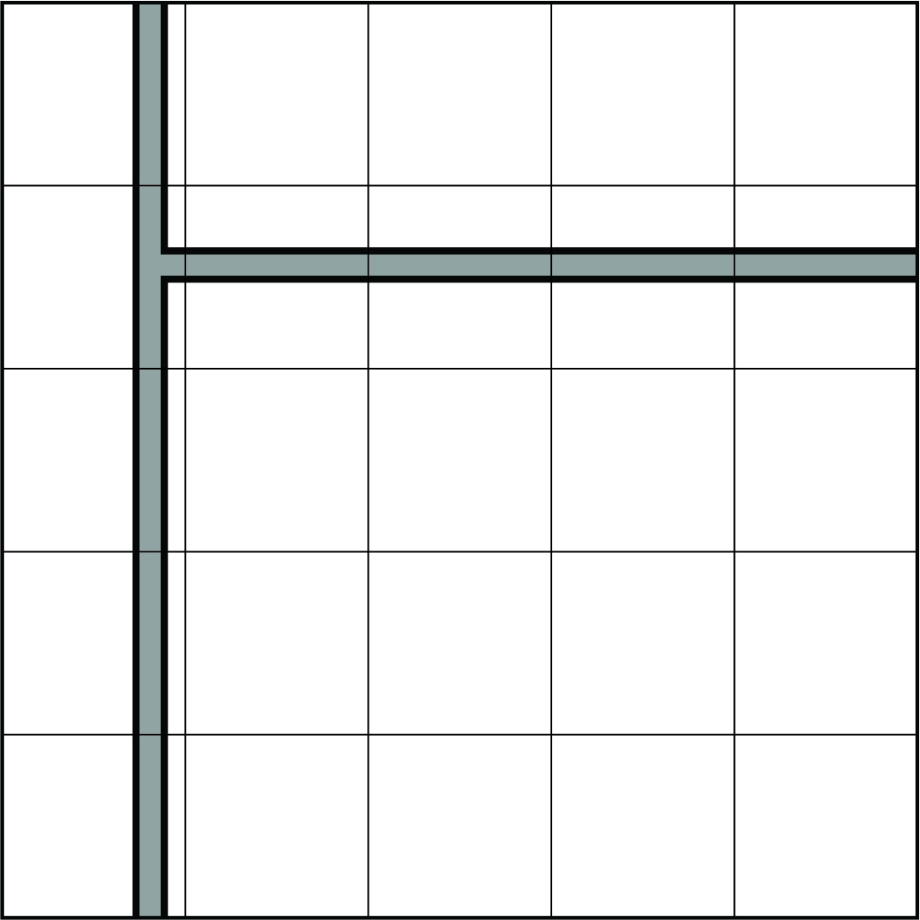 | 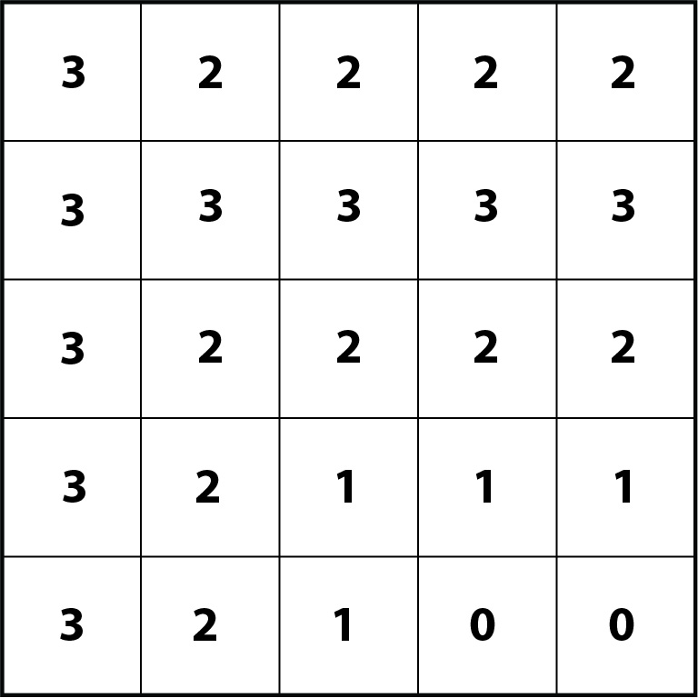 | Principle: Major roads are good – the closer, the better.  Rules:  -cells containing a road = 3  -cells bordering a cell with a road = 2  -cells that border a 2 (and don’t border a 3) =1  -all other cells = 0

You can use any rule you wish to, as long as you have a clear procedure for assigning the cell a value. For instance, if you think living along a major road is extremely important, you could assign the cells containing the road a “3” and all other cells a “0.” Here is another example: if you wanted to live as close as possible to a playground, you could write: “cells that contain a playground = 3, cells that border a playground cell = 2, cells that are diagonal from a playground cell = 1, all other cells =0.”

While you might personally have little preference for some of the layers, but for the sake of this exercise, please(!) don’t discard the layer with a rule like “no preference: all cells = 0.”

Please be consistent and clear with your rules (write them so that anyone else reading the rules would evaluate the cells of the grid in precisely the same way you do).

Please record your grid values, and clearly note the principle and the rules.
You are welcome to write the values directly on the map diagrams on the left, if that is your preference.
House Prices
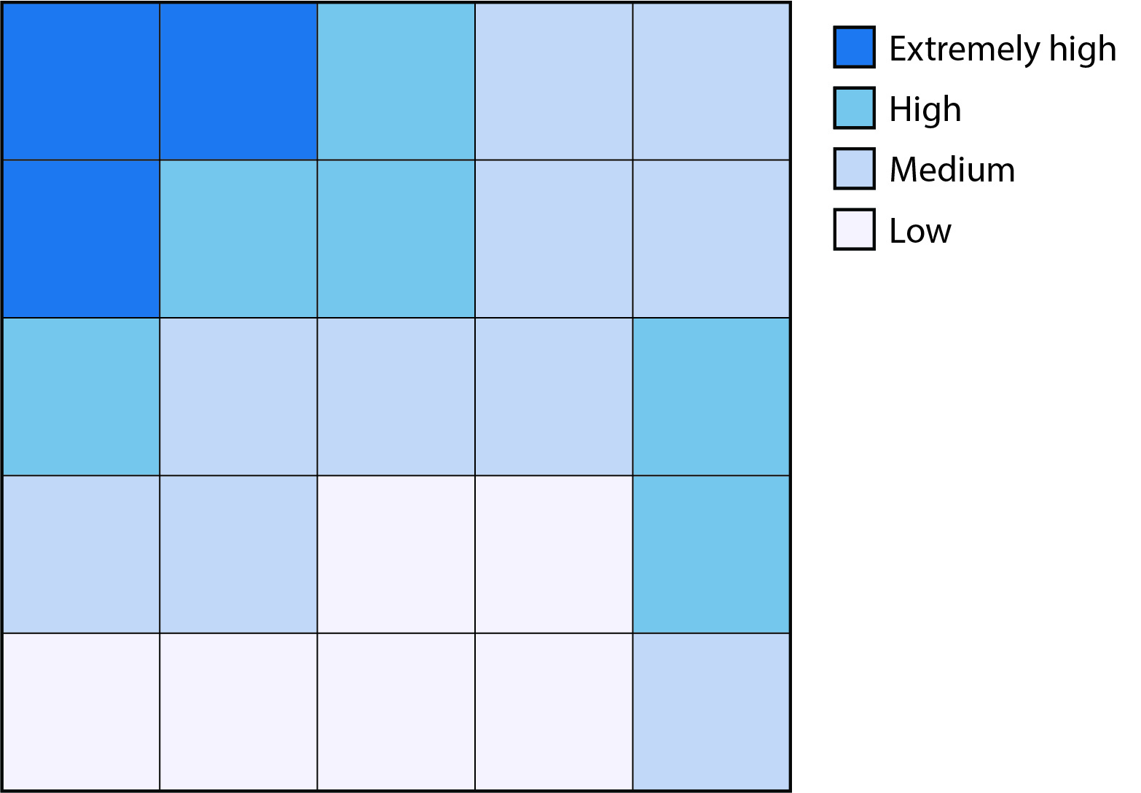 | 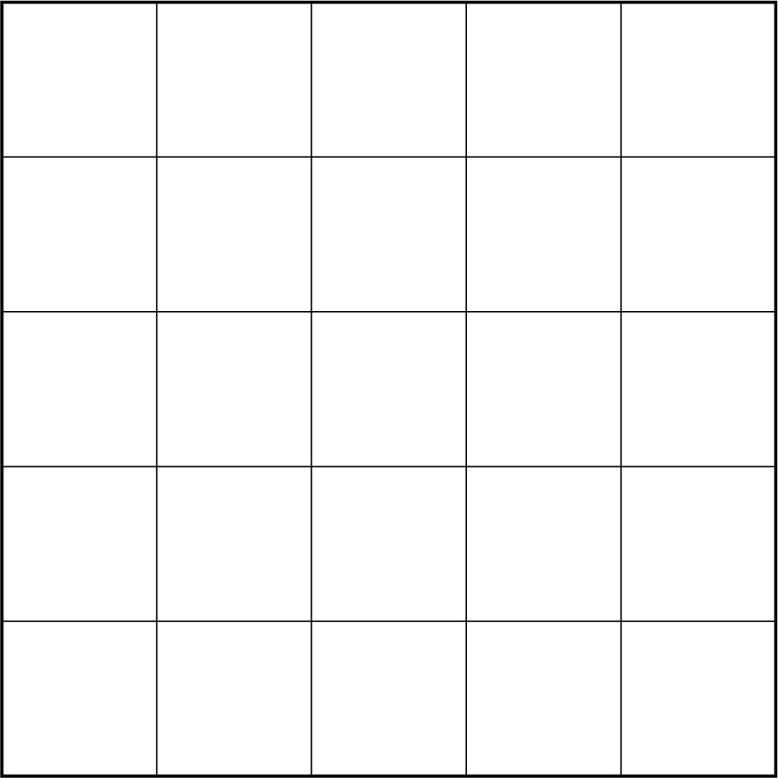 | Principle:  Rules:
Light Rail
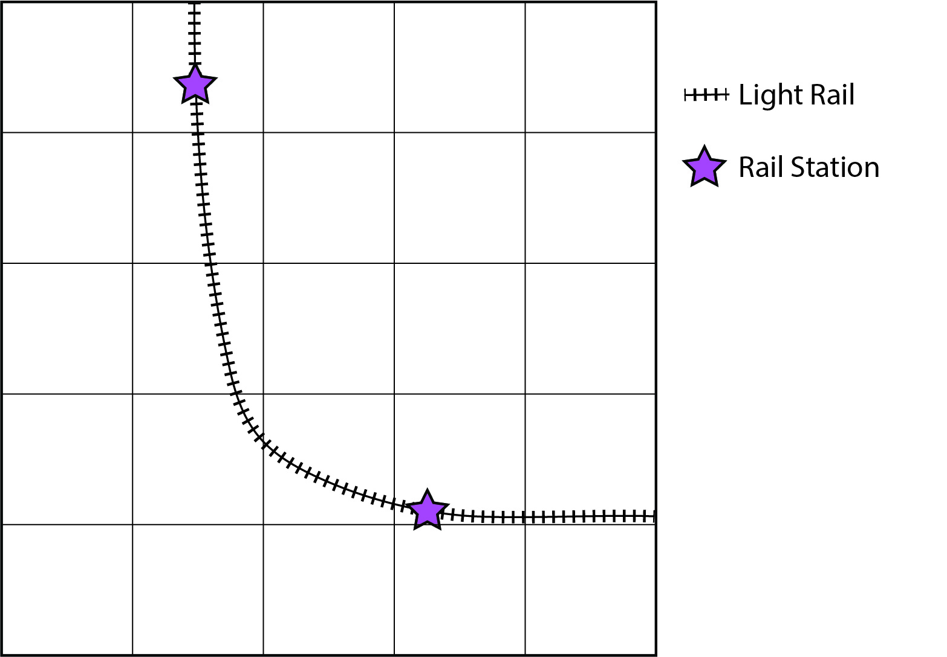 |  | Principle:  Rules:
Parks and Green Spaces
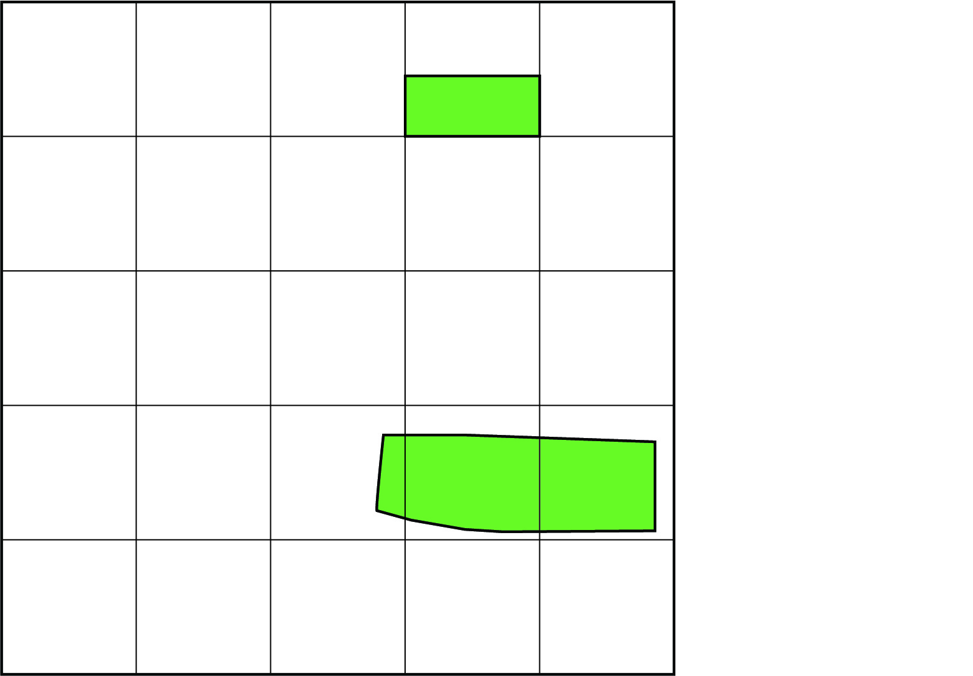 |  | Principle:  Rules:

Restaurants and Cafes
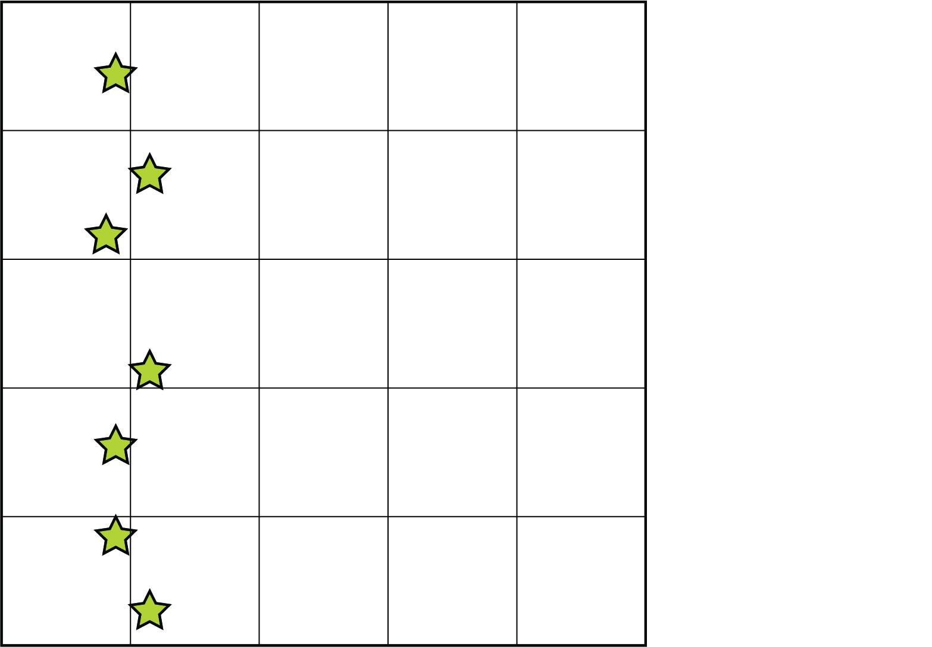 |  | Principle:  Rules:
Schools
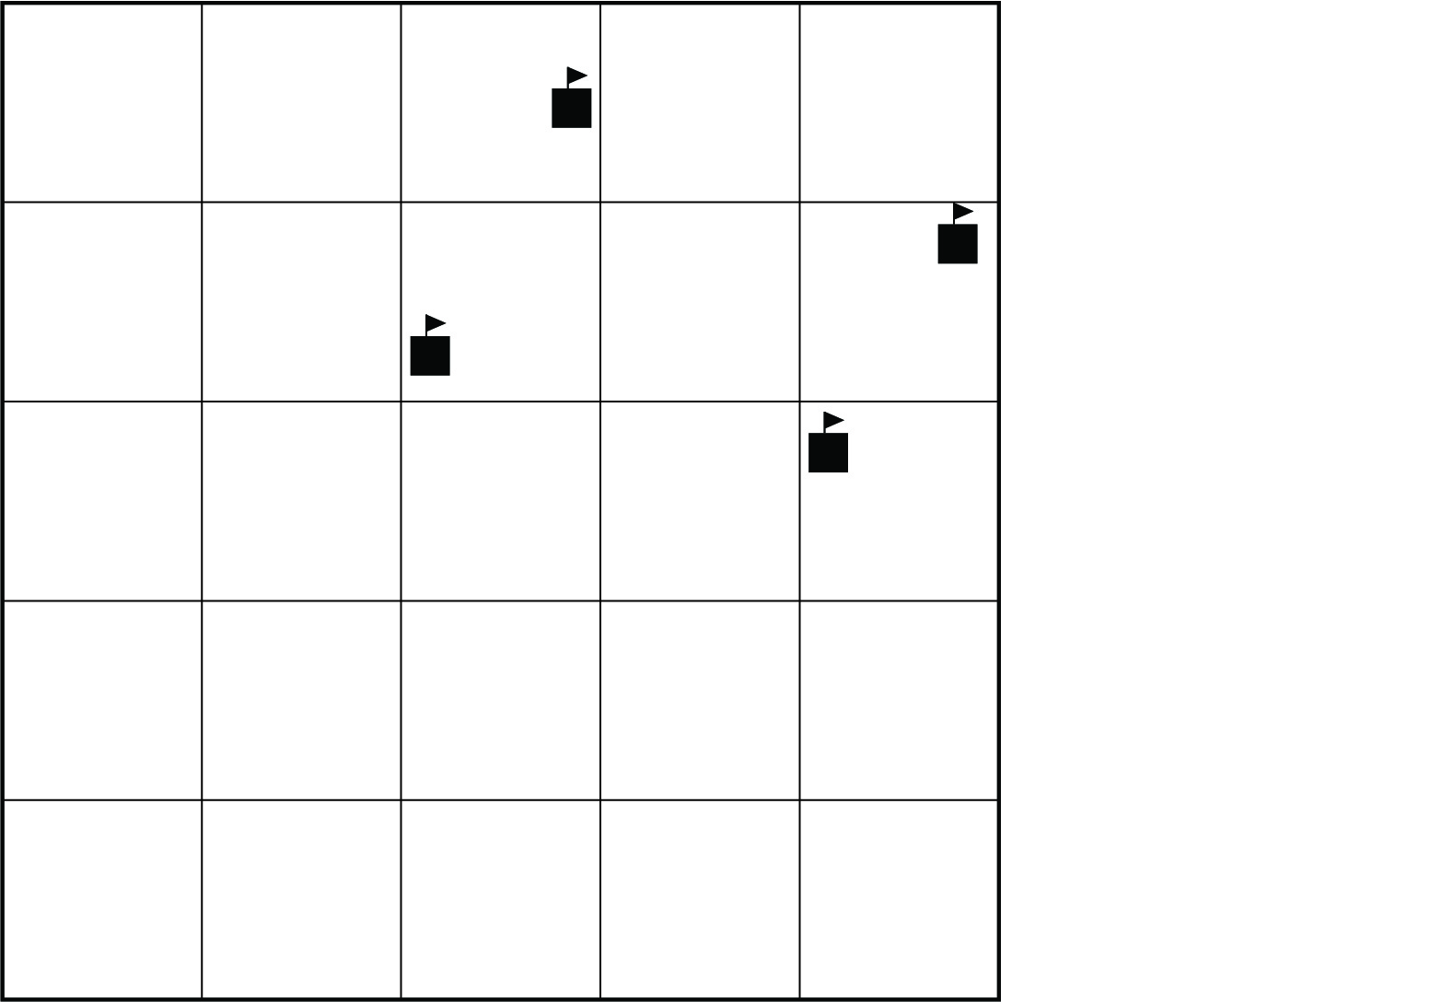 |  | Principle:  Rules:

Once you have completed your operations on each layer, add up the values of the corresponding cells in each grid. You should add up the top left cell for all five grids and record the sum in the top left cell, for example.

Record your final sums here:

The final grid should contain values between 0 and 15.
Higher values represent higher suitability, given what you are looking for.

