How to Make Maps: An Introduction to the Theory and Practice of Cartography
Explore a USGS Topographic Quadrangle

Overview

The purpose of this assignment is to familiarize you with some useful mapping tools and to provide another way for you to learn the material and practice working with the concepts covered in the text.

Exercise Setup

The US Government, and particularly the USGS, does a brilliant job providing some amazing resources to the public. Part of the intent of this exercise is to give you some familiarity with these basic mapping resources. This exercise requires you to locate and download a topographic quad.

A. In a web browser, go to the following URL:
https://ngmdb.usgs.gov/topoview/viewer/

This interface enables you to pan around the US (similar to how Google Maps works). Find the city of Morrison, located 10 or 15 miles to the southwest of Denver. When you click on the map near to Morrison, you should see several records appear on the right side of the screen.

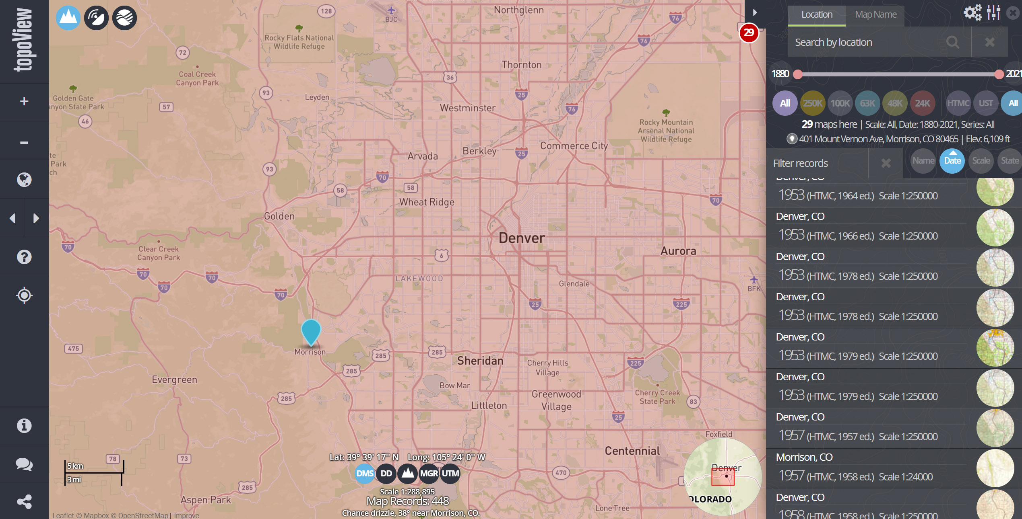

Notice that you can filter the maps to different scales above the list of maps. In this case, we are looking for one of the standard 1:24,000 maps, so you can click the button labelled “24K.”

B. Scroll down to the button of the screen and click on the bar labelled “Morrison, CO: 2019 (US Topo Scale 1:24:000”

C. You should see different download options appear on the right side of the screen – click on and download the “GeoPDF” format. This a basic pdf format that has been given additional functionality, enabling you to work with layers and take measurements.

D. There may be a bit of software setup you need to do for this exercise. Ensure that you have a version of Adobe Acrobat DC, the primary software for viewing and editing pdf files. You can download and install a copy of Acrobat from this website if you do not already have the application installed: https://get.adobe.com/reader/. It’s safe, free, and useful…

E. Once you have the software, open the file you downloaded in Acrobat DC, from where you should be able to view and use the tools described in the exercise.

Basic Map Use and Reading Topographic Quadrangle Maps

To start, you can explore the map without using any special tools.

1. What is the highest elevation you can find on the map? Provide the UTM coordinates.

2 Use the guide to topographic map symbols I have provided to provide your best answer to this question. Look around Bear Creek Lake in the southeast portion of the map. What do you think area filled with dashed blue lines represents? You can use the USGS symbol guide here (https://pubs.usgs.gov/gip/TopographicMapSymbols/topomapsymbols.pdf) to help.

3. What is the name of the mountain located at the following UTM coordinates: 484500mE, 4399750mN?

4. One brilliant feature of viewing topographic quadrangles in a .pdf format is some of the tools it offers.

Click on the “tools” tab at the top of the screen – you should see something that looks like this:

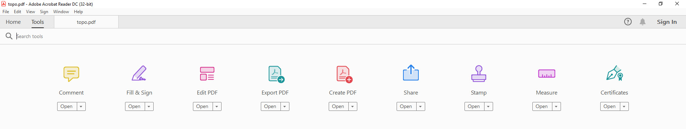

Click on the “measure” tool.

You should go back to your map, where you’ll see something at the top of the screen that looks like this:

Click on the “geospatial location tool” on the right side. Once this is clicked, the latitude longitude coordinates should be displayed on the lower right side of the screen – this shows where your cursor is.

Use the tool to find the coordinates 39.6735, -105.197.

What is the name of the road located there?
5. Another brilliant feature of the topographic pdfs is the ability to control layers. Look for the icon that looks like a stack of layers on the left side of your screen and click on it.

You should see a layers dialog box open on the left side of the screen. This enables you to toggle features on or off (such as grid lines, roads, or contours). The “eye” icon tells you that the layer is currently viewable. This can be incredibly helpful because you can turn off features that you’re not interested in to focus on the material you want to explore.

Turn off all the layers except for the orthoimage to have a look... The dialog should look something like this:

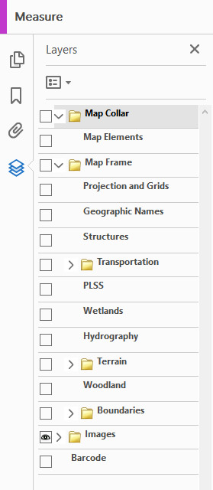
There are several tennis courts on the map. They should something like this:

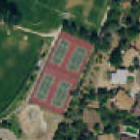

Look around until you can find a tennis and report its latitude / longitude coordinates using the geospatial location tool (described above).

6. Turn the images off and the road layers on. How many different road classifications are indicated on the map? What visual variables are used? The legend on the map will help for this one.

Part 2: Metadata

8. Look at the information at the lower left side of the map. Below, indicate from where the following are derived and the year of the data.

(a) roads

(b) hydrography

(c) contours

(d) Public Land Survey System

9. From when was the orthoimagery derived?

10. In which UTM zone is this map?

11. What geographic datums are listed?

12. What projection is the map in?

13. What is the name of the quadrangle to the Southeast of the map?

14. What is the magnetic declination for the center of the map (data are provided for 2019)?

15. What is the contour interval of the map?

Part 3: Making Distance and Area Measurements

For the next few questions, you should use the “measuring tool”, which is part of the same tool set you opened before. When you click on the tool, you should see a small box appear that shows different “snapping” and “measurement” types as shown below.

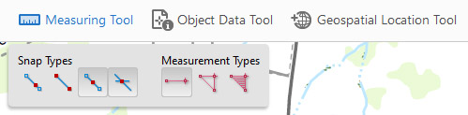

1. Use the perimeter tool (the red tool in the middle of the “measurement types” group) to measure the length of I-70, the major highway traversing the map from the west to the northeast. It will probably work best if you turn off snapping. What is the total length of I-70 as it is shown in the map?

2. What is the area of Bear Creek Lake (in the southeast portion of the map). Only measure the solid blue area of the lake. You can use the “area tool”—the red tool on the right—to answer this question. Provide your answer in square miles. Note that you can change the unit of measurement by right-clicking with the measure tool is selected.

3. [3] What is the azimuth of I-70 as it crosses the northern boundary of the mapped area? (Use the measurement tool to examine a segment of the highway near the edge of the map). The azimuth is shown before you complete the line…

