***How to Make Maps: An Introduction to the Theory and Practice of Cartography***

**Constructing Isolines**

**Overview**

**Isolines** (“equal lines”) refer to lines on a map that connect points of equal value. Isolines are a common cartographic technique for showing continuous data such as elevation, precipitation, air pollution, among many other topics.

Isolines 1) join points of equal value; 2) never intersect with itself or another contour; 3) form closed loops or start and end at the neatline of the map. All points between two isolines should fall between the values of the lines. A good technique is to look for value gaps in the data and start at the edge of the map. Note, however, that isoline maps often include closed loops as well.

**1. Building Isolines I**

This is a hypothetical contour map with point labels showing elevation in feet. Label the lowest contour at 10 feet and draw contours at intervals of 10 feet. The first couple of isolines are included as examples.

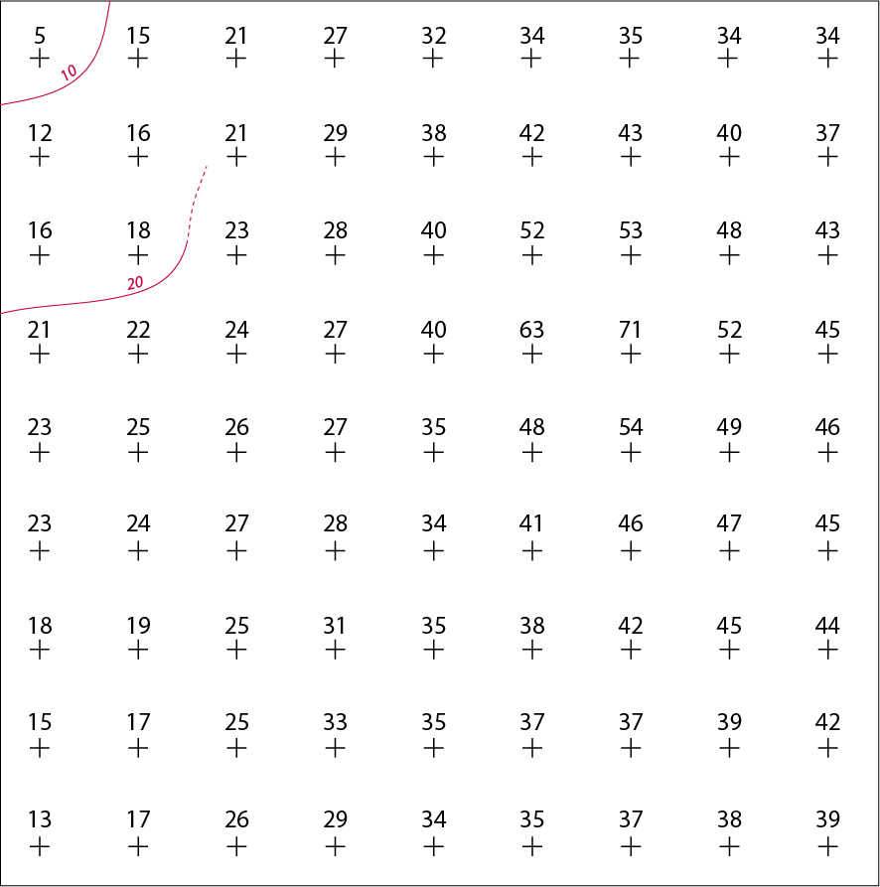

**2. Isolines II**

The map shows hypothetical precipitation measurements (in ml) in Europe. Construct the corresponding contour map of precipitation on top of the points. Use a contour interval of 300 ml and make the lowest value 600ml. Note that you only need to draw isolines on the land. This uses real-world data and can be tricky; I recommend using a pencil!

