**NAME:**

**Geog 2080: Introduction to Map Use and Analysis**

**Scale and Cartometry**

***How to Make Maps: An Introduction to the Theory and Practice of Cartography***

**Reading and Analyzing Maps**

**Overview**

Maps contain a huge number of elemental data points, but one of their real powers is derived from *analysis*, the ability to produce novel insight from data.

This exercise is intended to give you some practice performing very basic analytical calculations on maps—these include some basic *cartometry* problems (“cartometry” is the practice of performing calculations on maps), which you should solve and report.

**1. Converting a graphical or verbal scale to a representative fraction**

You have a Google map with a graphical scale (which is very common in digital cartography). You wish to convert the scale to an RF. All you have for the scale is a graphical scale on the upper left portion of the map that shows how far 1000 feet is on the map.

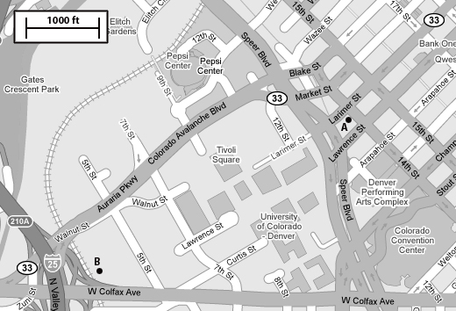

We can apply the basic scale equation – but this time we must fill in some information to get the RF (we are solving for *y* here). Note that you will have to take some measurements of a printout of the map…

$$\frac{x}{1000 ft}= \frac{map distance}{real distance} = \frac{1}{y}$$

1A) What is the representative fraction (RF) of the map?

1B) Articulate an approximate verbal scale.

1C) What is the distance between the points A and B (in feet or miles)?

This procedure can also be used when we can identify a feature with a known distance on a map (a football field, for example, since we know a football field is 100 yards, or 300 feet).

1D) [4 points] Determine the scale of the orthophoto image of the DTC area in Denver (on the following page). Remember to show your work.

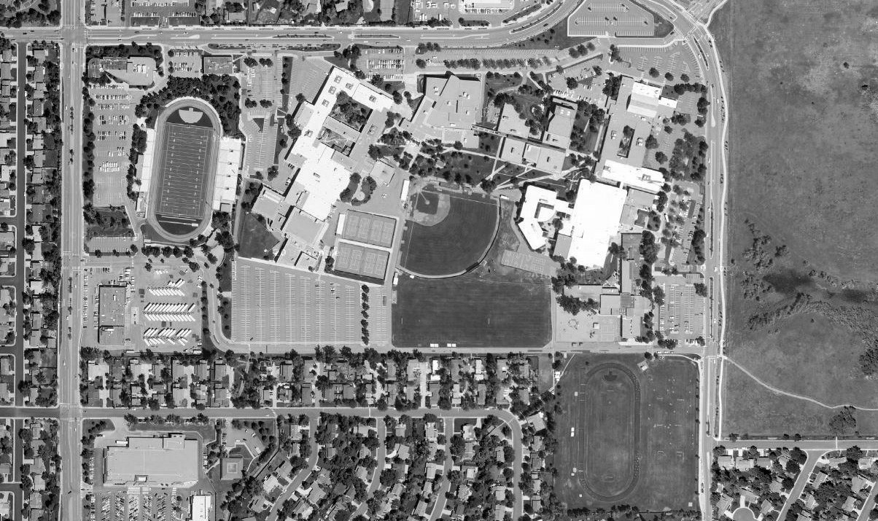

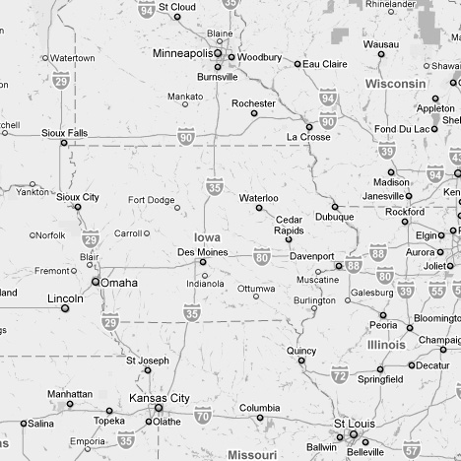1E) [2 points]We know that the flight distance  
between Kansas City and  
Minneapolis is 411 miles. (*the measured distance on the map is 3 ¼ inches*).

What is the RF of this map?

**2. Calculating distance from coordinates**

The following coordinates are given in meters. Round to the nearest tenth.

2A) [3.0 points] What is the distance between coordinate points (685,571) and (899, 1000)?

2B) [3.0 points] What is the distance between coordinate points (-405, -104) and (-700, 50.5)?

**3. Conversion and Cartometry Practice**

One of the challenges in cartometry (or just about any science that deals with measurements!) is dealing with different systems of measurement for distance, weight, volume, etc.

In this exercise, you are given different map scales and asked to fill in the blanks with the information you are given.

*The letters represent a specific map. Use the information provided to fill in the remaining spaces in the table.*

|  |  |  |  |  |  |  |
| --- | --- | --- | --- | --- | --- | --- |
|  |  | **A** | **B** | **C** | **D** | **E** |
|  | **Scale** | ***1:24,000*** | ***1:250,000*** | ***1:90,000*** |  |  |
| **Map Distance** | **cm** |  | ***7*** |  | ***4*** |  |
| **inches** | ***3*** |  | ***5*** |  | ***2*** |
| **Real world Distance** | **km** |  |  |  | ***20*** |  |
| **miles** |  |  |  |  | ***56*** |

**4. Calculating Area**

Calculate the area of the Erie Canal National Heritage Corridor using the grid-cell count method.

In this method:

(A) Calculate the real-world area of each cell.

(B) Count the cells in the area you are measuring. You should only count cells that have more than roughly half of the area covered by the feature you are measuring.

(C) multiply the number of cells by the area of each cell to calculate the total area.

**5. Applied Scale Problem**

*Two* maps of Minnesota (the East-West extent of the mapped area for *each* map is 600km and the map is north-oriented) have to be placed on a landscape map sheet with a width of 30cm. A right and left margin of 2cm and a distance of 2cm between the maps have to be maintained. What scale should be chosen for the maps? Report your answer as a representative fraction.

