***How to Make Maps: An Introduction to the Theory and Practice of Cartography*  
Reading and Analyzing Maps**

**Objectives**

One of the real power of maps comes from their ability to combine a large amount of data in an organized, efficient, and succinct form that enables user to explore patterns and even generate analytical insight.

This exercise is intended to prompt readers to practice reading maps as well as interpret and explore the huge amount of insight contained in them.

Many of the questions in this exercise rely on the Internet to direct readers to examine specific maps. Please write me at [peter.anthamatten@ucdenver.edu](mailto:peter.anthamatten@ucdenver.edu) if you find any of the web links are no longer functional.

1. There are many standard conventions that people have commonly use in producing and reading maps, forming a basic “language of maps”. To some extent, these conventions are international.

a. Visit <http://maps.gsi.go.jp/> where you should see some Japanese maps. Even if you don’t speak Japanese, identify two or three symbols and describe what you think they mean.

b. Is this map an example of a thematic or reference map?

1. The *Atlas of United States Mortality*, published by the CDC was released in 1997 to show the leading causes of death in the United States by Health Service Area, collections of counties defined by their provision of routine health care. An example of a map from this project is printed in Figure A.11 (page 245) of the text. You can view the pages of the atlas in digital format at a website published by the US Centers of Disease Control (CDC) (<https://www.cdc.gov/nchs/products/other/atlas/atlas.htm>). Take a bit of time to explore the pdf maps at the bottom of the page.

a. Examine the maps of heart disease (<https://www.cdc.gov/nchs/data/gis/atmaphd.pdf>). The maps are stratified into different social groups and the data are presented in a variety of alternative map representations. What patterns can you observe in the maps? Is heart disease mortality higher in some parts of the country than others? Where do you observe concentrations of high mortality rates for heart disease.

b. Pick a part of the US to analyze a bit more carefully (perhaps a place you live or one you’ve learned about). How does that place compare to the rest of the country in terms of heart disease? How does it compare to the rest of the country in terms of other causes of mortality.

c. Take a minute to compare the maps of heart disease with some of the other factors mapped in Appendix III (<https://www.cdc.gov/nchs/data/misc/atappiii.pdf>). Which of these factors are most closely correlated to the patterns you observed in heart disease?

d. Look at the maps at the back of the atlas, showing rates of poverty and education (among other things). Which of these maps are most closely correlated to the patterns you observed in heart disease?

e. Take a few minutes to scan the maps of other diseases. Can you observe any broad patterns? Can you generate any hypotheses to explain those patterns?

f. How have the authors indicated a lack of certainty in the data? What symbols do the maps use to communicate this lack of certainty? Is this effective? Explore the atlas to learn about where the data came from to build these maps. Do you have any concerns about the quality of the data.

1. The UK government has published an atlas with a similar idea, *the Environment and Health Atlas for England and Wales* at <http://www.envhealthatlas.co.uk/homepage/>. These are interactive maps that enable you to explore a variety of health issues in the UK.

a. How does the presentation of these maps compare to the United States Atlas of Mortality, the topic of the previous question?

b. Can you examine these maps to generate general insights about the environment and health of the UK?

1. Figure A.5 (page 239) shows a United Nations map of military deployment in Lebanon. You can view this map online at <https://digitallibrary.un.org/record/1473371> (you may have to scroll down the page a bit to see the map). This map was probably produced for a specialized audience who are familiar with the military symbols used and the region being mapped. List two things that could make the map easier to read for a non-specialist audience.
2. Examine the maps of altitude, rainfall, and the endemic area of malaria in Africa (below).

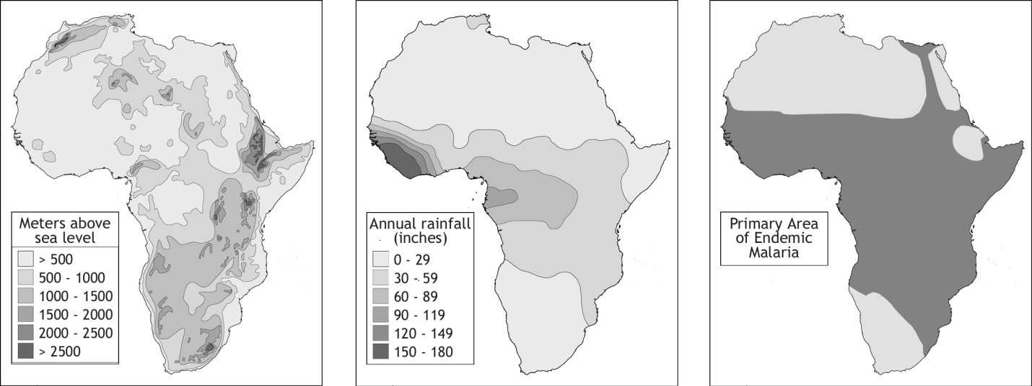  
Source: *Teaching Geography*, Gersmehl and Anthamatten 2008.

a. What insight can you draw from these maps?

b. What do you think explains the thin corridor of malaria endemicity in the northeast region of Africa?

1. View the map “Global Coronovirus Cases” at <https://www.nationsonline.org/oneworld/map/New-Coronavirus-2019-nCoV-world-map.htm>. Do you think this is a good map for comparing cases between countries? Do you see any problems with the way that the data are presented? Can you think of any suggestions for improving it?
2. Go to the following URL: <http://www-personal.umich.edu/~mejn/election/>. Read this page, which shows several different ways to present the 2008 election results in maps.

a. Which map do you think does the “fairest” job of displaying the results and why?

b. Which do you, as a map reader who is interested in looking at election results, find to be the best form for communicating the election results?

c. Identify two general voting patterns from these maps.

1. Visit the World Bank’s Global Solar Atlas (<https://globalsolaratlas.info/map>).

a. How would you describe the pattern on the map to someone who has not seen it? What appear to be the key factors contributing the general patterns?

1. The University of Texas provides a repository of high-quality print maps from around the world (<http://legacy.lib.utexas.edu/maps/>). Examine an example of a 1:100,000 topographic map of a part of Peru at <http://legacy.lib.utexas.edu/maps/topo/peru/cusco-peru-1656-100k-2001.pdf>.

a. What is the latitude and longitude of the Southeast corner of the map?

b. Find the area around the coordinates at 76° 25’ W, 7 ° 25’ S, just south of San Pedro. Can you identify what makes up the area, using the map symbols and the legend?

c. What is the contour interval on the map?

d. What do the blue numbers around the edge of the map indicate?

1. As noted in the text, one of the best-known early examples of analytical mapping was John Snow’s 1854 map of cholera in London, reproduced on the following page. Snow sought to explore the association between cases of cholera deaths and water sources. Each black mark parallel to the streets represents a single cholera death for the period examined.

a. Do you think that this map offers a compelling case that the source of cholera was the Broad Street Pump?

b. What do you like or not like about the map? Can you think of ways to improve the effectiveness of the map, given its intent and purpose?

c. As a 21st Century map reader, what additional information would like to see to help you come to a conclusion about the origin of the cholera outbreaks?

