***How to Make Maps: An Introduction to the Theory and Practice of Cartography*  
Build a Basic Choropleth Map in *ArcGIS Pro***

Part 1: Adding Data and Basic Symbology

**Objectives**

This purpose of this exercise to guide readers through the initial experience of making a map using ArcGIS Pro. Your task is to produce a basic, global-scale choropleth map that shows patterns in population density. A good internet connection and access to ArcGIS Pro is required to complete this exercise.

Take a few minutes to consider what sorts of data you need for a map like this and what potential sources data sources are; spend a little time to browse the internet and see what you can find… There are some clear and immediate data needs: (1) spatial data on country borders; (2) current and reliable data on population by country; and (3) spatial data on other elements that you want to include in the map, such as a map graticule.

1. As you work towards becoming a GIS or cartography professional, it’s a great idea to start building a personal library of good data sources. Go to [www.naturalearthdata.com](http://www.naturalearthdata.com) and download the “countries” shapefile for large-scale (1:10m) data. Make sure that you are careful about keeping track of your files.

## 🡪 from the main page, click on the “downloads” tab at the top of the page

## 🡪 click on the “cultural” button under the “large scale data” section

## 🡪 click on “download countries” under the “Admin 0 – countries” heading

## ([The download link is here](https://www.naturalearthdata.com/http/www.naturalearthdata.com/download/10m/cultural/ne_10m_admin_0_countries.zip))

1. Extract the zip files, taking care to keep track of your files.

## 🡪 most operating systems include a way to unzip files. (In Windows, right-click on the file and select “unzip”), If that does not work or you have trouble extracting the file, you can download and install an open-source file decompression application, such as 7-Zip (at this [link](http://www.7-zip.org)).

1. Open ArcGIS Pro and select a blank map template.
2. ESRI provides a lot of spatial data with its online services, which can sometimes be helpful in constructing your map. In this case, however, you’ll build the map from original data. Remove the layer “topographic” from the table of contents.

## 🡪 from the Contents tab, right-click on the “topographic” layer

## 🡪 select “remove”

1. Add the shapefile to the Contents to view it in ArcGIS Pro.

## 🡪 go to the “Map” tab at the top of the screen

## 🡪 select “add data” (the icon with a layer and plus symbol)

## 🡪 locate the files you extracted and click on “ne_10m_admin_0_countries.shp” file

## 🡪 click “OK”

1. Rename the layer in your GIS to “boundaries.”

## 🡪 right-click on the layer you just added

## 🡪 click “properties” to open the Layer Properties panel

## 🡪 select “General” from the items on the left if it is not already selected

## 🡪 change the current name to “boundaries”

*In ArcGIS Pro, you have access to many powerful tools in the Layer Properties panel, which you can access by right-clicking on the layer and selecting “Properties.”*

1. How to manage your GIS files is a matter of personal preference, but it is often a good idea to remove the attributes you do not need. As is often the case in GIS software, there are multiple pathways for achieving what you need to get done, and the following shows one among several ways to delete fields.

## 🡪 click on the “Analysis” tab at the top of the screen to open the Geoprocessing pane.

## 🡪 click on the icon of a red toolbox named ”Tools”

## 🡪 in the Geoprocessing pane that appears, enter “delete field” in the search bar and press return

## 🡪 click on the “delete field” tool

## 🡪 specify boundaries (the layer you added) in the dropdown menu for the “input table”

## 🡪 using the drop-down menus, remove the attributes you don’t need (for this exercise, you can delete everything except for “POP_EST,” which shows the population estimates by country)

1. Next you should give the map a good projection.

## 🡪 click on the “Analysis” tab

## 🡪 click on the toolbox icon named “Tools”

## 🡪 in the search field that appears, search for “project”

## 🡪 select the “Project (Data Management Tools)” tool

## 🡪 for “Input Dataset or Feature Class,” select the boundaries layer from the dropdown menu

## 🡪 for “Output Dataset or Feature Class,” specify the file location and name (I recommend calling it boundaries2)

## 🡪 click on the graticule icon next to “Output Coordinate System”

## 🡪 in the dialog box, go to “Projected Coordinate System”, and then “World” (you can also search for the projection in the field next to “XY Coordinate Systems Available”).

## 🡪 select “World_Robinson” and click the OK button

## 🡪 click on “Run” at the bottom of the Geoprocessing panel]

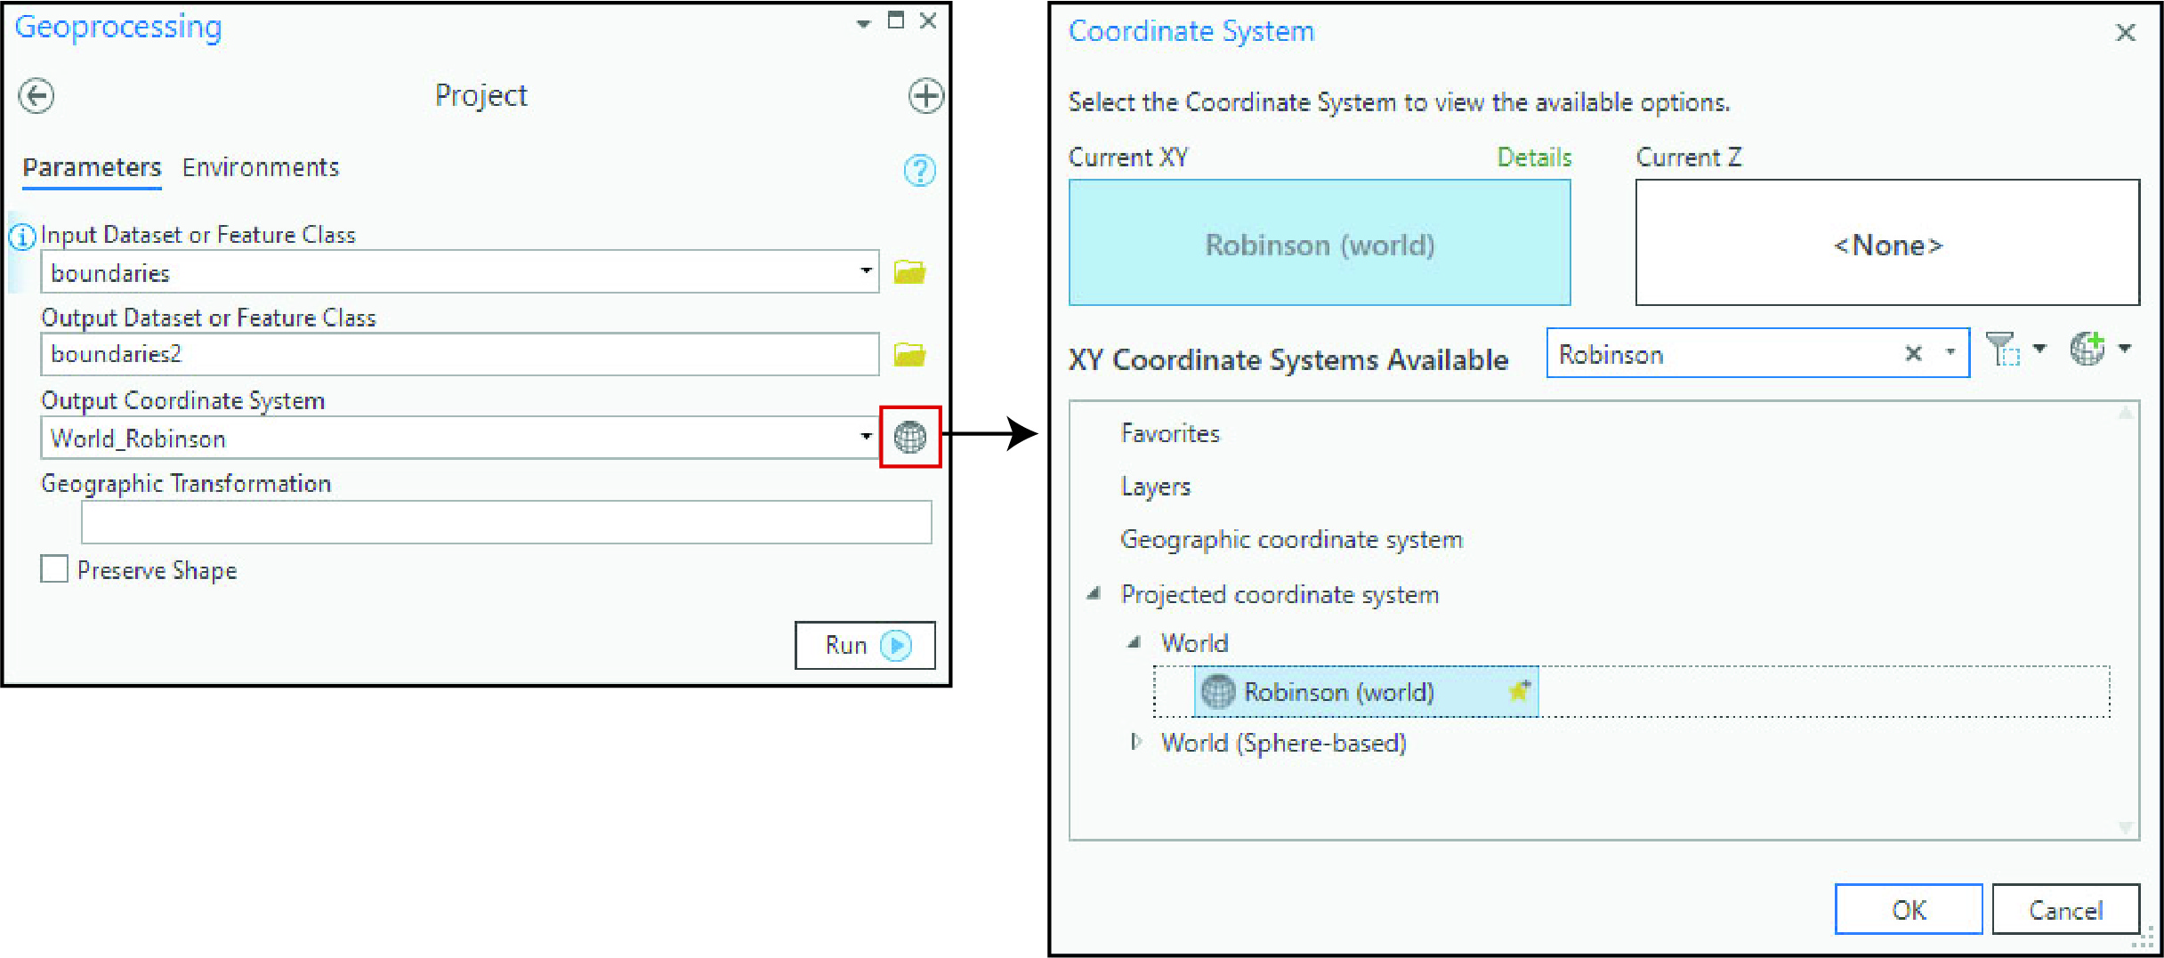

*The Project tool enables you to reproject features from your map. Note that it produces a new layer.*

1. Remove the original layer you downloaded.

## 🡪 right-click on boundaries in the Table of Contents

## 🡪 select “remove”

1. It’s often good practice to also specify the coordinate system you are working with in the Layer Properties, which controls the display of the layers.

## 🡪 double click on the map properties in the Contents pane (called “Map” in the Contents pane by default)

## 🡪 go to “Coordinate Systems” on the left of the Map Properties pane.

## 🡪 find and open the “Layers menu” – this shows you the coordinate systems of the layers loaded into the map

## 🡪 select “World Robinson” (as you did in step 8) and click OK

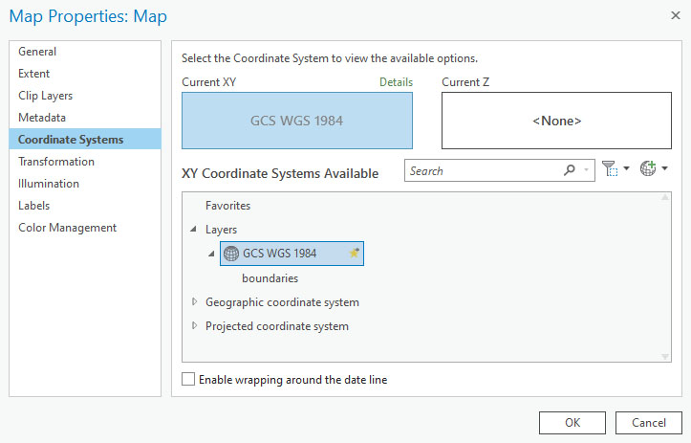

*The Map Properties pane controls how all of the layers in your map layout are displayed. You can control the display projection from the coordinate systems tab.*

1. Now you are ready to calculate population density. Make a new field called “popdens” in the “boundaries2” layer – make it double field format.

## 🡪 right-click on the boundaries2 layer in the Contents pane

## 🡪 select “attribute table”

## 🡪 at the top of the table that opened, select “Field: add”

## 🡪 you should see a list of the attributes in a new tab. Click on “field” in the final row.

## 🡪 change the name to “popdens” and then press the tab key until the column “data type” is highlighted

## 🡪 change the data type to “double” in the dropdown menu

## 🡪 press the tab key until you reach the “number format” column

## 🡪 change the number format to “numeric”

## 🡪 finally, go to the “fields” tab at the top of the screen” and click on “save”

## 🡪 close the attribute field window

*You can add new attributes and adjust the existing ones from the attribute table. This shows the dialogue box for adding a new attribute.*

1. Because the map should show population density, rather than absolute counts of population, you need to build new attribute for population density.

Make an attribute field to show the area. While the software automatically includes a field called “Shape_Area,” which indicates the size of each polygon, it is seldom in the unit of measurement you want to work with. To avoid the additional calculation and to ensure that you are working with correct data, you can manually calculate the area.

## 🡪add another field (call it “area_km”), specify the data type as “double” and the number format as “numeric”

## 🡪 right-click on the field you just created and select “calculate geometry”

## 🡪 indicate the property as “area” and the coordinate system as “World Robinson,” the same as your map

*The Geoprocessing tool enables you to calculate the area of features.*

1. Calculate the population density by performing another field operation—divide the population estimate by the area in square kilometers.

## 🡪 Go back to the attributes for the boundaries2 layer (right-click on the layer in the Contents pane and select “attribute table”)

## 🡪 right-click on the field you just created (POP_DENS) and select “calculate field”

## 🡪 Enter the following under the field labeled “POP_DENS=” You can add the text by clicking on the appropriate terms from the list. It should appear as “!POP_EST! / !areakm!”

## 🡪 Click on “run” The field should now be populated with the population per square kilometer

*You can calculate population density (or perform any other operation) using the Geoprocessing tool. For this exercise, the tool should look like this image.*

1. Now you’re ready to start building the map!

## 🡪 close the attribute windows

## 🡪 go to the symbology tab by right-clicking on the boundaries2 layer and selecting “symbology”

## 🡪 in the rolldown menu under “primary symbology,” select “graduated colors”

## 🡪 change the field to “POP_DENS,” pick a good categorization method (under “method”)

## 🡪 due to the way the data are distributed, some of the categorization schemes do not work well; select “quantiles.”

## 🡪 chose a monochromatic color scheme

## 🡪 show the new field you just built (POP_DENS) and classify the map into five quintiles.

## 🡪 select a mono-chromatic color scheme that makes a good, legible map

## It’s a good idea to experiment with the options in dialogue boxes like this to learn the software.

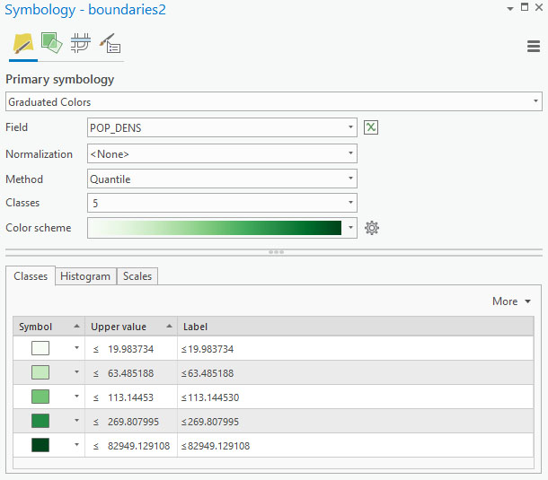

*The symbology pane (which you can access by right-clicking the layer name and selecting “symbology”) enables you to manipulate how the data are displayed on the map.*

1. When your map is ready, you can export the in a variety of formats for use with other applications.

## 🡪 click on the “share” tab

## 🡪 click on the “map” button with the green arrow icon

## 🡪 from here, you can specify where and in which graphical format you would like the map saved

Although a simple map image may be all you need for some purposes, the map is still incomplete because it lacks a title, legend, and other elements that may help viewers read it. You can learn about how to build a good layout in the next tutorial (“Building a Layout”). Save your work from this exercise to continue with the next one.